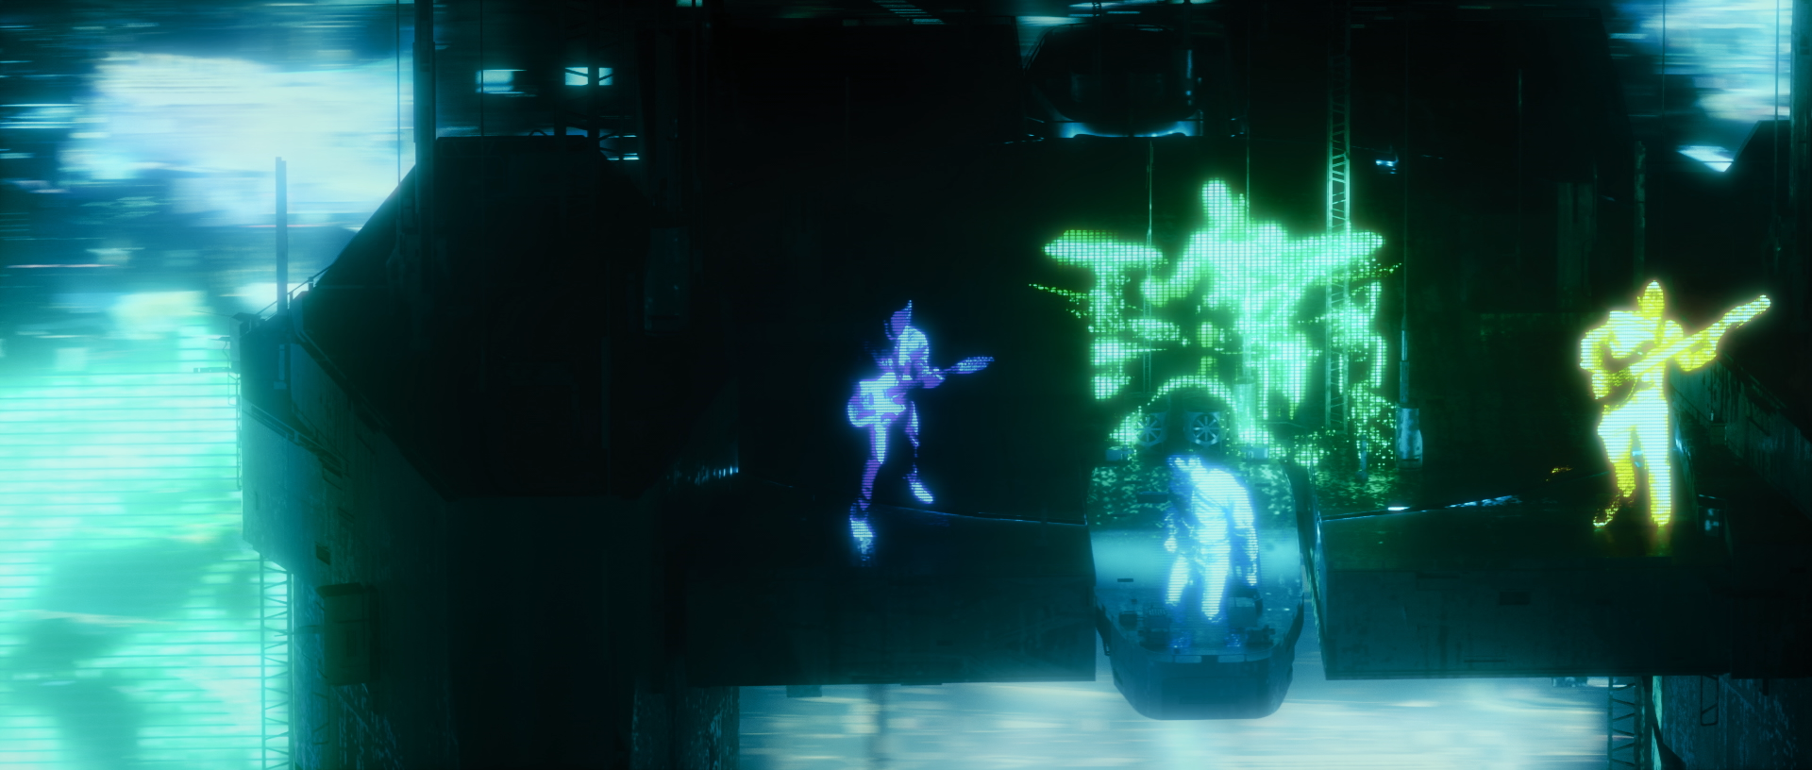

CHART TOPPERS ENTER SHIKARI TO PREMIER ‘THE GREAT UNKNOWN’ VIDEO THIS TUESDAY ON YOUTUBE

ENTER SHIKARI TO APPEAR ON CHANNEL 4’S SUNDAY BRUNCH THIS WEEK

“It's the sound of grand ambition being realised.” **** Q Magazine

“(Nothing Is True & Everything Is Possible) only serves to show off their genius further.” KKKK Kerrang!

“It’s a crash course in their unruly genius – a Greatest Hits waiting for you to learn the words.” **** NME

“… the record sounds like a Greatest Hits, only with songs on it that no one knows yet.” ***** Metro

“Rou Reynolds’s versatile vocals and precision production steer the St Albans quartet from riotous electro to disorientating jazz.” Sunday Times Culture

“What Shikari have managed to achieve over the course of the album is nothing short of spectacular.” **** DORK

“… uncompromising excellence…" Louder Than War

“… as the album charges so confidently towards innovation it would be foolish to suggest it’s anything other than brilliant ... they’re now distinct leaders, paving a new and exciting trail for those in their ever-growing shadow.” 8/10 Gigwise

"Nothing Is True & Everything Is Possible’ proves once more why Enter Shikari are not only one of the best, but also one of the most important bands of our generation." Punktastic

Following the release of Enter Shikari’s critically acclaimed number 2 album ‘Nothing Is True & Everything Is Possible’ on So Recordings last week, the band will premier the video for ‘The Great Unknown’ this Tuesday 12th May at 6pm on YouTube: https://youtu.be/iwe0uVrjihA The band will be online to answer fan questions before, during, and after the premier.

‘The Great Unknown’ video was directed by POLYGON who was also responsible for the ‘The Dreamers Hotel’ and ‘Stop The Clocks’ videos, as well as recent work for Tame Impala and Bring Me The Horizon. The video was produced entirely during the lockdown period, with the band members individual performances self-shot at home and whisked to Paris to be turned into magic.

Frontman Rou Reynolds said:
"The Great Unknown is a song about existential dread. A song about the need for new ideas and new beginnings. I’m so glad we were able to still make a video for this song, what with the current state of affairs, and I’m glad we were able to convey the emotions intrinsic to the song with this video - our state of isolation and desolation but also determination and connection. Yet again it was a great pleasure to work with Polygon, albeit remotely this time! I won’t forget taking directions from him on Skype, as I recorded my scenes in front of a homemade green-screen in my bedroom!"

Polygon himself added:
"The Great Unknown is an invitation for viewers to dive into a futuristic and gloomy world, where high-end buildings mix with gigantic holograms. The concept of the video is to create a parallel between the state we’re all in at the moment and an ultra pessimistic vision of the world… It seems like there is no redemption nor glimmer of hope in this massive city, but even the darkest night will end and the sun will rise.
I’m really happy with the result of this video and I hope people will enjoy it. It’s truly amazing working with the band and management for they’ve always been supportive of these kind of ideas and always been giving me total freedom regarding the direction and execution of what are at first silly lines on a notepad or badly drawn doodles. I’ll forever be thankful for all the opportunities the band have given me."

This past Sunday (10th May) Enter Shikari appeared on Channel 4’s Sunday Brunch. The show broadcast the first ever “live” performance of a ‘Nothing Is True & Everything Is Possible’ track, which the band recorded, shot and mixed at home, edited by long-time Shikari visual collaborator Oleg Rooz in Kiev, Ukraine. Rou Reynolds was also interviewed remotely by Tim Lovejoy.

The band will also headline the NHS benefit online festival Five4Five on Saturday 16th May. Enter Shikari will perform a short set which will be free to watch, but with viewers encouraged to donate £5 to watch the two-day event, with all proceeds to https://www.nhscharitiestogether.co.uk. Other artists on the bill include Don Broco, Fatherson and Deaf Havana. More details at www.five4fivefest.com

Enter Shikari have long been vocal supporters of the National Health Service as seen in 2015’s ‘Anaesthetist’ single, taken from the album ‘The Mindsweep’: https://youtu.be/V1OIxKYmdG0

’Nothing Is True & Everything Is Possible’ entered the Official UK Charts at number 2, making it Enter Shikari’s highest ever chart position, as well as number 1 in the OCC Cassette and Rock Charts. This marks the band’s fifth Top 10 album of their career joining 2007’s debut ‘Take To The Skies, ‘A Flash Flood Of Colour’ (2012), ‘The Mindsweep’ (2015) and ‘The Spark’ (2017). Listen in full here

Enter Shikari have announced an extensive UK / European tour for Autumn / Winter 2020 which has seen unrivalled demand.

UK Tour dates below:

NOVEMBER 2020
Wed 11 UK. Southampton - Guildhall
Thu 12 UK. Manchester - Victoria Warehouse
Fri 13 UK. Cardiff - Great Hall – SOLD OUT
Sat 14 UK, London - Alexandra Palace
Mon 16 UK. Middlesbrough - Town Hall
Wed 18 UK. Edinburgh - Usher Hall wq
Thu 19 UK. Nottingham - Rock City
Fri 20 UK. Nottingham - Rock City – SOLD OUT
Sat 21 UK. Birmingham - O2 Academy

Tickets available here: www.entershikari.com/shows

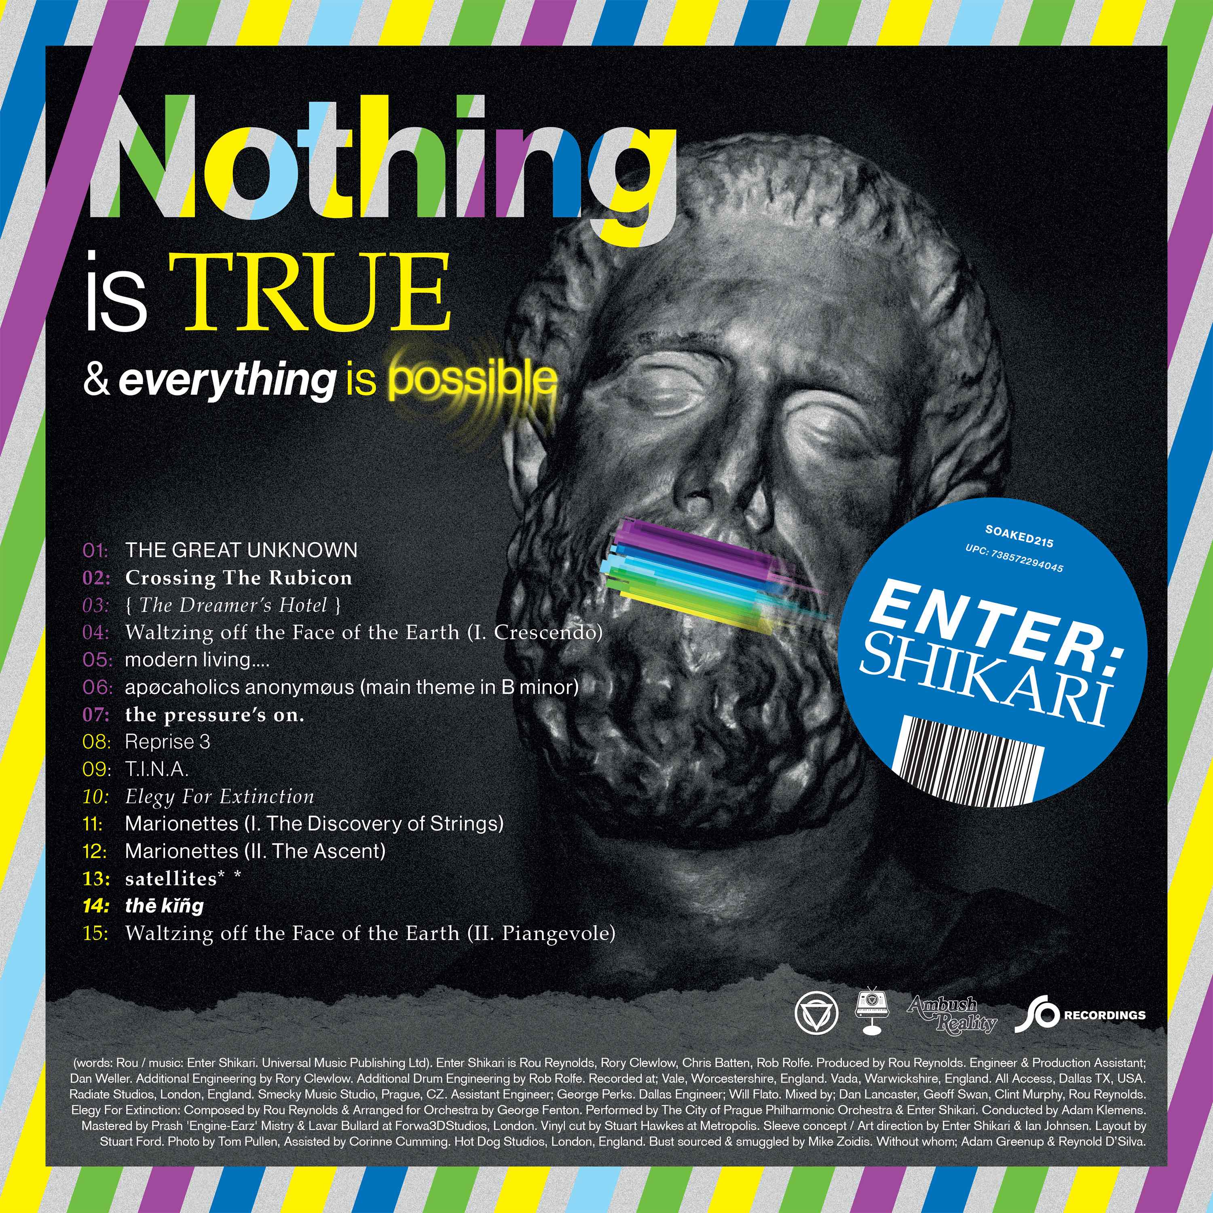
High res artwork
’Nothing Is True & Everything Is Possible’ tracklist:
- 1.The Great Unknown
- 2.Crossing The Rubicon
- 3. { The Dreamers Hotel }
- 4. Waltzing off the Face of the Earth (I. Crescendo)
- 5. modern living…
- 6. apocoholics anonymous (main theme in B minor)
- 7. the pressure’s on
- 8. Reprise 3
- 9. T.I.N.A
- 10.Elegy For Extinction
- 11. Marionettes (I. The Discovery of Strings)
- 12. Marionettes (II. The Ascent)
- 13. satellites
- 14. the king
- 15. Waltzing off the Face of the Earth (II. Piangevole)

Watch ‘The Dreamer’s Hotel’ video

Official Website | Facebook | Twitter | Instagram

For more information and press enquiries please contact:
Warren Higgins
warren@chuffmedia.com
020 8281 0989

