THE ACES SHARE MUSIC VIDEO FILMED IN QUARANTINE FOR “MY PHONE IS TRYING TO KILL ME”

THE ACES ANTICIPATED SOPHOMORE ALBUM UNDER MY INFLUENCE RELEASED 12TH JUNE

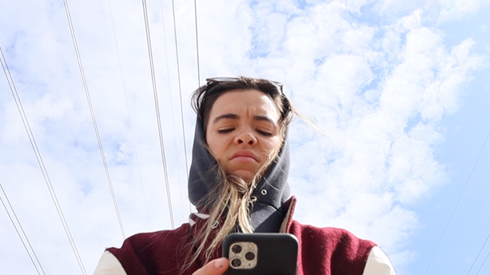

The Aces have released the music video for their most recent single, “My Phone Is Trying To Kill Me” today, taken from their highly anticipated new album Under My Influence released 12th June via Red Bull Records. Watch it here, Created by the band whilst in quarantine, the homemade video delves into the pressures of social media and the attachment one can feel to their digital devices.

"Given the time, we’re not able to make music videos in the way we normally would, but we didn’t wanna let that stop us”, The Aces explain, “so we decided to grab our phones and cameras and take the matter into our own hands and make a little homemade music video for ‘My Phone is Trying to Kill Me.’ It ended up being hilarious and so much fun to make and we hope you enjoy watching it as much as we did making it!”

Last week The Aces announced their sophomore album Under My Influence, and shared an exciting preview of the album with their fans. Check out the trailer here. The album will include their recent hits, “Daydream,” “Lost Angeles,” and “My Phone Is Trying To Kill Me” amongst others. Pre-order it today here.

Spread over 14 tracks, Under My Influence brings fans deeper into The Aces’ world of funk-tinged romance, heartfelt breakups, and relentless positivity—no matter what’s going on. Together, sisters Cristal and Alisa Ramirez (vocals/guitar and drums, respectively), McKenna Petty (bass), and Katie Henderson (lead guitar/vocals)—all friends since grade school in Provo, Utah—explore growing up and falling in love in the 21st century with candid honesty and endearing relatability. From lead single “Daydream” to the beachy “Kelly,” anthemic “My Phone Is Trying To Kill Me” to the bittersweet “Lost Angeles,” The Aces push their sound to more buoyant heights, grounded in learned realities. Where When My Heart Felt Volcanic left off with the hope of a lover returning, Under My Influence finds The Aces standing tall, cheeky, and fantastically independent. When The Aces were just starting out, their website described the group as “a band of four girls preparing to take over the world.” Well, preparation time is over. With Under My Influence, The Aces have officially entered a full-fledged global takeover. No “Daydreaming” needed.

UNDER MY INFLUENCE Tracklist:
- Daydream
- New Emotion
- My Phone is Trying to Kill Me
- Kelly
- Can You Do
- All Mean Nothing
- 801
- I Can Break Your Heart Too
- Lost Angeles
- Not Enough
- Cruel
- Thought of You
- Going Home
- Zillionaire

Pre-order Under My Influence here
Get “Daydream” here
Get “Lost Angeles” here
Get “My Phone Is Trying To Kill Me” here

About The Aces
It’s been two years since the quartet released their acclaimed debut album, When My Heart Felt Volcanic. In those two years, the band sold out their U.K / European and U.S headline tour, supported 5 Seconds of Summer, and spent countless hours documenting everything in-between in the songs that make up Under My Influence. Universally relatable and yet deeply personal, The Aces return with the confidence only time and true friendship can bring. Under My Influence isn’t just an album brimming with honesty, it’s an album brimming with trust—trust in themselves, as individuals, as a group, and with their fans.

Follow The Aces
Instagram | Twitter | Facebook | SoundCloud | YouTube | Spotify

For more information and press enquiries please contact:
Warren Higgins
warren@chuffmedia.com
020 8281 0989

