MACHINE GUN KELLY RELEASES “BLOODY VALENTINE” VIDEO
STARRING MEGAN FOX
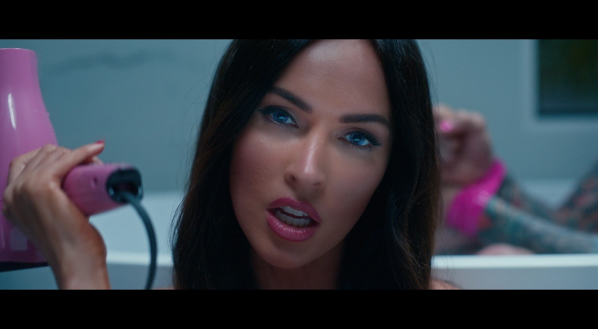

Machine Gun Kelly (EST 19XX/Bad Boy/Interscope Records) releases the official music video for his latest hit single “Bloody Valentine,” the first single off his forthcoming Tickets to My Downfall album. In the video, we see an affectionate-twisted love story between actress Megan Fox and Machine Gun Kelly. Directed by Michael Garcia, the video shows off Machine Gun Kelly’s edgy persona while Megan Fox takes full control of their fictional romance. The music video made its broadcast premiere on MTV Live, MTVU and on the Viacom Times Square billboard. Over the last few weeks, “Bloody Valentine” has reached massive heights by landing #1 on the Billboard Rock Digital Song Sales chart and #3 on the Billboard Hot Rock Songs chart. “Bloody Valentine” has also been streamed over 10 million times globally. Entertainment Weekly described “Bloody Valentine” as “propulsive lovelorn emo goodness.” Watch the “Bloody Valentine” video HERE.

More recently, Machine Gun Kelly released a behind the scenes for the making of “Bloody Valentine” along with a lyric video on YouTube. He also made an appearance on The Late Late Show with James Corden featuring a high-octane quarantine performance of “Bloody Valentine” with Blink-182’s Travis Barker. Never one to shy away from his love for his hometown, especially during these times, Machine Gun Kelly recently provided over 40,000 meals to the Greater Cleveland Food Bank and bought lunch for hundreds of Cleveland residents at twelve restaurants throughout the city dubbed “Machine Gun Kelly Feeds the City.” Additionally, he has been gearing up for the Tickets To My Downfall album release with his successful series Lockdown Sessions, which has amassed over 70M views. Covering classics, a few which include Paramore’s “Misery Business,” Oasis’ “Champagne Supernova” and a Rihanna approved “Love On The Brain.” Several of the videos have trended #1 across YouTube.
For more information, please visit www.machinegunkelly.com

Machine Gun Kelly “Bloody Valentine” eSingle
Retail: https://smarturl.it/BloodyValentine
Video: https://smarturl.it/BloodyValentineVideo

For more information and press enquiries please contact:
Warren Higgins
warren@chuffmedia.com
020 8281 0989

