ANNOUNCE ‘THE JOURNEY’ 2021 AUTUMN TOUR & NEW ALBUM

TICKETS ON SALE FRIDAY 4TH DECEMBER, 10AM
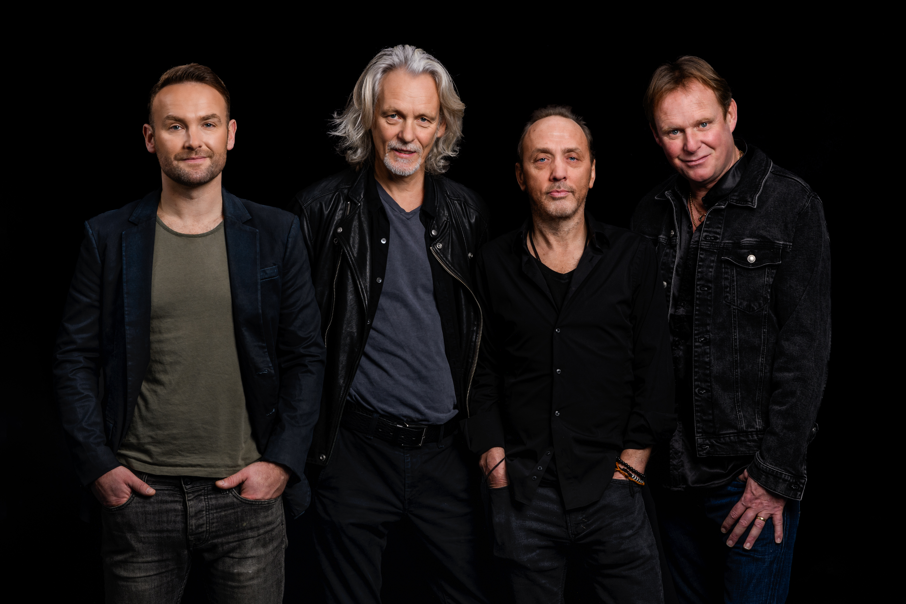

With 2021 looking brighter for all, love really will be all around as WET WET WET are heading back out on the road for a full theatre tour in autumn. Kicking off ‘The Journey’ tour in their beloved homeland of Scotland, the band will visit 20 cities across the UK in what will be their largest tour since 2019’s sold-out run.

Having spent a fair amount of time in their homes this year, the band turned their creative juices on to entertain fans via their ‘Wet Wet Wet from Home’ sessions, rearranging original classics in videos viewed by tens of thousands. Now itching to see their fans in person, the tour will be their second full run with singer Kevin Simm who was seamlessly welcomed into the fold in 2018. Previously a member of BRIT Award winning band Liberty X, Kevin won the 2016 series of The Voice UK.

When asked about the excitement of a new tour, Graeme Clark said
‘Nothing comes near to playing a live gig, from travelling to the venue for the soundcheck, to getting psyched before you go on, the roar when the lights go down, doing your gig with your musical brothers, to the bow at the end of the show. When you get it right it completely re-energises you. Going out on a tour is one of the most exhilarating things you can do in life.’

Next year will also see the band release their first album with Kevin at the helm, entitled ‘The Journey’ it is available to pre-order now. Neil Mitchell explains ‘Releasing a new Wets studio album in 2021 is all the more
unusual because of these weird times that we're living in. Having Kevin as our singer now gives the band and
the new album a different dynamic and an excitement that has reinvigorated Wet Wet Wet for an exciting journey ahead…’

Kevin Simm followed, ‘I have loved being part of the band, performing with the lads and singing an incredible catalogue of songs. We have really gelled on stage and as friends off it, so it was the next natural step to write and release some new music.’

Wet Wet Wet are undeniably a musical phenomenon, having made an incredible impact with their music over the last four decades, becoming one of the most successful bands in British pop history. Selling in excess of 15 million singles and albums to date, Wet Wet Wet have featured in the UK official singles and album charts for over an immense 500 weeks. With number 1 hits including ‘With A Little Help From My Friends’ and ‘Goodnight Girl’, 1994’s ‘Love Is All Around’ was the biggest selling single of the year, when it spent 15 weeks at No1, making it the longest spell at the top for any UK artist – a record that still stands.

Tommy Cunningham concluded ‘2021 is going to be one of the most challenging but most successful years in our entire 30-year plus career. We will not go down. We will fight on and the journey continues. Wet Wet Wet have a very bright future and we all can’t wait.’

WET WET WET – ‘THE JOURNEY’ AUTUMN TOUR 2021

Thursday 28th October Perth Concert Hall
Friday 29th October Aberdeen Music Hall
Saturday 30th October Edinburgh Usher Hall
Sunday 31st October Nottingham Theatre Royal
Tuesday 2nd November Halifax Victoria Theatre
Wednesday 3rd November Buxton Opera House
Thursday 4th November Bury St. Edmunds Apex Theatre
Saturday 6th November Eastbourne Royal Hippodrome Theatre
Sunday 7th November Hastings White Rock Theatre
Monday 8th November Guildford G Live
Tuesday 9th November Portsmouth Guildhall
Thursday 11th November Cheltenham Town Hall
Friday 12th November Margate Winter Gardens
Saturday 13th November Stevenage Concert Hall
Sunday 14th November Poole Lighthouse
Tuesday 16th November Crawley The Hawth Theatre
Wednesday 17th November Weymouth Pavilion
Thursday 18th November Birmingham Town Hall
Saturday 20th November Scunthorpe Baths Hall
Sunday 21st November Newcastle Tyne Theatre

Tickets will go on sale 10am Friday 4th December 2020 from www.myticket.co.uk/artists/wet-wet-wet and venue box offices. VIP Soundcheck packages are available.
Fans who pre-order the album from https://wetwetwet.tmstor.es/ prior to Thursday 3rd December will receive access to an exclusive ticket pre-sale.

wetwetwet.co.uk / @wetwetwetuk

For all media enquiries please contact Warren @chuffmedia.com on 07762 130510

