ANNOUNCE AUTUMN ’21 UK & EUROPEAN TOUR

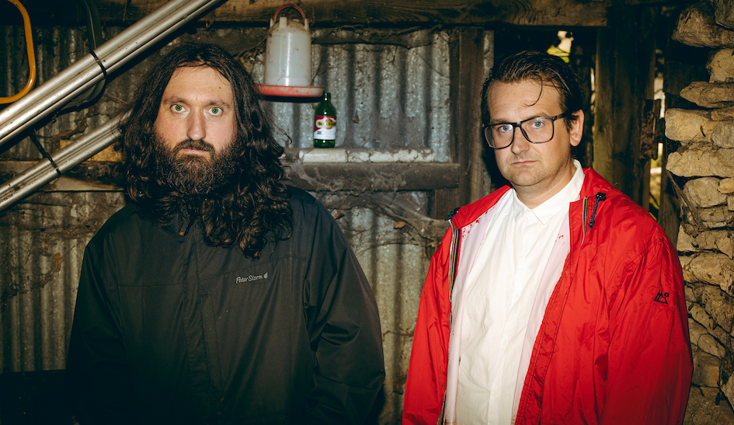

“Extremely entertaining, a bonkers and bombastic epic, as melodramatic and pompous as it is dark" The Quietus
‘Remarkable in very many ways’ **** MOJO

Young Knives released their 7th and arguably greatest album “Barbarians” back in September. Hailed as one of the best albums of the year by taste makers such as The Quietus and Mojo Magazine, fans have awaited with bated breath for the moment that they could finally see this masterpiece performed live.

During lockdown the duo have hosted a popular series of livestreams from a delipidated 1980’s Addis “rambler” Caravan, but now the show must take to the road as today the Oxford brothers Henry and House of Lords have announced a run of UK and EU dates at the end of 2021.

“Playing some shows, playing some shows.....playing some GOD DAMN shows! It's real, they are DEFINITELY going to happen, there is no doubt in our minds WHATSOEVER! Yes, shows, with audiences, and loud mutha f*ckin' P.A systems, and sweat and booze and blood and no b*llocking disease, and LOVE, don't forget love: Love spewing out all over the floor. The lights, the theatre of it all, the post-show deafness and BIG SMILES on our faces and BIIIIIIG SMILES on your faces too. It will be the best of times.”

THE WAIT IS NEARLY OVER.

Tickets are on sale Friday 26th Feb 10am, available from https://young-knives.com/shows/

20.11.21 - GLASGOW STEREO
22.11.21 - MANCHESTER NIGHT & DAY
25.11.21 - LONDON COLOURS
28.11.21 - BRIGHTON PATTERNS
29.11.21 - BIRMINGHAM HARE & HOUNDS
30.01.21 - LEEDS BRUDENELL SOCIAL CLUB
01.12.21 - CARDIFF CLWB IFOR BACH

19.01.22 - AMSTERDAM PARADISO
20.01.22 - COLOGNE BLUE SHELL
21.01.22 - HAMBURG MOLOTOW
22.01.22 - BERLIN CASSIOPIEA
24.01.22 - COPENHAGEN IDEAL BAR
26.01.22 - PARIS LA MAROQUINERIE

Young Knives: Website | Facebook | Twitter | Instagram

For more info please contact Warren@chuffmedia.com on 07762 130510

