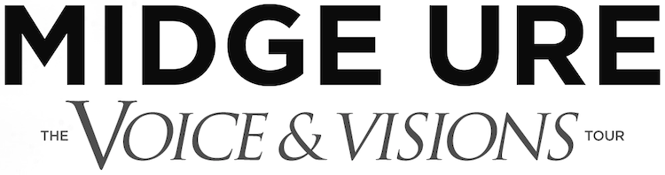

TICKETS ON SALE 10AM, FRIDAY 22ND JANUARY

Following the overwhelming response to 2019’s ‘The 1980 Tour’, Midge Ure & Band Electronica are delighted to return to the road in 2022 with the ‘Voice & Visions’ tour, celebrating 40 years since the release of Ultravox’s Rage In Eden and Quartet albums.

At the start of 1981, Ultravox were laying their claim to be one of the defining acts of the 80s following the global success of hit ‘Vienna’. Heading back into the studio the same year invigorated, they recorded their second album with Ure as frontman, Rage in Eden, which hit the Top 5 in the UK album charts. Quartet, their third album with Ure, came in quick succession in 1982 with production from legendary Beatles producer George Martin. Continuing the band’s impressive chart run, it became their third Top 10 album, featuring four Top 20 singles including the anthem ‘Hymn’.

The ‘Voice & Visions’ tour will begin at York’s historic Grand Opera House on 22nd February, visiting an astounding 26 cities across the UK before culminating at Liverpool Philharmonic Hall on 2nd April. Transporting fans back to the decade of electronics, experimentation, synthesizers and great songwriting, the albums highlights will be showcased alongside landmark hits from Ure’s incredible back catalogue.

Midge Ure said of the tour;
‘I can’t begin to tell you how great it feels to be back out touring after the uncertainty of the past two years and it is especially exciting to delve back in time and revitalise two standout albums from my career, Rage in Eden and Quartet. This is the logical and emotional follow up to the 1980 tour'

Tickets will go on sale 10am, Friday 22nd January preceded by a pre-sale at 10am, Wednesday 20th January from midgeure.gigantic.com and venue box offices.
MIDGE URE & BAND ELECTONICA 2022 DATES

22nd February - York Grand Opera House
23rd February Nottingham Rock City
24th February Hull Bonus Arena
26th February Glasgow Barrowland
28th February Aberdeen Music Hall
2nd March Blackburn King Georges Hall
3rd March Edinburgh Usher Hall
4th March Manchester Albert Hall

5th March Cambridge Corn Exchange
8th March Northampton Royal & Derngate
9th March Torquay Princess Theatre
13th March Aylesbury Waterside Theatre
14th March Ipswich Regent Theatre
16th March Leicester De Montfort Hall
17th March Bath Forum
18th March Swindon Meca
20th March Newcastle O2 City Hall
21st March Llandudno Venue Cymru
22nd March Sheffield City Hall
24th March Guildford G Live
25th March Southampton Engine Rooms
26th March Cardiff Tramshed
29th March Southend Cliffs Pavilion
31st March Poole Lighthouse
1st April Birmingham Symphony Hall
2nd April Liverpool Philharmonic Hall

For all media enquiries please contact Warren@chuffmedia.com on 07762 130510

