DRUG STORE ROMEOS

Announce socially distanced gigs this February

SHARE NEW SINGLE ‘JIM, LET’S PLAY’
out now via Fiction
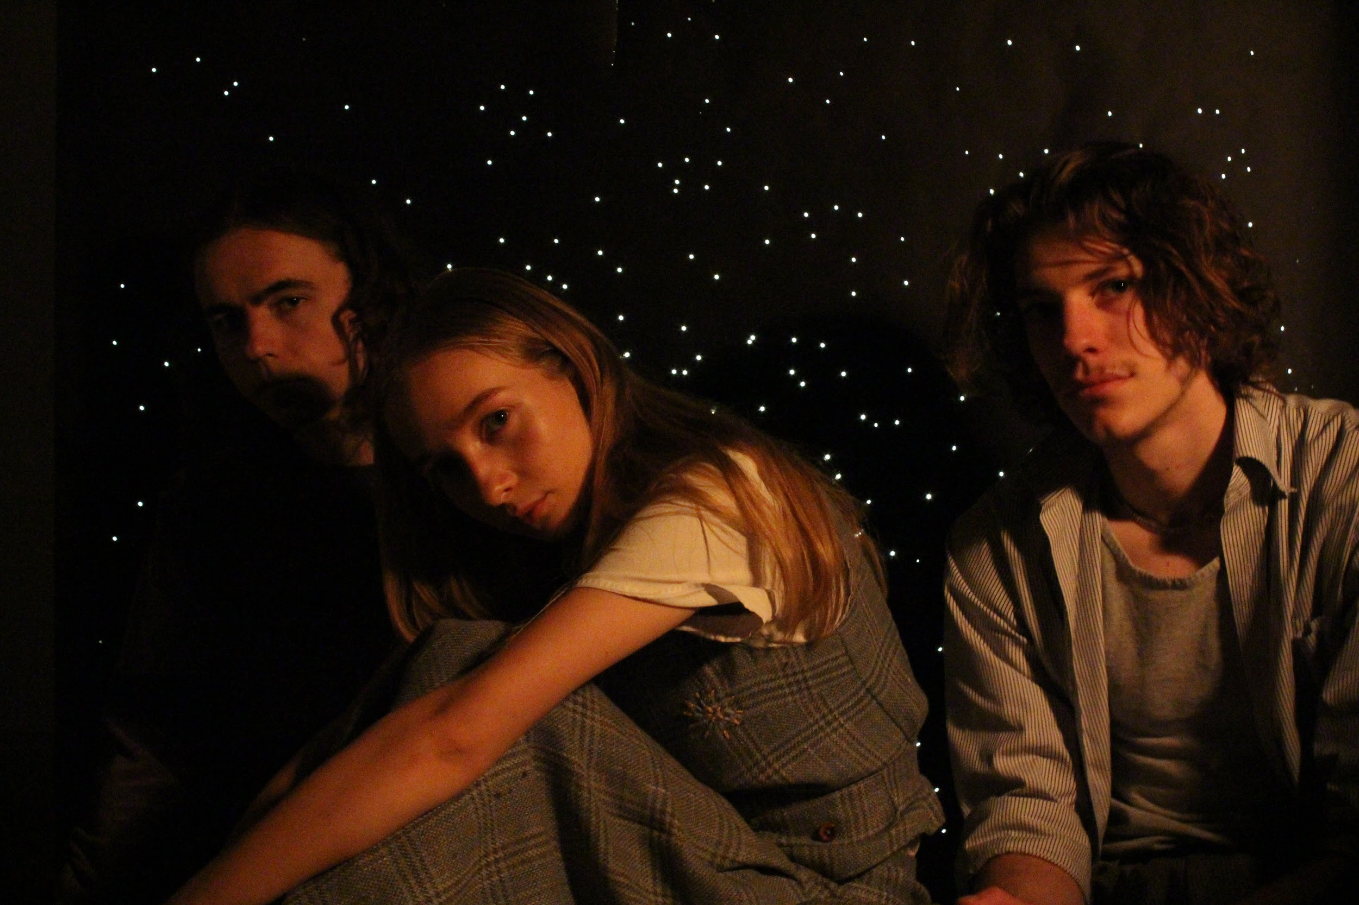

Photo credit: Erin Hambly

“intricate and intoxicating indie rock soundscapes that belie their tender years.” The FADER
“This is the sound of a band who know exactly who they are.” - The Line Of Best Fit
“Think Charlotte Gainsbourg meets Mazzy Star” - Gigwise
“endearing, gentle and engrossing” - So Young
“Lush dream pop is the order of the day” - DIY
“they're the band we need to drag us into the spring” - London In Stereo
“a spectre of fleeting sounds that draw you into a meditative state” - Dork

Listen to ‘Jim, Let’s Play’ HERE Watch video HERE

Drug Store Romeos have today revealed their latest single ‘Jim, Let’s Play’ on Fiction. The single premiered as Lauren Laverne’s ‘While You Were Sleeping’ track on BBC Radio 6 Music.

The trio from Fleet, Hampshire, who’ve already toured with the likes of The Orielles, The Big Moon and Soccer Mommy, have drawn attention from global tastemakers such as The FADER and BBC Radio 6 Music since emerging in late-2019. ‘Jim, Let’s Play’ carries on Drug Store Romeos’ thrilling run of form and further establishes them as one of the most innovative and exciting new bands of the moment. Drug Store Romeos have also announced a small run of socially distanced shows this coming February:

February 2021
14th - Castle and Falcon, Birmingham
16th - Wardrobe, Leeds
17th - Broadcast, Glasgow
18th - YES, Manchester
19th - Omeara, London

The band’s recent singles ‘Now You’re Moving’, ‘Frame Of Reference’ and ‘Quotations For Locations’. have sat perfectly on the fault lines of digital perfection and human imperfection. The band describe ‘Jim, Let’s Play’ as the turning point in their journey as Drug Store Romeos - the moment in which they eschewed reverb-heavy dreamy pop and began to embrace the minimal playground of synthesiser and dry upfront vocals we know today.

The single - produced by George Murphy and mixed by Ali Chant (Soccer Mommy, Aldous Harding, Perfume Genius) - is also an homage to cult Boston songwriter The Space Lady, whose otherworldly Casio-led pop has captured the imagination of generation upon generation of underground musicians since her emergence in the ‘70s. The band’s Sarah Downey explains: “We were improvising with the cut-up method in my bedroom when, all at once the words ‘Jim’ and ’Lets play’ jumped out of the cut out word sheet onto a melody that caught it in the air. The Space Lady fans would be pleased to hear the lady herself approves this message (we sent her the song and she gave it the go-ahead!). At the time of writing we were all in awe with her Greatest Hits album. She greatly influenced our evolving sound and we felt it right to leave a little thank you to her in one of our songs.”

***
Drug Store Romeos formed at college in nearby Farnborough when childhood friends Jonny (Gilbert) and Charlie (Henderson) pinned an ad about finding a bassist for their new band to the school’s notice board - Sarah replied and quickly proved herself a better vocalist than either of them. The trio spent the subsequent 24 hours discussing their love of Stereolab over messenger and watching Portishead and Mild High Club videos in the college’s computer lab.

The band soon cut their teeth playing live at college, at Guildford Boiler Room and Aldershot West End Centre, rather than the familiarly trodden paths in London - although they did frequent Brixton Windmill as often as three times a week at one point; carrying all of their equipment back to Fleet by train as none of the band were old enough to drive. The 3am walk home from Fleet station, with amps and flight cases slung over their shoulder, would become a rite of passage; the quiet countryside influencing their hushed atmospheric sound and nocturnal aesthetics as much as their shared affection for Suburban Lawns, Broadcast, and Tom Tom Club.

Lyrical abstractness / concrete meaning. Danceability / lyingdownability. Minimalism / fullness. Introspective melancholy / playfulness. Lo fi / hi fi. Drug Store Romeos play with the senses and flip the expectations, finding the sweet spot every time.
***
Drug Store Romeos - Jim, Let’s Play

1. Jim, Let’s Play

For all media information please contact:

Warren at Chuff Media
Tel. 07762 130 510
warren@chuffmedia.com

