SOUL II SOUL
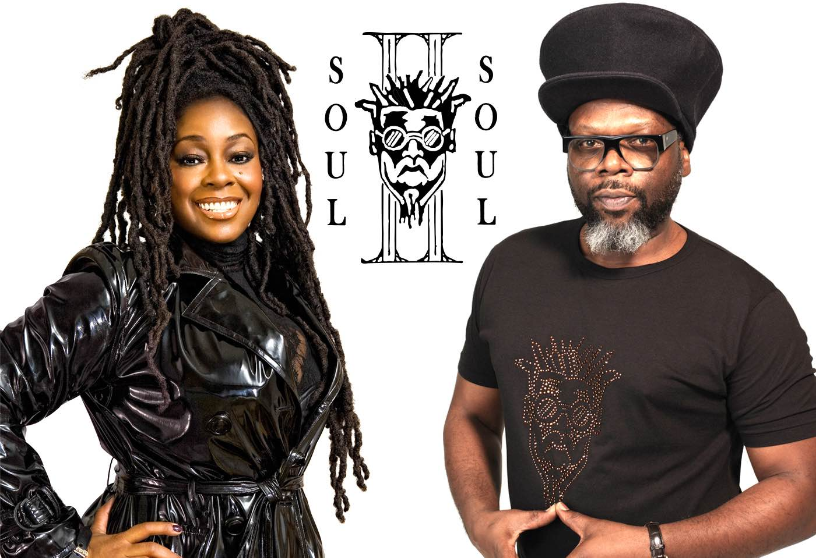

‘CLUB CLASSICS’ UK TOUR
RESCHEDULED DATES ANNOUNCED
JANUARY, FEBRUARY & MARCH 2022

ALSO PERFORMING AT
LONDON, ROYAL ALBERT HALL – APRIL 18th 2022

Soul II Soul have announced rescheduled dates due to the global Covid-19 restrictions for their forthcoming ‘Club Classics’ tour.

They will complete a 15-date UK tour in 2022 starting on January 21st at the Tramshed, Cardiff and will finish at with a career-defining show at London’s Royal Albert Hall on April 18th. Tickets for the tour are available via bit.ly/SoulClubClassics

Regarding the tour Jazzie B says, "Who would have thought that after thirty-odd years later we’d still be on the road with this thing? It’s been a helluva journey – literally! – and I feel truly blessed. Now, I’m looking forward to going back to some of the familiar venues where we’ve made a lot of friends, I’m just as pumped about testing out places we’ve never been before but I'm seriously excited about playing the Royal Albert Hall. I want to thank to the fullness everybody who’s given their support up until now, and I’ll see you along the way – a happy face, a thumpin’ bass for a lovin’ race."

The double Grammy Award winning and five-time Brit Award nominated British band tour the UK as they pay tribute to their legendary debut album Club Classics Vol. One. It follows from the phenomenal success of their tour of the album in 2018 with sold out shows across the country.

The forthcoming shows promise to be an even greater spectacle with astounding production and surprises.

During the course of their stellar career the band have sold over 10 million albums worldwide and main man Jazzie B was awarded an OBE for services to music in 2008, as well as winning an Ivor Novello Award for Inspiration, as “the man who gave British black music a soul of its own”.

With huge hits including ‘Keep On Movin’ (which sold over a million copies in the US alone) and the UK number one single ‘Back To Life (However Do You Want Me)’, Soul II Soul progressed from being one of the leaders of the 1980s warehouse scene to pioneering British black music around the world, and securing commercial success for themselves and the huge amount of artists they have influenced.

SOUL II SOUL ‘CLUB CLASSICS’ TOUR DATES
JANUARY 2022
21st – Cardiff, Tramshed
22nd – Bristol, O2 Academy
28th – Glasgow, Barrowlands
29th – Manchester, Academy

FEBRUARY 2022
11th – Newcastle, O2 City Hall
12th – Hull, Asylum
18th – Brighton, Dome
19th – Portsmouth, Guildhall
25th – York, Barbican
26th – Nottingham, Rock City

MARCH 2022
4th – Liverpool, Eventim Olympia
5th – Birmingham, O2 Institute
18th – Norwich, UEA
19th – Cambridge, Corn Exchange

APRIL 2021
18th – London, Royal Albert Hall

For all media enquiries please contact Warren@chuffmedia.com on 07762 130510

