THE BIG MOON ANNOUNCE NEW SINGLE BARCELONA - LISTEN HERE

ANNOUNCE AUTUMN UK HEADLINE TOUR

+ SHARE A BEHIND THE SCENES “MAKING OF THE ALBUM” MINI-DOCUMENTARY

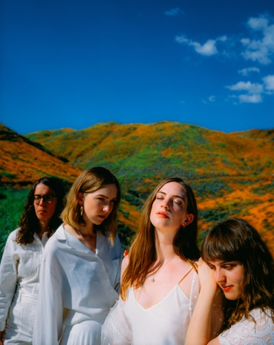

Credit – Pooneh Ghana
Image here

THE TOP 20 ALBUM ‘WALKING LIKE WE DO’ OUT NOW VIA FICTION

“oozes confidence, attitude and class…what a great album” Sunday Times Culture
“subtly devastating” **** The Guardian
“this dawning of a new moon could be a real contender for one of the year’s best” **** Q Magazine
“Expansive lyrically, thematically and sonically…they’re always right where they need to be” **** DIY Magazine
“It’s really proper great” ***** DORK
“ambitious arrangements, cinematic in scope” **** The Independent
“bold, romantic and packed with instant hits” **** The Evening Standard
“a love letter to the dirty streets of London…recalls such English eccentrics as The Kinks, Blur, Pulp and Arctic Monkeys” **** The Telegraph
**** Daily Star

The Big Moon have today announced the release of new single ‘Barcelona’, taken from their new album ‘Walking Like We Do’, out now on Fiction Records. They’re also thrilled to announce details of a headline tour of the UK for the Autumn.

Vocalist Juliette Jackson on Barcelona:

“There’s a moment in your late twenties where suddenly everything changes, and this last couple of years I’ve really hit that moment - my friends are moving on, moving away, starting to have babies and buy houses and go on to big new adventures. In a band you can kind of get a bit stuck... you go away on tour for long periods, and each time you come home you find things have changed again. You start to feel left behind. You become an overgrown teenager. You’re simultaneously happy for them but also a bit sad that they left you behind – it’s bittersweet.”

The band, currently out on a full tour of the UK and Ireland in support of Bombay Bicycle Club, and have already sold-out a short tour for the Spring, will head back out across the UK in October for eight dates, concluding with their biggest headline show to date at The Forum in London on the 30th October.

Tickets for all new shows will be on sale from next Friday (14th February), with tickets available on pre-sale from 10am on Weds 12th February to those on the band’s mailing list.

To coincide with the announcement of the new tour, The Big Moon are pleased to share a brilliantly personal and funny behind-the-scenes documentary, shot by the band during their time at Maze Studios in Atlanta recording in 2019 and edited by the band’s own Fern Ford. Watch it HERE.

The Big Moon Live:
7th February – London, Alexandra Palace (w/ Bombay Bicycle Club)
10th February – Dublin, Vicar Street (w/ Bombay Bicycle Club)
11th February - Dublin, Vicar Street (w/ Bombay Bicycle Club)
12th February – Belfast, Ulster Hall (w/ Bombay Bicycle Club)

SPRING HEADLINE TOUR:
27th February – Bristol, The Fleece – Sold Out
28th February – Liverpool, O2 Academy 2
29th February – Edinburgh, Summerhall Arts Centre – Sold Out
2nd March – Nottingham, Contemporary – Sold Out
3rd March – Oxford, O2 Academy 2 – Sold Out
4th March – London, Oslo – Annie Mac Presents… – Sold Out
9th March – Paris, Le Point Ephémère
10th March – Cologne, MTC
11th March – Berlin, Privatclub
13th March – Amsterdam, Paradiso
14th March – Antwerp, Trix Bar

23rd May – Warrington, Neighbourhood Weekender
28th June – London, Finsbury Park (w/ Kings Of Leon)
2nd July – Belgium, Rock Werchter
4th July – Halifax, The Piece Hall (w/Kaiser Chiefs)
5th July – Halifax, The Piece Hall (w/Kaiser Chiefs)
17th July – Salisbury, Larmer Tree Festival
31st July – Sheffield, Tramlines
1st August – Steventon, Truck Festival
9th August – Newquay, Boardmasters Festival
20th - 23rd August – Fairmile, Beautiful Days Festival
30th August – Lincoln, Lost Village

AUTUMN HEADLINE TOUR:
21st October – Sheffield, The Leadmill
22nd October – Glasgow, The Garage
23rd October – Newcastle, Riverside
24th October – Manchester, Academy 2
26th October – Brighton, Concorde 2
27th October – Cardiff, The Tramshed
28th October – Birmingham, The O2 Institute 2
30th October – London, The O2 Forum

For more information and press enquiries please contact:

Simon Neal
simon@chuffmedia.com
020 8281 0989

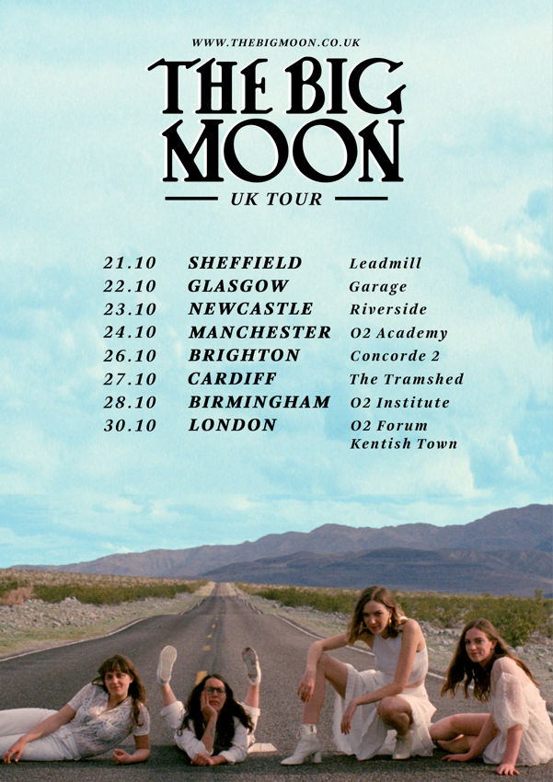

www.thebigmoon.co.uk

