MICHAEL KIWANUKA SHARES DETAILS OF HIS THIRD ALBUM, “KIWANUKA”

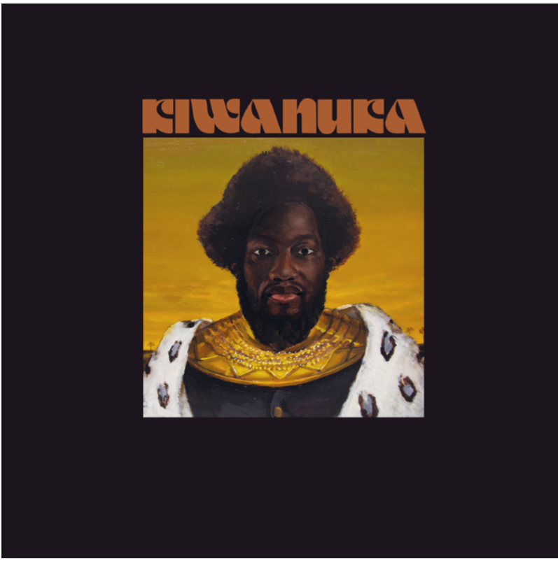

NEW ALBUM RELEASED 25TH OCTOBER 2019 THROUGH POLYDOR RECORDS. PRE-ORDER THE ALBUM NOW.

LISTEN TO THE ALBUM’S FIRST SINGLE, “YOU AIN’T THE PROBLEM”, STREAMING NOW

UK TOUR DATES RECHEDULED FOR 2021

Michael Kiwanuka is very pleased to announce details of his stunning third album, KIWANUKA.

KIWANUKA is released on 25th October 2019 through Polydor Records. It is the follow-up to Michael’s number 1 album, Love & Hate, released back in July 2016 that resonated broadly both critically and in the public’s affections, netting the British musician his second Mercury Prize nomination and his second and third BRIT nominations too.

Recorded in New York, LA and London, Michael returned to the studio with Danger Mouse and Inflo, the same production team that combined so magnificently on Love & Hate, KIWANUKA finds a new assuredness in Michael’s writing, and takes the basic sonic blueprint of that last record to a dizzying new realm.

Listen to You Ain’t The Problem HERE

Introduced here with You Ain’t The Problem, Michael’s typically assured, bold, and strident vocal brims with confidence, but what it conceals is almost two years questioning his own ability and identity. How do you follow a record that achieved everything he had ever wanted to achieve? How do you contain the pressure you put on yourself, let alone the expectations to everybody else? What are the expectations of a Michael Kiwanuka record? Does any of it matter?

He perhaps needn’t have worried too much. KIWANUKA sets off on a journey that evokes the psychedelic haze of its predecessor, but ramps up a very broad sense of scale. With his exquisite band of players, Michael channels an assortment of the late greats (a nod to Gil Scott-Heron here, Bobby Womack flecked there, and the ever present Otis Redding vocally) for a richly rewarding record that sits typically at odds with the notion and expectations of a successful British singer-songwriter in 2019, and moves even further away from the folk-imbued vintage soul of his debut album, Home Again, back in 2012.

Michael will tell you of his love for records that entwine their songs with incidental skits and shape-shifting spiralling outros, so that the listener experience is almost that of listening to one long, dramatic song. KIWANUKA fulfils that winding, dream-like haze, unhurried, and is peppered with some of the best songs of Michael’s career to date. At its very heart is a song called Hero; a scorched epic that propagates the essence of the whole record into a sub five-minute psych-fuzz song.

Where Love & Hate showcased Michael’s prowess with a guitar, KIWANUKA showcases an ear for musical adventure. Themes that resonated so loudly previously return here, namely Michael’s life-long confusion and questioning of his own identity, but also that of hope and of power. That Michael has spent the past year or two writing and nurturing the record, whilst also finding a newly discovered love for documenting his life behind a lens, lends itself to the suggestion of an artist putting a microscope on his own life.

Whilst many of his new findings are layered beneath a warm fuzz of instrumentation, KIWANUKA is Michael serving from the heart, from the mind, and from the soul.

Michael explains: "The last album came from an introspective place and felt like therapy, I guess. This one is more about feeling comfortable in who I am and asking what I want to say. Like, how could I be bold and challenge myself and the listener? It is about self-acceptance in a more triumphant rather than melancholy way. It’s an album that explores what it means to be a human being today.”

“When I first signed a record deal, people would ask me, ‘So what are you going to be called?’. And I never thought of that; calling myself Johnny Thunders or whatever, like singers from the past. So, on this album it’s kind of a defiant thing; I’m engaging with who I am and I’m not going to have an alter ego, or become Sasha Fierce or Ziggy Stardust, even though everyone's telling me I need to be this, that or the other. I can just be Michael Kiwanuka.”

The incredible album artwork was painted by Atlanta’s fast-rising young artist, Markeidric Walker.

Album Tracklisting: You Ain’t The Problem/Rolling/I’ve Been Dazed/Piano Joint (This Kind Of Love) Intro/Piano Joint (This Kind Of Love) Main/Another Human Being/Hero/Hard To Say Goodbye/Final Days/Interlude (Loving The People)/Solid Ground/Light

Pre-order KIWANUKA HERE

*NEW* UK Headline Dates, 2021:

30-Mar-21 Blackpool Empress Ballroom
3-Apr-21 Brighton Centre
16-Sep-21 Cambridge Corn Exchange
26-Mar-21 Glasgow O2 Academy
27-Mar-21 Hull Bonua Arena
5-Apr-21 Leeds O2 Academy
1-Apr-21 Leicester De Montfort Hall
6-Apr-21 London O2 Academy Brixton
17-Sep-21 London Alexandra Palace
29-Mar-21 Manchester O2 Apollo
15-Sep-21 Newcastle O2 Academy
2-Apr-21 Plymouth Pavilions

For more information and press enquiries please contact:
Warren Higgins
warren@chuffmedia.com
020 8281 0989

