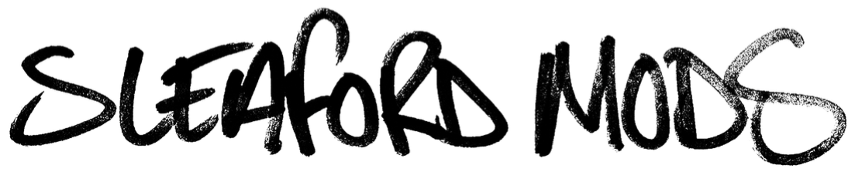
ETON ALIVE
NEW ALBUM OUT FEBRUARY
PLUS UK SHOWS JUST ANNOUNCED

Sleaford Mods are one of the most important, politically charged and thought provoking duos currently making their mark on the UK music scene and beyond. They are now poised to release their fifth studio album entitled ‘Eton Alive’ in February 2019. The album, which features 12 new tracks from the prolific artists, was recorded in Nottingham. The record will be the first release on Jason and Andrew’s newly formed label ‘Extreme Eating’ and their first album since parting ways with Rough Trade Records.

“Eton Alive speaks for itself really. Here we are once again in the middle of another elitist plan being digested slowly as we wait to be turned into faeces once more. Some already are, some are dead and the rest of us erode in the belly of prehistoric ideology which depending on our abilities and willingness, assigns to each of us varying levels of comfort that range from horrible to reasonably acceptable, based on contribution. So after the digestive system of the Nobles rejects our inedible bones we exit the Arse of Rule, we fall into the toilet again and at the mercy of whatever policies are holding order in the shit pipe of this tatty civilisation. It is here our flesh regenerates as we rattle into another form, ready, and ripe for order”. – Jason Williamson.

In support of the release Sleaford Mods have also announced a 33-date tour of the UK.
Tickets go on general sale Friday 7th December at 9am.

‘Eton Alive’ tracklisting
Into The Payzone
Kebab Spider
Policy Cream
OBCT
When You Come Up To Me
Top It Up
Flipside
Subtraction
Firewall
Big Burt
Discourse
Negative Script

ETON ALIVE UK TOUR 2019
FEBRUARY
07 – BELFAST, LIMELIGHT

MARCH
01 – NEWCASTLE, BOILER SHOP
02 – LIVERPOOL, O2 ACADEMY
06 – YORK, FIBBERS
07 – HULL, ASYLUM
08 – MIDDLEBROUGH, TOWN HALL
09 – LEEDS, STYLUS
13 – HOLMFIRTH, PICTUREDROME
14 – SHEFFIELD, PLUG
15 – MANCHESTER, ACADEMY
16 – KENDAL, BREWERY ARTS CENTRE
21 – LINCOLN, ENGINE SHED
22 – STOKE, SUGARMILL
23 – BIRMINGHAM, O2 INSTITUTE

APRIL
04 – WREXHAM, CENTRAL STATION
05 – CARDIFF, UNIVERSITY Y PLAS
06 – BRISTOL, O2 ACADEMY
11 - LEAMINGTON SPA, ASSEMBLY
12 – LEICESTER, O2 ACADEMY
13 - NORWICH, UEA WATERFRONT
17 – IPSWICH, CORN EXCHANGE
18 – NORTHAMPTON, ROADMENDER
19 – MARGATE, DREAMLAND
20 - BEXHILLDE LA WARR, PAVILION
25 – SOUTHEND, CHINNERYS
26 – READING, SUB 89
27 – OXFORD, O2 ACADEMY

MAY
02 – PORTSMOUTH, PYRAMIDS
03 – BOURNEMOUTH, OLD FIRE STATION
04 – SOUTHAMPTON, ENGINE ROOMS
09 – DERBY, THE VENUE
10 – CAMBRIDGE, JUNCTION
11 – HITCHIN, CLUB 85

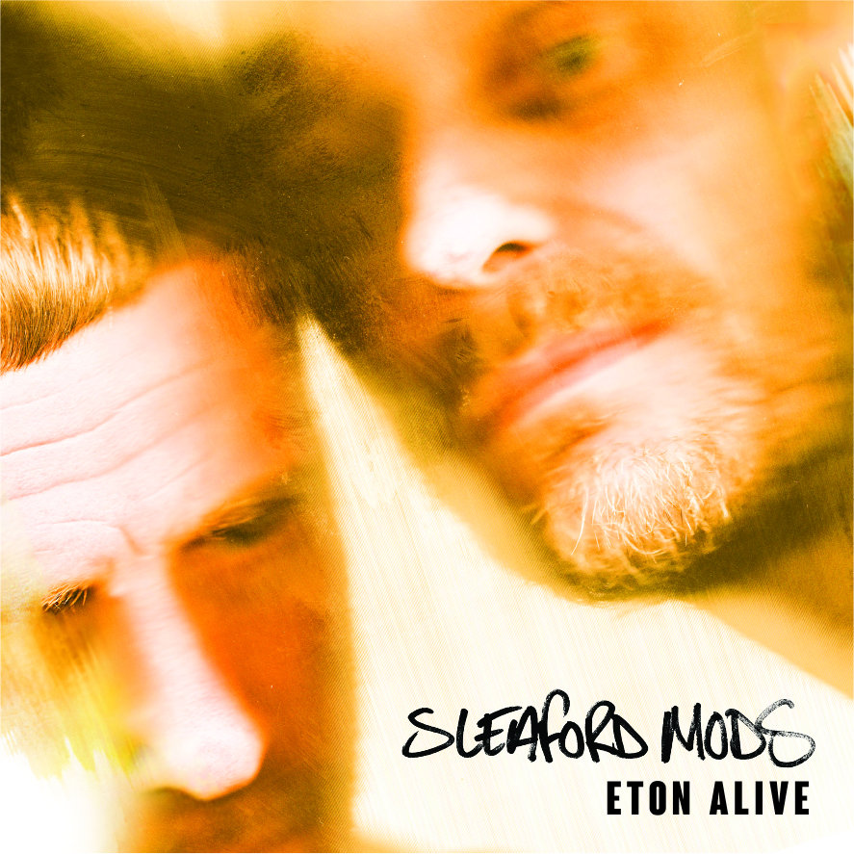

For more information and press enquiries please contact:

Warren Higgins
warren@chuffmedia.com
020 8281 0989

