Present

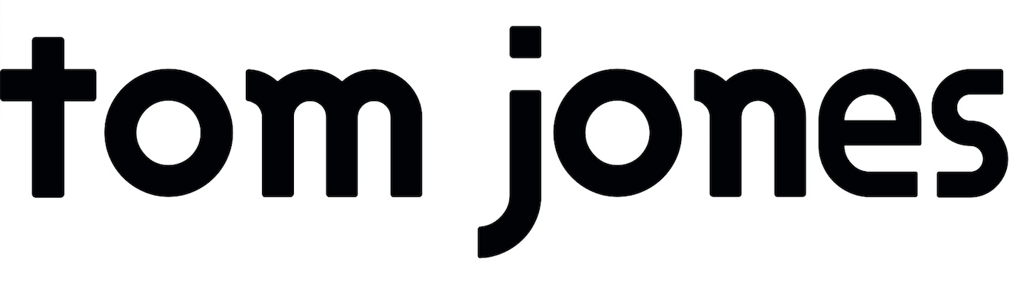
SATURDAY 19TH JUNE 2021

HAYDOCK PARK RACECOURSE

Join in the conversation online #JCLive21
The Jockey Club Live are proud to announce national legend TOM JONES will return to Haydock Park on Saturday 19th June 2021.

Tom Jones’ career has spanned over half a century, and has seen him win many accolades including a BRIT Award for Outstanding Contribution to Music and a Silver Clef Award for Lifetime Achievement. A global star, who was knighted by Her Majesty the Queen in 2006, has amassed 36 top 40 UK hits and has a continued worldwide reputation as one of the great vocalists, earning the nickname ‘The Voice’. He continues to be a judge on the hit ITV show of the same name. Returning to Haydock Park he will be performing from his huge repertoire of hits, spanning genres and generations including ‘Kiss’, ‘Delilah’ and ‘It’s Not Unusual’.

Dickon White, Jockey Club Racecourses’ North West Regional Director said:
‘It’s great to announce that Sir Tom Jones will be returning to our course after seven years away. Our music nights are always hugely popular so we advise you to purchase your tickets early to make sure you do not miss out.’

The Jockey Club Live are leading promoters on the UK live scene, delivering spectacular line-ups of some of the hottest chart talent and legendary household names to some of the world’s most famous racecourses. The Jockey Club Live concerts at Haydock Park Racecourse have been a staple in the region’s social calendar and over the past few years hosting thousands of fans of live music, with performances from artists including Kylie, Olly Murs and Nile Rodgers & CHIC.

The events are renowned for combining a fun filled evening at the races with a spectacular evening concert in the informal and relaxed open-air setting of the hallowed turf.

The Jockey Club racecourses have world-class customer facilities, featuring an array of award-winning restaurants that cater for all tastes, from fine dining through to delicious bistro food. The Jockey Club’s racecourses welcome over 2million people a year for some of the UK’s biggest racing events so you can be sure a fantastic evening.

Tickets are on sale now via thejockeyclublive.co.uk. Tickets for Tom Jones start at £43.12 for adults and £22.40 for children (inclusive of transaction fees). Children aged four and below are free of charge, children from five to seventeen years old must have a ticket to attend. All T&C’s are available on haydock.thejockeyclub.co.uk. There will be hospitality packages available to suit all budgets. Book with confidence! The Jockey Club Live offer a money back guarantee if cancelled.

In addition to Haydock Park, The Jockey Club Live will be hosting live concerts across Sandown Park, Market Rasen, Aintree, Newmarket and Carlisle racecourses next summer.

THE JOCKEY CLUB LIVE CONFIRMED 2021 EVENTS:
11th June Nile Rodgers & Chic, Aintree Racecourse
18th June The Script, Newmarket Racecourses
19th June Tom Jones, Haydock Park Racecourse
25th June Rick Astley, Newmarket Racecourses
16th July Bryan Ferry, Newmarket Racecourses
17th July Olly Murs, Haydock Park Racecourse
23rd July Tom Jones, Newmarket Racecourses
28th July Nile Rodgers & Chic, Sandown Park Racecourse
30th July Olly Murs, Newmarket Racecourses
5th August Craig David, Sandown Park Racecourse
13th August Pete Tong & The Heritage Orchestra, Newmarket Racecourses
28th August McFly, Newmarket Racecourses

Note: This show was originally scheduled for Saturday 20th June 2020. All previously purchased tickets remain valid.

For all media information, including previews, interviews, reviews etc for
The Jockey Club Live, contact Warren or Jenny at Chuff Media – tel. 020 8281 0989 name@chuffmedia.com

About The Jockey Club Live
The Jockey Club Live is an innovative event entertainment promoter specialising in combining live music and racing. Since it’s launch in 2014 the Jockey Club Live has promoted over 120 concerts with a combined attendance of over 1 million and was revealed
by Music Week as the UK’s 6th largest music promoter. The Jockey Club Live’s vision is to bring the biggest names in pop music to racing events across the country; giving consumers an exceptional experience of live music and racing.
http://www.thejockeyclublive.co.uk

About Haydock Park Racecourses
Haydock Park is a dual-purpose racecourse, staging 32 racing days on the Flat and over Jumps in 2020, and a leading conference centre in the north west of England. More information is available at haydock.thejockeyclub.co.uk

Haydock Park is part of The Jockey Club which stages thrilling sporting occasions including The Randox Health Grand National, The Cheltenham Festival and The Investec Derby.

Millions of people every year enjoy the special experiences The Jockey Club offers through racing, music, food and entertainment. Governed by Royal Charter, every penny made goes back into British Racing to help the sport thrive.

The Jockey Club was founded in 1750 and today is the largest commercial group in Britain's second-biggest spectator sport, operating 15 racecourses nationwide, The National Stud, Jockey Club Estates, Jockey Club Catering, Jockey Club Live and the charity, Racing Welfare. For more information, visit www.thejockeyclub.co.uk

