Present

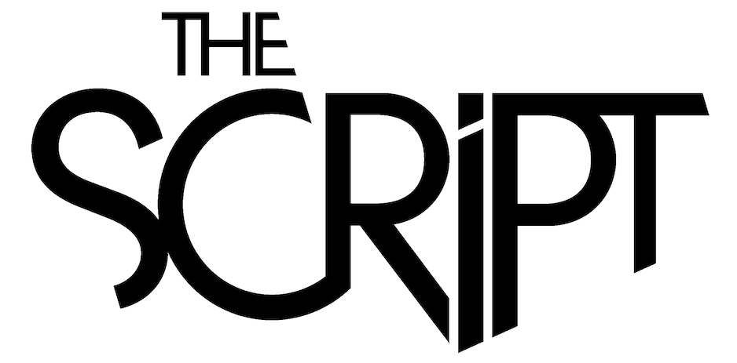

NEWMARKET NIGHTS AT NEWMARKET RACECOURSES

FRIDAY 18TH JUNE 2021
Join in the conversation online #JCLive21
The Jockey Club Live are excited to announce the first headliner of Newmarket Nights 2021; THE SCRIPT.

The alt-pop trio, fronted by Danny O’Donoghue, are one of the most successful Irish acts of recent times, achieving 6 billion streams, 30 million single sales, 10.8 million album sales, over 12 million monthly Spotify listeners and 1.8 million ticket sales globally.

Having returned in 2019 with the emotive, stadium-bound first single ‘The Last Time’, their sixth studio album ‘Sunsets & Full Moons’ continued the success of their previous LPs, with the band having clocked up an incredible four UK Number 1 albums.

The arena-filling band will open the summer season at Newmarket Racecourses on Friday 18th June 2021, with hits including ‘The Man Who Can’t Be Moved’, ‘Hall of Fame’, ‘For The First Time’ and ‘Superheroes’.

Danny O’Donoghue, The Script, said
‘Guys, we're really excited to be headlining Newmarket Racecourses on the 18th June, it’s going to awesome. We shall see you there!’

Sophie Able, General Manager of Newmarket Racecourses, said
‘We are thrilled to announce that The Script will be making their Newmarket Nights debut on Friday 18th June. The Script are renowned for their spectacular live show and we can’t wait to welcome them to the July Course.’

The Jockey Club Live are leading promoters on the UK live scene, delivering spectacular line-ups of some of the hottest chart talent and legendary household names to some of the world’s most famous racecourses. Summer Saturday Live and Newmarket Nights are a staple in the region’s social calendar and each year host tens of thousands of fans of live music. Past headliners have included Kylie, George Ezra and Little Mix.

The events are renowned for combining a fun filled evening at the races with a spectacular evening concert in the informal and relaxed open-air setting of the hallowed turf. Newmarket

Nights won the ‘Best Event for Groups’ at the prestigious 2018 Group Leisure & Travel Awards.

The Jockey Club racecourses have world-class customer facilities, featuring an array of award-winning restaurants that cater for all tastes, from fine dining through to delicious bistro food. The Jockey Club’s racecourses welcome over 2million people a year for some of the UK’s biggest racing events so you can be sure a fantastic evening.

Tickets are on sale now via thejockeyclublive.co.uk. Tickets are priced starting at £39.20 (inclusive of fees). All T&C’s are available on newmarket.thejockeyclub.co.uk. There will be hospitality packages available to suit all budgets. Book with confidence! The Jockey Club Live offer a money back guarantee if cancelled.

In addition to Newmarket, The Jockey Club Live will be hosting live concerts across Sandown Park, Market Rasen, Aintree, Haydock Park and Carlisle racecourses next summer.

THE JOCKEY CLUB LIVE CONFIRMED 2021 EVENTS:
11th June Nile Rodgers & Chic, Aintree Racecourse
18th June The Script, Newmarket Racecourses
19th June Tom Jones, Haydock Park Racecourse
25th June Rick Astley, Newmarket Racecourses
16th July Bryan Ferry, Newmarket Racecourses
17th July Olly Murs, Haydock Park Racecourse
23rd July Tom Jones, Newmarket Racecourses
28th July Nile Rodgers & Chic, Sandown Park Racecourse
30th July Olly Murs, Newmarket Racecourses
5th August Craig David, Sandown Park Racecourse
13th August Pete Tong & The Heritage Orchestra, Newmarket Racecourses
28th August McFly, Newmarket Racecourses

Note: This show was originally scheduled for Friday 19th June 2020. All previously purchased tickets remain valid.

For all media information, including previews, interviews, reviews etc for
The Jockey Club Live, contact Warren or Jenny at Chuff Media – tel. 020 8281 0989 name@chuffmedia.com

About The Jockey Club Live
The Jockey Club Live is an innovative event entertainment promoter specialising in combining live music and racing. Since it’s launch in 2014 the Jockey Club Live has promoted over 120 concerts with a combined attendance of over 1 million and was revealed by Music Week as the UK’s 6th largest music promoter. The Jockey Club Live’s vision is to bring the biggest names in pop music to racing events across the country; giving consumers an exceptional experience of live music and racing.

About Newmarket Racecourses
Newmarket’s two magical racecourses, the Rowley Mile and the July Course, together form the greatest venue in the East of England. Hosting exhilarating world class Flat racing, pulsating music nights, great value family days, award-winning restaurants and exceptional conferences, in 2016 Newmarket Racecourses proudly celebrated 350 years of extraordinary royal patronage.

Newmarket Racecourses are part of The Jockey Club which stages thrilling sporting occasions including the Randox Health Grand National, The Cheltenham Festival and The Investec Derby. Millions of people every year enjoy the special experiences on offer through racing, music, food and entertainment. Governed by Royal Charter, every penny made goes back into British Racing to help the sport thrive. The Jockey Club was founded in 1750 and today is the largest commercial group in Britain’s second-biggest spectator sport (2018 turnover: £214.6 million), operating 15 racecourses nationwide, The National Stud, Jockey Club Estates, Jockey Club Catering, Jockey Club Live and the charity, Racing Welfare. For more information visit www.thejockeyclub.co.uk.

