Presents
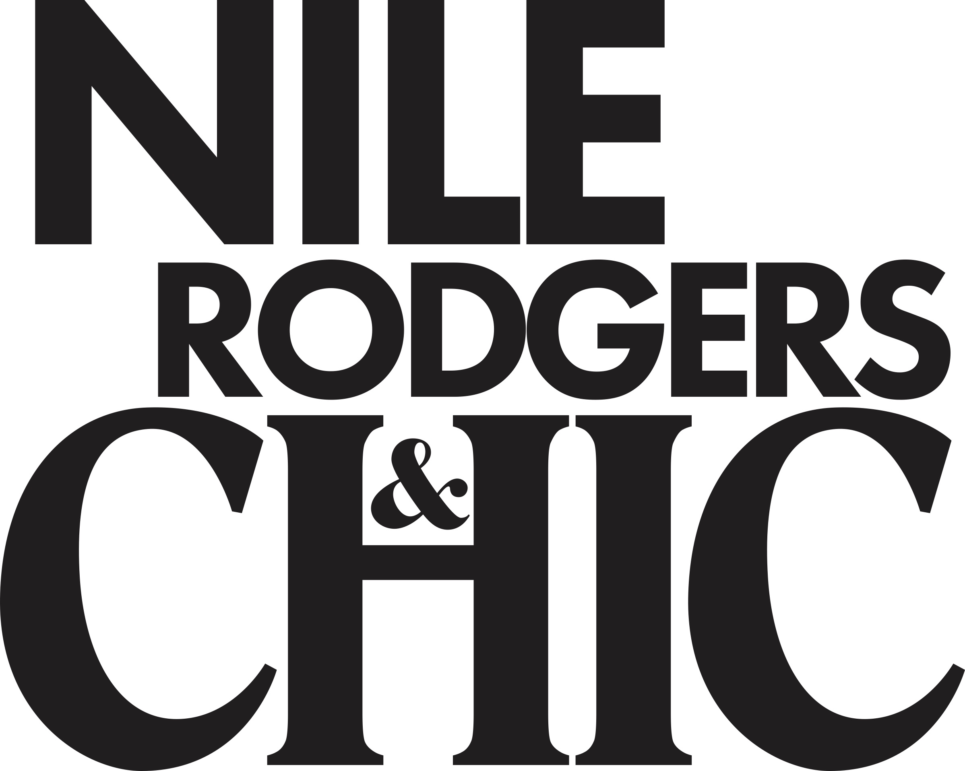

AN OPEN AIR CONCERT AT SANDOWN PARK RACECOURSE
WEDNESDAY 28TH JULY 2021
Join in the conversation online #JCLive21

The Jockey Club Live are thrilled to announce the return of the legendary NILE RODGERS & CHIC to Sandown Park Racecourse on Wednesday 28th July 2021.
Nile Rodgers’ talent and his honorable legacy is nothing short of extraordinary, having won multiple GRAMMY awards as a composer, producer, arranger and guitarist, he consistently challenges the boundaries of modern music. As co-founder of CHIC, and the Chairman of the Songwriters Hall of Fame, Rodgers pioneered a musical language that generated chart-toping hits like “Le Freak” and sparked the advent of hip-hop with “Good Times”. Collaborating with some of the most illustrious artists over the years, his revolutionary productions for the likes of David Bowie (incl. ‘Lets Dance’), Diana Ross (incl. ‘Upside Down’, ‘I’m Coming Out’) and Madonna (incl. ‘Material Girl’, ‘Like A Virgin’) have sold over 500 million albums and 75 million singles worldwide while his influential collaborations with Daft Punk, Avicii, Sigala, Disclosure and Sam Smith reflect the vanguard of contemporary music.

With a chart topping music career spanning four decades, fans can expect to hear some of the most acclaimed and much-loved pop anthems of all time. Nile Rodgers & CHIC are sure to put on a performance truly like no other.

Phil White, Regional Director, London Region, Jockey Club Racecourses said:
We’re absolutely delighted to have Nile Rodgers & CHIC return to our summer line up on Wednesday 28th July here at Sandown Park Racecourse. They never fail to impress and are a truly outstanding act. We know they’ll create an incredible atmosphere and have everyone up dancing and we can’t wait!”
The Jockey Club Live concerts at Sandown Park Racecourse are a staple in the region’s

social calendar and over the past few years have hosted thousands of fans of live music, with performances from artists including George Ezra, Olly Murs and Tom Jones. The events are renowned for combining a fun filled evening at the races with a spectacular evening concert in the informal and relaxed open-air setting of the hallowed turf.
The Jockey Club racecourses have world-class customer facilities, featuring an array of award-winning restaurants that cater for all tastes, be it Fine Dining through to delicious bistro food. The Jockey Club venues welcome over 2 million people a year for some of the UK’s biggest racing events so you can be sure that you will have a fantastic evening.
Tickets are on sale now via thejockeyclublive.co.uk. Tickets are priced starting at £52.08 for adults and £28 for under 18’s (inclusive of transaction fees). All T&C’s are available on sandown.thejockeyclub.co.uk. There will be hospitality packages available to suit all budgets. Book with confidence! The Jockey Club Live offer a money back guarantee if cancelled.

In addition to Sandown Park, The Jockey Club Live will be hosting live concerts across Market Rasen, Newmarket, Aintree, Haydock Park and Carlisle racecourses next summer.
THE JOCKEY CLUB LIVE CONFIRMED 2021 EVENTS:
11th June Nile Rodgers & Chic, Aintree Racecourse
18th June The Script, Newmarket Racecourses
19th June Tom Jones, Haydock Park Racecourse
25th June Rick Astley, Newmarket Racecourses
16th July Bryan Ferry, Newmarket Racecourses
17th July Olly Murs, Haydock Park Racecourse
23rd July Tom Jones, Newmarket Racecourses
28th July Nile Rodgers & Chic, Sandown Park Racecourse
30th July Olly Murs, Newmarket Racecourses
5th August Craig David, Sandown Park Racecourse
13th August Pete Tong & The Heritage Orchestra, Newmarket Racecourses
28th August McFly, Newmarket Racecourses
Note: This show was originally scheduled for Wednesday 29th July 2020. All previously purchased tickets remain valid.

For all media information, including previews, interviews, reviews etc for
The Jockey Club Live, contact Warren or Jenny at Chuff Media
tel. 020 8281 0989 name@chuffmedia.com

About The Jockey Club Live
The Jockey Club Live is an innovative event entertainment promoter specialising in combining live music and racing. Since it’s launch in 2014 the Jockey Club Live has promoted over 120 concerts with a combined attendance of over 1 million and was revealed by Music Week as the UK’s 6th largest music promoter. The Jockey Club Live’s vision is to bring the biggest names in pop music to racing events across the country; giving consumers an exceptional experience of live music and racing.

About Sandown Park Racecourse
Founded in 1875, Sandown Park Racecourse has provided the backdrop to some of the greatest moments in horse racing history. A day at the races at Sandown Park has it all with top-level racing throughout the year including the bet365 Jump Finale, Coral-Eclipse Summer Festival and Betfair Tingle Creek Christmas Festival meetings as well as the popular Music Nights. More information is available at www.sandown.co.uk.

Sandown Park Racecourse is part of The Jockey Club, which stages thrilling sporting occasions including the Randox Health Grand National, The Cheltenham Festival and The Investec Derby. Millions of people every year enjoy special experiences through racing, music, food and entertainment. Governed by Royal Charter, every penny The Jockey Club makes goes back into British Racing to help the sport thrive. Founded in 1750, The Jockey Club is the largest commercial group in Britain’s second biggest spectator sport operating 15 racecourses nationwide, The National Stud, Jockey Club Estates, Jockey Club Catering, Jockey Club Live and the charity, Racing Welfare. For more information visit www.thejockeyclub.co.uk.

