Present

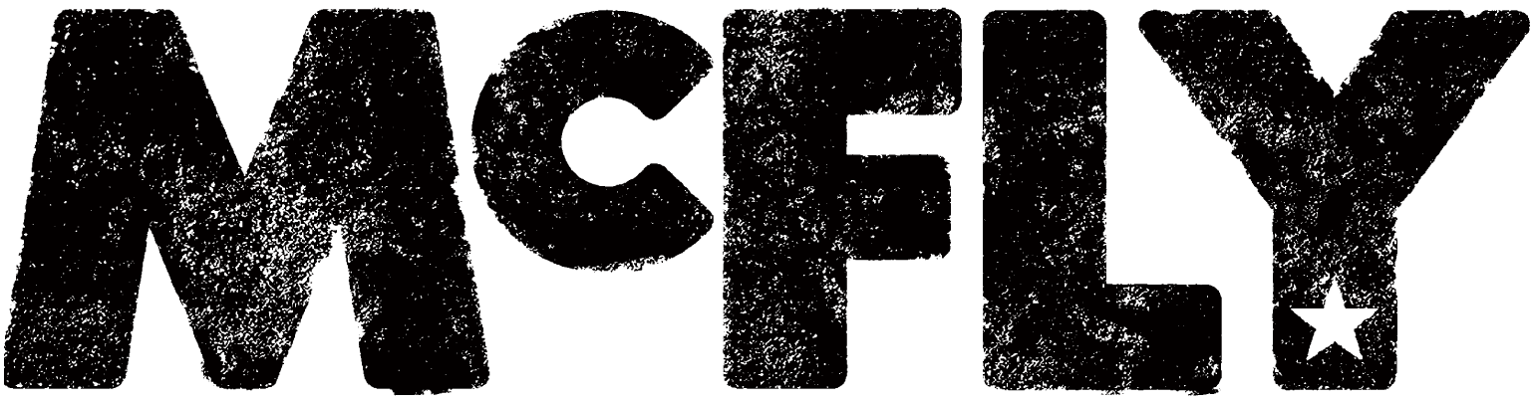
SATURDAY 28TH AUGUST 2021

HEADLINING FAMILY-FRIENDLY SUMMER SATURDAY LIVE AT NEWMARKET RACECOURSES

Join in the conversation online #JCLive21
The Jockey Club Live are thriled to reveal that McFLYwill headline the season’s family-friendly Summer Saturday Live on Saturday 28th August.

With seven UK number-one singles, five top-ten albums, six sell-out tours and ten million records sold worldwide, McFLY are without question one of the most significant British pop acts of the twenty-first century. Since hitting the big time as the youngest band ever to have a debut album go straight to number one — beating The Beatles’ long-standing record — Tom, Danny, Dougie and Harry have become one of our best-loved bands, not to mention major stars in their own right. Tom has become a wildly bestselling children’s author; Danny a TV mainstay with his regular appearances as a judge on The Voice Kids; Dougie has combined his burgeoning acting career with a passionate role as an environmental campaigner; and Strictly winner Harry has wowed West End audiences, starring in the hit dance show Rip it Up.

Having taken a break after touring as the pop phenomenon that was McBusted — the band return with a spectaular live show playing their best-loved mega-hits such as All About You, Obviously, Star Girl, One for the Radio and Shine a Light.

Sophie Able, General Manager of Newmarket Racecourses, said
'After delighting the Newmarket audience as one half of supergroup McBusted in 2015, we are excited to welcome McFly back to headline the July Course in their own right. Taking place on the August bank holiday, Summer Saturday Live is a wonderful event for the whole family - with McFly headlining we are sure this will be an unforgettable and fitting end to the summer!’

The Jockey Club Live are leading promoters on the UK live scene, delivering spectacular line-ups of some of the hottest chart talent and legendary household names to some of the world’s most famous racecourses. Summer Saturday Live and Newmarket Nights are a staple in the region’s social calendar and each year host tens of thousands of fans of live music. Past headliners have included Kylie, George Ezra and Little Mix.

The events are renowned for combining a fun filled afternoon at the races with a spectacular evening concert in the informal and relaxed open-air setting of the hallowed turf. Newmarket Nights won the ‘Best Event for Groups’ at the prestigious 2018 Group Leisure & Travel Awards.

The Jockey Club racecourses have world-class customer facilities, featuring an array of award-winning restaurants that cater for all tastes, from fine dining through to delicious bistro food. The Jockey Club’s racecourses welcome over 2 million people a year for some of the UK’s biggest racing events so you can be sure a fantastic evening.

Tickets are on sale now via thejockeyclublive.co.uk. Tickets are priced starting at £42.56 for adults and £21.28 for children (inclusive of fees). Please note child tickets are limited and for ages under 16. All T&C’s are available on newmarket.thejockeyclub.co.uk. There will be hospitality packages available to suit all budgets. Book with confidence! The Jockey Club Live offer a money back guarantee if cancelled.

In addition to Newmarket, The Jockey Club Live will be hosting live concerts across Sandown Park, Market Rasen, Aintree, Haydock Park and Carlisle racecourses next summer.

THE JOCKEY CLUB LIVE CONFIRMED 2021 EVENTS:

11th June Nile Rodgers & Chic, Aintree Racecourse
18th June The Script, Newmarket Racecourses
19th June Tom Jones, Haydock Park Racecourse
25th June Rick Astley, Newmarket Racecourses
16th July Bryan Ferry, Newmarket Racecourses
17th July Olly Murs, Haydock Park Racecourse
23rd July Tom Jones, Newmarket Racecourses
28th July Nile Rodgers & Chic, Sandown Park Racecourse
30th July Olly Murs, Newmarket Racecourses
5th August Craig David, Sandown Park Racecourse
13th August Pete Tong & The Heritage Orchestra, Newmarket Racecourses
28th August McFly, Newmarket Racecourses

Note: This show was originally scheduled for Saturday 29th August 2021. All previously purchased tickets remain valid.

For all media information, including previews, interviews, reviews etc for
The Jockey Club Live, contact Warren or Jenny at Chuff Media – tel. 020 8281 0989 name@chuffmedia.com

About The Jockey Club Live
The Jockey Club Live is an innovative event entertainment promoter specialising in combining live music and racing. Since it’s launch in 2014 the Jockey Club Live has promoted over 120 concerts with a combined attendance of over 1 million and was revealed by Music Week as the UK’s 6th largest music promoter. The Jockey Club Live’s vision is to bring the biggest names in pop music to racing events across the country; giving consumers an exceptional experience of live music and racing.

About Newmarket Racecourses

Newmarket’s two magical racecourses, the Rowley Mile and the July Course, together form the greatest venue in the East of England. Hosting exhilarating world class Flat racing, pulsating music nights, great value family days, award-winning restaurants and exceptional conferences, in 2016 Newmarket Racecourses proudly celebrated 350 years of extraordinary royal patronage.

Newmarket Racecourses are part of The Jockey Club which stages thrilling sporting occasions including the Randox Health Grand National, The Cheltenham Festival and The Investec Derby. Millions of people every year enjoy the special experiences on offer through racing, music, food and entertainment. Governed by Royal Charter, every penny made goes back into British Racing to help the sport thrive. The Jockey Club was founded in 1750 and today is the largest commercial group in Britain’s second-biggest spectator sport (2018 turnover: £214.6 million), operating 15 racecourses nationwide, The National Stud, Jockey Club Estates, Jockey Club Catering, Jockey Club Live and the charity, Racing Welfare. For more information visit www.thejockeyclub.co.uk.

