Present
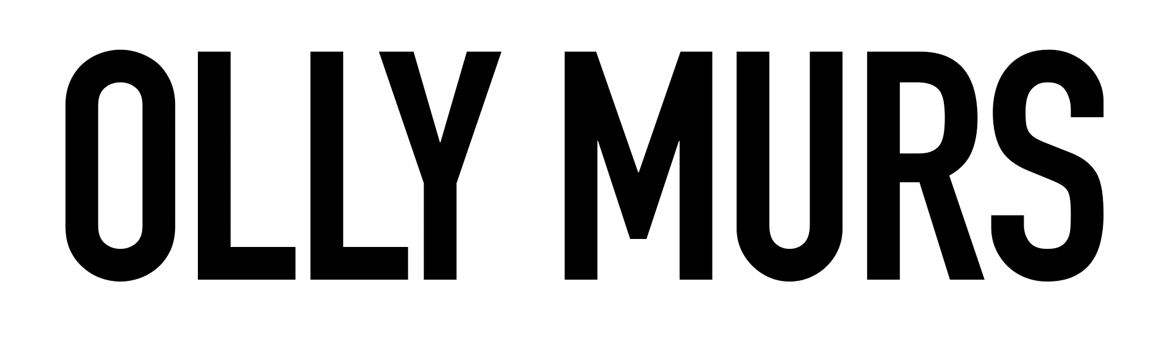

FRIDAY 30TH JULY 2021

NEWMARKET RACECOURSES

Join in the conversation online #JCLive21

Part of 2021 Summer UK Tour
25 date tour starts June 5th in Swansea
Olly Murs today announces a huge 25 date UK tour for next summer. With much of 2020 coming to a standstill due to the Covid-19 pandemic, next year’s shows aim to put a smile back on the face of the country where he will perform his biggest hits, including tracks from his recently certified triple platinum album ‘Never Been Better’.

It’s still been a busy year for Olly, who recently captained England in this year's Soccer Aid, and is looking to retain his crown as winning judge on his third series of The Voice, which has currently been postponed at the semi final stages. In lockdown, he also managed an impressive body transformation, working closely with personal trainer Rob Solly, and sharing his fitness routine exclusively with Men’s Health. He is also working on new music to be shared next year.

Olly kicks off his tour on June 5th 2021 in Swansea, and includes two dates for The Jockey Club Live at Newmarket Racecourses and Haydock Park.

Tickets will be on sale at 9am on Friday 9th October via thejockeyclublive.co.uk, with a presale available to customers at 9am on Thursday 8th October. Tickets for Olly Murs start at £42.56 for adults (inclusive of 12% booking fee). Book with confidence! The Jockey Club Live offer a money back guarantee if cancelled.

All T&C’s are available on newmarket.thejockeyclub.co.uk. There will be hospitality packages available to suit all budgets.

Tickets are available from 9th October at www.thejockeyclublive.co.uk

THE JOCKEY CLUB LIVE CONFIRMED 2021 EVENTS:

11th June Nile Rodgers & Chic, Aintree Racecourse
18th June The Script, Newmarket Racecourses
19th June Tom Jones, Haydock Park Racecourse
25th June Rick Astley, Newmarket Racecourses
16th July Bryan Ferry, Newmarket Racecourses
17th July Olly Murs, Haydock Park Racecourse
23rd July Tom Jones, Newmarket Racecourses
28th July Nile Rodgers & Chic, Sandown Park Racecourse
30th July Olly Murs, Newmarket Racecourses
5th August Craig David, Sandown Park Racecourse
28th August McFly, Newmarket Racecourses

The Jockey Club Live events are renowned for combining a fun-filled evening at the races with a spectacular evening concert in the informal and relaxed open-air setting of the hallowed turf.

The Jockey Club racecourses’ have world-class customer facilities, featuring an array of award-winning restaurants that cater for all tastes, from fine dining through to delicious bistro food. The Jockey Club’s racecourses welcome more than 2 million people a year for some of the UK’s biggest racing events so you can be sure of a fantastic evening.

In addition to Newmarket, The Jockey Club Live will be hosting live concerts across Sandown Park, Market Rasen, Aintree, Haydock Park and Carlisle racecourses next summer.

For all media information, including previews, interviews, reviews etc for
The Jockey Club Live, contact Warren at Chuff Media – tel. 07762 130510 warren@chuffmedia.com

About The Jockey Club Live
The Jockey Club Live is an innovative event entertainment promoter specialising in combining live music and racing. Since its launch in 2014 the Jockey Club Live has promoted more than 120 concerts with a combined attendance of moe than 1 million and was revealed
by Music Week as the UK’s 6th largest music promoter. The Jockey Club Live’s vision is to bring the biggest names in pop music to racing events across the country; giving consumers an exceptional experience of live music and racing.
http://www.thejockeyclublive.co.uk

About Newmarket Racecourses
Newmarket’s two magical racecourses, the Rowley Mile and the July Course, together form the greatest venue in the East of England. Hosting exhilarating world class Flat racing, pulsating music nights, great value family days, award-winning restaurants and exceptional conferences, in 2016 Newmarket Racecourses proudly celebrated 350 years of extraordinary royal patronage.

Newmarket Racecourses are part of The Jockey Club which stages thrilling sporting occasions including the Randox Health Grand National, The Cheltenham Festival and The Derby at Epsom Downs. Millions of people every year enjoy the special experiences on offer through racing, music, food and entertainment. Governed by Royal Charter, every penny made goes back into British Racing to help the sport thrive. The Jockey Club was founded in 1750 and today is the largest commercial group in Britain’s second-biggest spectator sport (2018 turnover: £214.6 million), operating 15 racecourses nationwide, The National Stud, Jockey Club Estates, Jockey Club Catering, Jockey Club Live and the charity, Racing Welfare. For more information visit www.thejockeyclub.co.uk.

