CELESTE
ANNOUNCES NEW SINGLE ‘STOP THIS FLAME’

Wins BBC Sound of 2020 poll in addition to BRITs Rising Star Award
Stream ‘Stop This Flame’ here
Download hi res press shot here

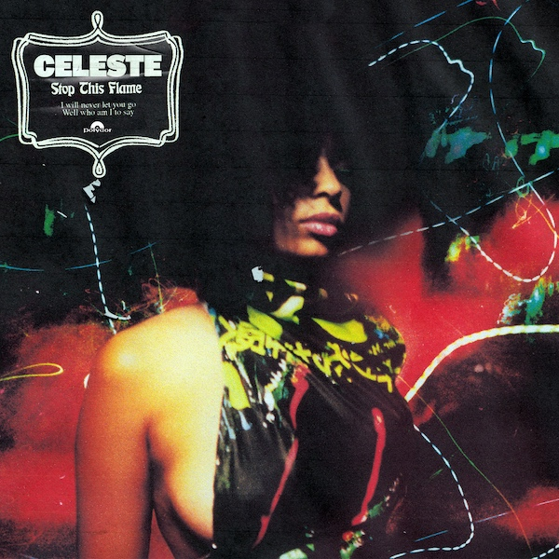

“A once-in-a-generation talent ... the finest British soul singer to emerge in years” – NME
“Smoky, jazz-tinged soul reimagined for the modern age” – Q
“She is so obviously the real soul-baring deal” – Sunday Times Culture
“Celeste has a voice that will break your heart” – Notion
“Incredible, stunning, everything” – Jorja Smith
“Strange is a special song. It’s not often you hear an artist like that” – Sam Fender

Still basking in the glow of her recent announcement as the winner of the 2020 BRITs Rising Star award, and having today been hailed the winner of the prestigious BBC Sound of 2020 poll, ascendant soul singer Celeste releases her incendiary new single ‘Stop This Flame’. The rousing track – out now on Polydor Records – is the British-Jamaican artist’s first taste of new music in what is set to be a very busy year, with the BRITs win landing her a prestigious performance at the upcoming ceremony on February 18th, as part of the live television broadcast. Following the BRIT Awards Celeste will head back out on tour with UK singer-songwriter Michael Kiwanuka in March ahead of her biggest UK and European headline shows to date the following month, including a night at London’s O2 Shepherds Bush Empire on Wednesday April 29th.

"In essence, Stop This Flame is a song about seeing it through to the end,” Celeste reveals. “Whether it’s about not letting go of love, not letting go of a dream or stridently coming through some form of adversity. The song has always evoked those feelings within me.”

Brighton-raised Celeste credits her maternal grandfather for introducing her to the legendary artists who would go on to influence her sound, a modern take on the timeless, heartache-tinged soul of smoky jazz bars and velvet-voiced storytellers. Her granddad would play cassette tapes of Aretha Franklin and Ella Fitzgerald on repeat in his old Jaguar, leaving a young Celeste transfixed and hungry to hear more, discovering a deep connection to the raw emotion of these classic songs. “In my songwriting I'm far more inspired by heartbreak,” she says now. “There's a darkness even though some songs are underlined with optimism. Those moments were far more thought-provoking for me.”

With teenage years spent in bedroom jam sessions practising covers of everything from Sly And The Family Stone, The Clash and The Specials to Alice Coltrane, Janice Joplin, Thelonious Monk and Ray Charles, eventually the entirely self-taught artist found her own voice, writing her first original compositions. Honing her sound over the following years the young artist has garnered critical acclaim for releases including her breakout Lately EP and singles including ‘Father’s Son’, a deftly heartbreaking rumination on her complicated relationship with her late father, ‘Coco Blood’, accompanied by a colour-drenched video by in-demand director Crackstevens aka Akinola Davies Jr (Blood Orange, Neneh Cherry), and ‘Strange’, which launched with a breathtaking COLORS session and saw heavy support from BBC Radio 1.

Live, Celeste has stopped audiences in their tracks with debut appearances at festivals from Glastonbury to Primavera, support slots with the likes of Michael Kiwanuka, Janelle Monae and Neneh Cherry, not to mention 3 sold out shows at London’s Omeara in November. The latter garnered a five star review from NME who hailed the emerging artist “a once-in-a-generation talent ... the finest British soul singer to emerge in years,” continuing, “If there’s any justice, super-stardom is just around the corner.” With accolades coming in left, right and centre, it seems they might be right.

Celeste 2020 UK/EU live dates:

January
16 – Eurosonic Festival

March
2 – O2 Southampton Guildhall, Southampton^
3 – O2 Academy, Bournemouth^
5 – O2 Academy Brixton, London^
6 – O2 Academy, Birmingham^
7 – O2 Apollo, Manchester ^
9 – Corn Exchange, Cambridge^
10 – De Montford Hall, Leicester^
12 – O2 Academy, Leeds^
13 – O2 Academy, Newcastle^
14 – Barrowlands, Glasgow^

April
21 – Belleville, Paris*
22 – Printemps De Bourges, Bourges*
24 – Paradiso Noord, Amsterdam*
25 – BIRD, Rotterdam*
27 – King Tuts, Glasgow (SOLD OUT)*
28 – Deaf Institute, Manchester (SOLD OUT)*
29 – O2 Shepherds Bush Empire (SOLD OUT)*

May
1 – Les Nuits Botanique, Belgium*
5 – Standtgarten, Cologne*
6 – Kranhalle, Munich*
8 – Pitchfork Festival, Berlin

^supporting Michael Kiwanuka
*headline shows

Connect with Celeste:
https://www.instagram.com/celeste
https://www.facebook.com/celestewaite

For more information and press enquiries please contact:

Simon Neal
simon@chuffmedia.com
020 8281 0989

