THE BIG MOON ANNOUNCE NEW SINGLE ‘WHY’

TAKEN FROM THE TOP 20 ALBUM ‘WALKING LIKE WE DO’, OUT NOW VIA FICTION – STREAM / BUY HERE

RELEASE PART ONE OF ‘TRACK X TRACK’ PODCAST

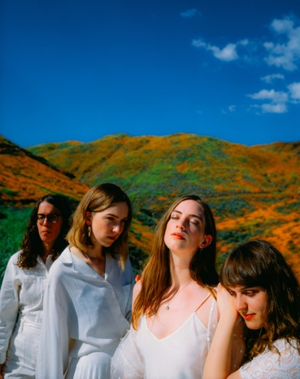

Credit – Pooneh Ghana
Image here

“oozes confidence, attitude and class…what a great album” Sunday Times Culture
“subtly devastating” **** The Guardian
“this dawning of a new moon could be a real contender for one of the year’s best” **** Q Magazine
“Expansive lyrically, thematically and sonically…they’re always right where they need to be” **** DIY Magazine
“It’s really proper great” ***** DORK
“ambitious arrangements, cinematic in scope” **** The Independent
“bold, romantic and packed with instant hits” **** The Evening Standard
“a love letter to the dirty streets of London…recalls such English eccentrics as The Kinks, Blur, Pulp and Arctic Monkeys” **** The Telegraph

The Big Moon have announced their new single ‘Why’ taken from their critically acclaimed Top 20 album ‘Walking Like We Do’. Stream or buy the album here. The band have also released the first part of their new podcast, discussing the origins and creation of each album track. Listen to Track x Track 1– It’s Easy Then here.

In response to the worldwide Covid-19 emergency, the band have also contributed to ‘Songs For The National Health Service’, a one-off compilation album of exclusive, unreleased tracks by some of the biggest names in indie, with all proceeds funding specialist PPE for hospitals and NHS key workers via Hoods For Heroes. More info here

Following their full UK support tour with Bombay Bicycle Club through January and February this year, and their own run of headline dates through late February and March, the band will be hitting the road for their biggest headline tour to date this October. The run of dates kicks off in Sheffield on 21st October, and takes in Glasgow, Newcastle, Manchester, Brighton, Cardiff and Birmingham, finishing up at London’s The O2 Forum on 30th October. Tickets are on sale now via www.thebigmoon.co.uk

SUMMER DATES:
4th July – Halifax, The Piece Hall (w/Kaiser Chiefs)
5th July – Halifax, The Piece Hall (w/Kaiser Chiefs)
30th Aug – Lincoln, Lost Village
5th Sept – Warrington, Neighbourhood Weekender

AUTUMN HEADLINE TOUR:
21st October – Sheffield, The Leadmill
22nd October – Glasgow, The Garage
23rd October – Newcastle, Riverside
24th October – Manchester, Academy 2
26th October – Brighton, Concorde 2
27th October – Cardiff, The Tramshed
28th October – Birmingham, The O2 Institute 2
30th October – London, The O2 Forum

www.thebigmoon.co.uk

For all press enquiries please contact:
Warren Higgins
warren@chuffmedia.com
020 8281 0989

