cid:image001.png@01D55CED.874DB900

RELEASE NEW SINGLE ICE CREAM SUNDAE

ANNOUNCE UK & IRELAND DATES IN DECEMBER

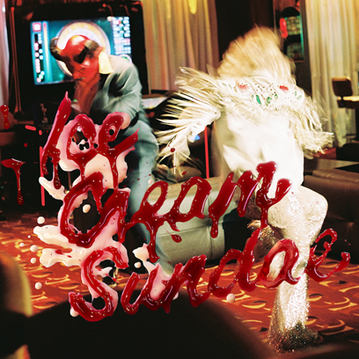

Inhaler have announced details of a brand new single. Ice Cream Sundae is the Dublin quartet’s first release via Polydor and is out on Thursday 5th September. A shimmering indie-rock anthem, a sense of melancholia lurks beneath its gleaming exterior. “It’s about loss and gain,” says singer Elijah Hewson. “I like writing about normal teenage experiences that everybody can relate to. I’m just trying to write about the joy of being alive, being a teenager, and the bad things that can come with that.”

Produced by Antony Genn, Ice Cream Sundae is the band’s third single, following on from the atmospheric pop of My Honest Face and the expansive epic It Won’t Always Be Like This. Hewson (vocals, guitar), Josh Jenkinson (guitar), Robert Keating (bass) and Ryan McMahon (drums) formed in school in Dublin and quickly set about writing tracks that pulled their influences – ranging from The Stone Roses, Joy Division, Depeche Mode, Interpol, The Cure and more – together and twisted them into a sound of their own.

Theirs songs have connected with a rapidly expanding diehard fanbase. Only a handful of tickets remain to shows on their upcoming tour around the UK and Europe and My Honest Face has been streamed over one million times on both Apple Music and Spotify. Their progress has been rapid; it’s just over a year ago that the band turned up to play at Ireland’s Electric Picnic festival in Hewson’s car with no crew and found a rammed tent waiting for them to perform. “That was the moment where we were like, ‘We can do this’,” says Jenkinson. Ice Cream Sundae signals the arrival of a huge talent. “I want to ride this thing until the wheels come off,” says Hewson. Inhaler are on the verge of blowing up big.

Inhaler have announced new UK dates in December in addition to their. Tickets are on sale now.

**28th Sep** Belfast  Voodoo

**30th Oct** Glasgow King Tut's Wah Wah Hut

**1st Oct** Leeds Brudenell Social Club

**2nd Oct** Nottingham Rough Trade

**4th Oct** Leicester The Cookie

**6th Oct** Southampton Heartbreakers

**7th Oct** Brighton Komedia

**8th Oct** Norwich The Waterfront

**9th Oct** London Camden Assembly

**11th Oct** Birmingham Castle & Falcon

**12th Oct** Glasgow Tenement Trail

**13th Oct** Bristol The Exchange

**25th Oct** Liverpool Arts Club

**26th Oct** Sheffield Plug

**27th Oct** Newcastle The Cluny

**9th Dec**  Manchester Gorilla

**10th Dec**   London Garage

**18th Dec**  Dublin Button Factory

**19th Dec**   Dublin Button Factory

**Connect with Inhaler:**

[TWITTER](https://eur02.safelinks.protection.outlook.com/?url=https%3A%2F%2Ftwitter.com%2Finhalerdublin&data=02%7C01%7Csusie.ember%40umusic.com%7Cddb7e130da1c4c74e1af08d72f98b000%7Cbbcb6b2f8c7c4e2486e46c36fed00b78%7C1%7C0%7C637030205160517744&sdata=gNsQP9uCC8SXKsjoKCl9I3tf6v04GzHh786NhiJNNU4%3D&reserved=0)

[INSTAGRAM](https://eur02.safelinks.protection.outlook.com/?url=https%3A%2F%2Fwww.instagram.com%2FInhalerdublin%2F&data=02%7C01%7Csusie.ember%40umusic.com%7Cddb7e130da1c4c74e1af08d72f98b000%7Cbbcb6b2f8c7c4e2486e46c36fed00b78%7C1%7C0%7C637030205160517744&sdata=aMk%2B%2FFrCcbAiE32leIDbX5QqT6sGzIEh063dX1IXCRk%3D&reserved=0)

[FACEBOOK](https://eur02.safelinks.protection.outlook.com/?url=https%3A%2F%2Fwww.facebook.com%2FInhalerDublin%2F&data=02%7C01%7Csusie.ember%40umusic.com%7Cddb7e130da1c4c74e1af08d72f98b000%7Cbbcb6b2f8c7c4e2486e46c36fed00b78%7C1%7C0%7C637030205160527739&sdata=vIKNPA3p7cFZcVVTVf2KHEM%2BqqLugROxGog7AwRHbro%3D&reserved=0)

For more information please contact [simon@chuffmedia.com](mailto:simon@chuffmedia.com)/ 020 8281 0989