APRE announce new single
'Go Somewhere'

LISTEN HERE / WATCH HERE
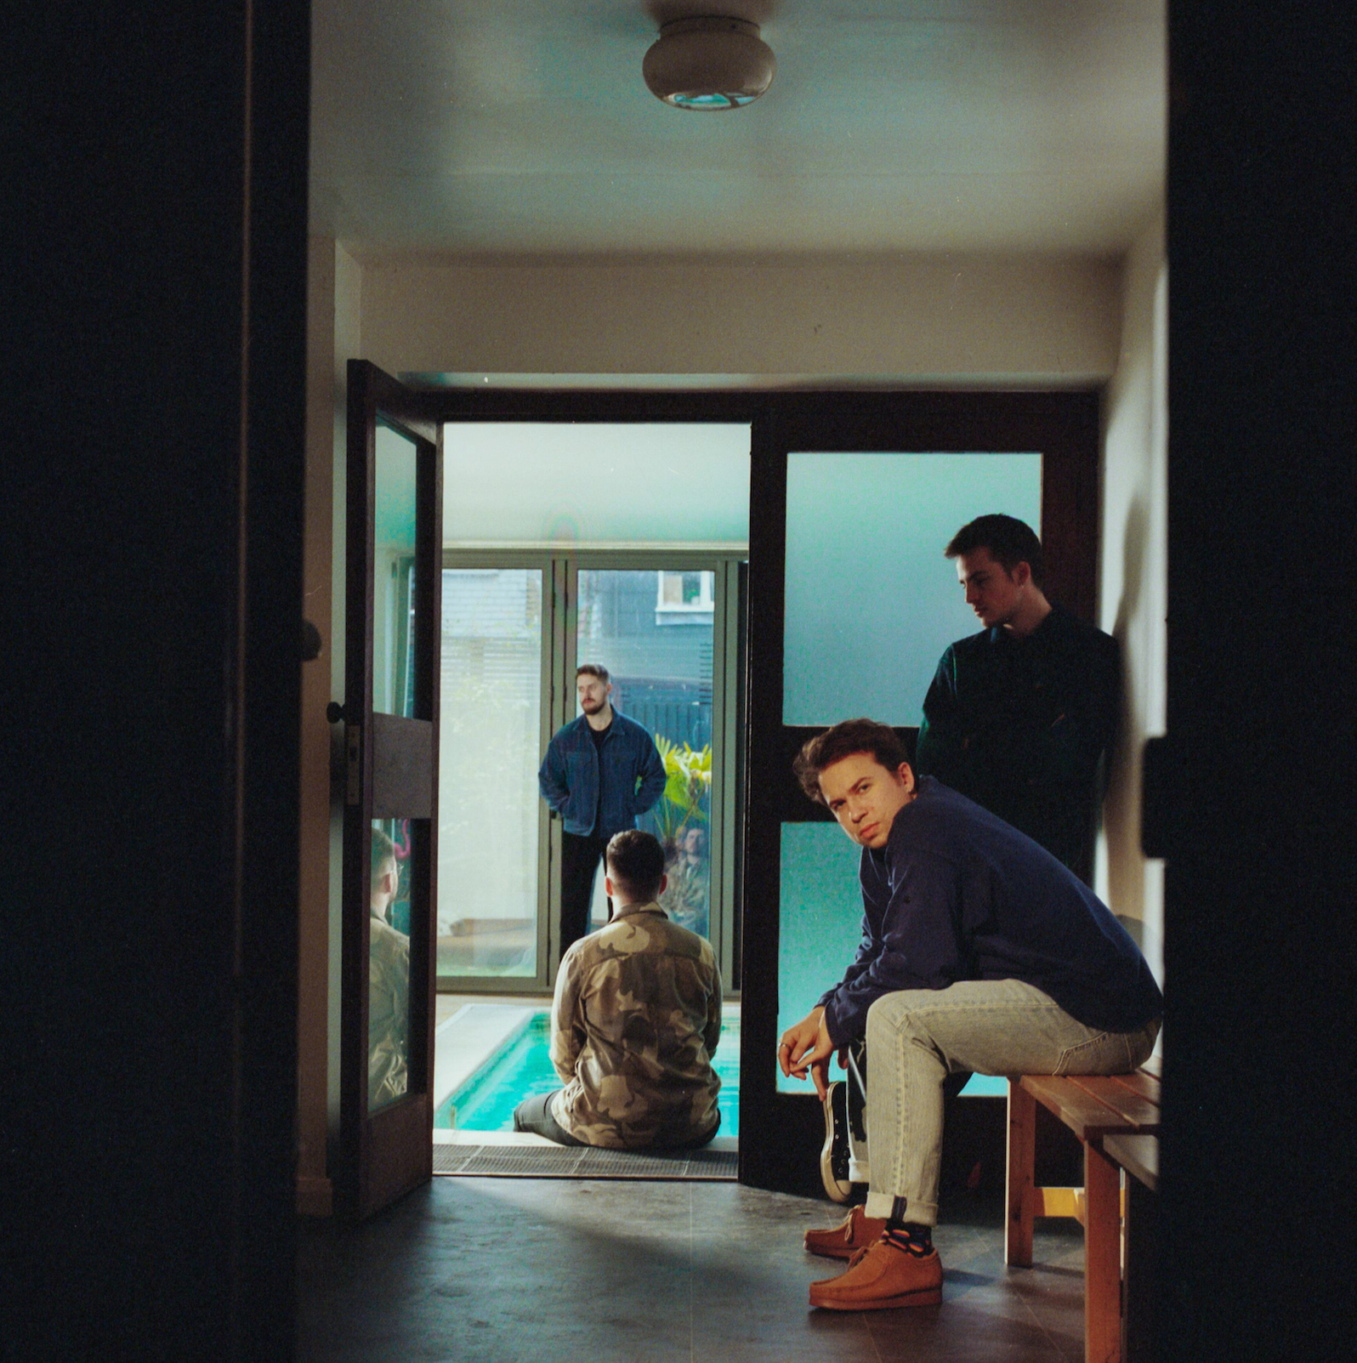

“One of the UK’s freshest new bands…with an emphasis on emotional and political turmoil, APRE’s sound engages with the wider issues surrounding us all” Wonderland
“Unapologetically huge...melds Tears for Fears and Foals to stirring effect" Sunday Times
“One of the most exciting bands in the alt-pop sphere”
Dork
“A humbling anthem…passionate yet refreshing indie-pop gold”
The Line of Best Fit
"Rich, perfectly produced…shrewd observational narratives." CLASH

APRE have today released brand new single 'Go Somewhere', which is available now on Polydor Records. Following a series of acclaimed introductory EPs, the band recently played a sold-out date at London's Scala as part of their nationwide UK tour. Having also cut their teeth live alongside the likes of Sam Fender, Friendly Fires, Inhaler and Lany, 'Go Somewhere'
will join acclaimed recent single 'Your Heart's Like A Jungle' on APRE's next longer-form project (more music and revised touring info to follow soon).

'Go Somewhere' is hugely-accomplished cut of escapist, alternative-pop from APRE (arriving arguably just when we need escapism the most). Lyrically, 'Go Somewhere' - the boys say - "is sung from the point of view of a single night: it describes the realisation that you can take your brain to another universe, and the urge to bring the people you love with you on that journey." Ultimately though, 'Go Somewhere' is the realisation that the fantasy of getting lost - whether in money, hedonism, or romance - is temporary, but what you learn can last a lifetime.

APRE are one of the UK's most exciting, astute new bands. Fronted by co-vocalists Charlie and Jules, the group appear as inspired by the socially conscious, observational lyricsm of Pet Shop Boys as the indie lineage of acts like Foals, via the culture-colliding production of Peter Gabriel. The band's innately massive-sounding songs derive, too, from a more introspective, outsider-status. Finding few creative opportunities in their respectively suburban upbringings, it was the unlikely confinement of a West London chess club where APRE formed, and first found their own outlet for escapism. And it's the harsh reality of the outside world that the band have frequently spun on its head over the last couple of years. Whether addressing the turbulent political climate ('Guns Down'), the more isolating aspects of technology ('Everyone's Commute') or how modern relationships survive all this (see recent single 'Your Heart's Like A Jungle'), APRE have refined their eclectic, experimental sound into songs which are as hugely accomplished as they are emotionally open.

Currently working on much more music from home - the band have always written, recorded, and produced everything DIY - 'Go Somewhere' is a timely reminder of the kind of universal, positive, and affirming pop music that's still possible when you can't actually go anywhere at all.

For more information and press enquiries please contact:

Warren Higgins
warren@chuffmedia.com
020 8281 0989

