Shares ‘You’re Too Precious’
LISTEN HERE

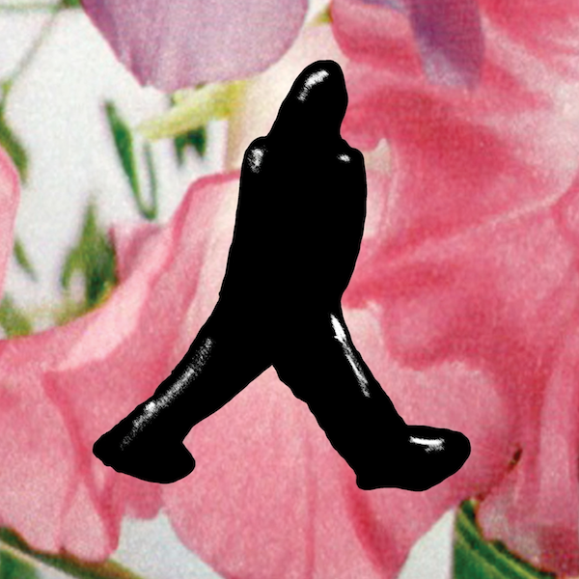

'You’re Too Precious' marks Blake’s first release of 2020, and a period in which James has also won widespread praise for his intimately uplifting live streams under lockdown. These have already featured a 2-hour production masterclass, on top of career-spanning sets including fan favourites, intimate covers, and a further taste of brand new material...

'You're Too Precious' follows James Blake's acclaimed fourth album 'Assume Form', which has clocked nearly 400 million streams and cemented his status as one of the most important musicians, producers and songwriters of his generation. In the last couple of years alone, the Mercury Prize and Grammy Award winner has worked with the likes of Kendrick Lamar, Beyoncé, Jay Z, Frank Ocean and Rosalía. All this coincides with a more personal evolution for James, who has spoken candidly about his experiences of mental health, modern-day masculinity, and – as 'You're Too Precious' and his home performances are a testament too - now appears more open and inventive than ever.

Follow James Blake: Website / Spotify / Instagram / Facebook / Twitter

For all press enquiries please contact:

Warren Higgins
warren@chuffmedia.com
020 8281 0989

