JONAS BROTHERS RELEASE NEW SINGLE “WHAT A MAN GOTTA DO”

MUSIC VIDEO CO-STARRING PRIYANKA CHOPRA JONAS, SOPHIE TURNER, & DANIELLE JONAS OUT NOW

PERFORMING LIVE FROM THE 62nd GRAMMYS® JANUARY 26th

HAPPINESS BEGINS UK TOUR KICKS OFF JANUARY 29th

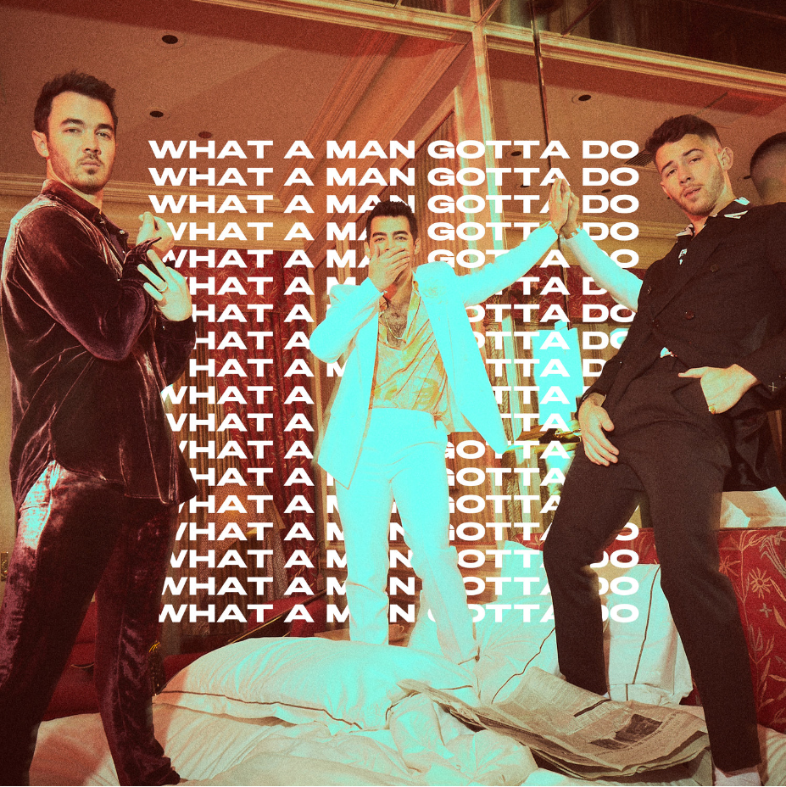
Download press materials here

After mounting the biggest comeback of the decade last year, GRAMMY® Award-nominated trio Jonas Brothers release their first new single of 2020, “What A Man Gotta Do,” today. Get it HERE via Republic/Polydor Records.

“What A Man Gotta Do” charges forward on upbeat acoustic guitar and a percussive groove. This high-energy bounce culminates on the hook where they coyly ask, “What a man gotta do to be locked up by you?” Continuing a tradition of event-level visuals, the group also reveals a blockbuster music video co-starring their significant others: Priyanka Chopra Jones, Sophie Turner, and Danielle Jonas. Directed by Joseph Kahn, the band and the ladies put their own smart, satirical, spirited and sexy twist on classic films such as Risky Business, Grease, and Say Anything.

Watch it HERE.

Jonas Brothers will pull out all the stops next Sunday January 26 when they perform “What A Man Gotta Do” for the very first time at the 62nd annual GRAMMYS® in Los Angeles. Plus, they vie for the “Best Pop Duo/Group Performance” statue at the ceremony.
The song arrives hot on the heels of the band’s blockbuster comeback album,
Happiness Begins. Not only did it bow at #1 on the Billboard Top 200 (#2 on the UK’s Official Album charts), go platinum, and set the stage for the sold out Happiness Begins Tour
(UK dates kick off Wed 29th Jan) across arenas everywhere, but it also yielded the Hot 100 #1 smash “Sucker,” which proved definitive for 2019. Most importantly, it set the stage for the biggest, boldest, and brightest era of Jonas Brothers yet.

Be on the lookout for more surprises and big news very soon.
The preeminent male group of this century, Jonas Brothers opened the floodgates for a new era of titans in pop music. Following a six-year hiatus, Jonas Brothers took 2019 by storm with the surprise release of their critically acclaimed and widely successful single "Sucker." The double-platinum single debuted at #1 on Billboard's Hot 100, becoming the first #1 for the band and the first #1 debut from a group this century. The song emerged as a cultural phenomenon, ranking #1 on Billboard’s critic's picks list of the “50 Best Songs of 2019,” and standing out as the top song on U.S. Radio in 2019, according to Nielsen Music/MRC Data.

Making history once more, the band delivered their third #1 album debut with the release of their platinum-selling album Happiness Begins. The band continued to soar with their sold-out “Happiness Begins Tour,” with over 1 million tickets sold. The tour received unanimous praise with Billboard writing, “The ‘Happiness Begins’ Tour feels like a celebration of everything in the Jonas Brothers' career, but also the beginning of their larger-than-life new chapter,” and The Washington Post claiming, “There hasn’t been a boy band in recent history that’s made a comeback quite like Jonas Brothers.” Moreover, Rolling Stone summed it best, “Following a six year hiatus, it almost feels like the Jonas Brothers are bigger than ever.”

The band closed out a banner year with the release of “Only Human,” another Top 5 hit on both Top 40 and Hot AC radio airplay charts. What’s more, they garnered a bevy of awards, including a 2019 MTV Video Music Award for "Best Pop Video" and two 2019 Teen Choice Awards for "Artist Of The Decade" and "Choice Summer Group.” Plus, they were nominated in top categories at the American Music Awards, including “Favorite Duo or Group Pop/Rock” and “Favorite Song Pop/Rock.” Most recently, they notched their second GRAMMY® nomination for “Best Pop Duo/Group Performance.”

HAPPINESS BEGINS UK TOUR DATES:
Wed 29th Jan Birmingham Arena Birmingham
Sun 2nd Feb The 02 London
Mon 3rd Feb The SSE Arena Wembley London
Wed 5th Feb The SSE Hydro Glasgow
Thurs 6th Feb Manchester Arena Manchester
JONAS BROTHERS HAPPINESS BEGINS
https://JonasBrothers.lnk.to/HappinessBegins
JONAS BROTHERS SOCIALS
http://instagram.com/jonasbrothers
http://twitter.com/jonasbrothers
https://www.facebook.com/JonasBrothers
https://www.youtube.com/user/JonasBrothersMusic

For more information and press enquiries please contact:

Jenny Entwistle
jenny@chuffmedia.com
020 8281 0989

