KING OF THE SEA SHANTY NATHAN EVANS RELEASES ORIGINAL SONG & REMIX OF GLOBAL VIRAL HIT “WELLERMAN” OUT TODAY VIA UNIVERSAL

LISTEN TO “WELLERMAN” [HERE]
LISTEN TO “WELLERMAN (220 KID & BILLEN TED REMIX)” [HERE]

REMIX ADDED STRAIGHT TO SPOTIFY’S HOT HITS PLAYLIST

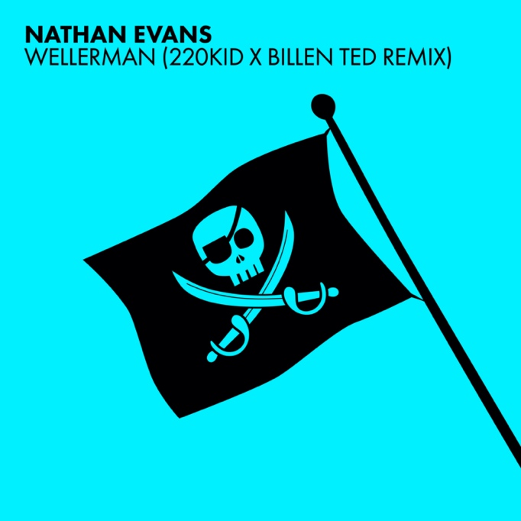

(LONDON, U.K., FRIDAY 22 JANUARY 2021) After kickstarting the sea shanty phenomenon that has swept the globe in recent weeks, one of the most exciting breakout stars of 2021, Nathan Evans today releases his debut track “Wellerman” and “Wellerman 220Kid & Killen Ted Remix” via Universal. “Wellerman” is available to listen to [HERE] and “Wellerman 220Kid & Billen Ted Remix” is available to listen to [HERE], out now on all streaming platforms.

The genre is everywhere right now and it’s all down to Nathan that a new generation are discovering the thrills of fisherman-themed, multi-harmonised folk music. It all began when Nathan, from Airdrie, North Lanarkshire in Scotland, decided to start uploading songs to TikTok after completing his morning duties as a postman. The first track he shared was a cover of Leave Her, Johnny, the traditional Irish shanty that dates back to the early part of the last century. But what happened next was off the scale, with the video racking up eye-popping numbers. Something about this music and Nathan’s charismatic delivery connected in a big, big way.

By the time Nathan uploaded a rendition of the New Zealand whaling ballad The Wellerman a few months later, he was at the centre of a new cultural movement whirling around sea shanties. To date, he has over 500,000 TikTok followers and The Wellerman has amassed an astonishing seven million views and more. Now, taking his music career full time, he follows in the chart dominating footsteps of those he has always admired including Dermot Kennedy and Lewis Capaldi as well as finding unlikely fans in Andrew Lloyd Webber, Gary Barlow and Ronan Keating who have also uploaded their own renditions of the song alongside the current 1.6 billion videos using the hashtag #seashanty on TikTok.

He has begun an international love of sea shanties that have seen the craze sweep the globe, popping up in a variety of platforms from football posts to prime-time TV shows. UK producer 220 Kid’s remix of Wellerman became a viral sensation of its own, exploding out of Instagram and receiving radio plays from

Radio 1’s Scott Mills, Nick Grimshaw and Capital Dance’s Mistajam. Ahead of its release, it’s already Top 20 in the Shazam chart.

Sea shanties have rocketed from cult tradition to a fevered mainstream concern. Everyone is doing it: Manchester City created their own sea shanty meme ahead of a league game against Crystal Palace and Jimmy Fallon and The Roots performed a sea shanty rendition of Olivia Rodrigo’s hit song Drivers License on Fallon Tonight. Nathan himself will perform a special version of The Wellerman, which is currently number five on Spotify’s global viral chart, as part of the BBC’s coverage of Manchester United v Liverpool’s FA Cup tie this weekend.

In a feature about how Nathan kickstarted this global trend, The Independent said, “The sea shanty frenzy has taken on a life beyond TikTok, even landing a spot on BBC Radio 4, and being Googled more than at any other time in history”. The Guardian wrote that sea shanties have “become something of a global online obsession” and the LA Times described how sea shanties have “taken over the internet”.

Lifting the spirits of those in the pandemic today Nathan says: “back in the day when the shanties were sung, it was to bring everybody together, to keep them all in time, to keep the morale high” and that’s exactly what he has done a century later.

Head of UK Music Operations at TikTok, Paul Hourican says, "Watching Nathan's brilliant and original videos inspire our community and kick start a global trend, demonstrates the power of TikTok. He's a talented musician and we are delighted that he has found such a great label partner in Polydor. We look forward to working more with Nathan and his team and are excited to see what comes next.”

Connect with Nathan Evans

TikTok | Instagram

For more information on Nathan Evans contact Warren@chuffmedia.com on 07762 130510

