TAME IMPALA RELEASE NEW SINGLE
"PATIENCE" - LISTEN HERE

MUSICAL GUEST ON SATURDAY NIGHT LIVE ON MARCH 30TH

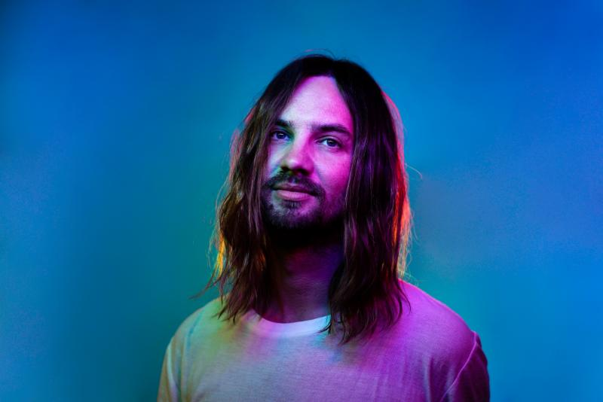

Tame Impala (Kevin Parker) today releases "Patience," the first new music since his GRAMMY nominated, RIAA Gold-Certified 2015 release, Currents. The new track is out today on Fiction Records. Listen here. "Patience" is a mid-tempo chugger of 70's disco and 90's house, stoned on the house-made Tame Impala lysergic liquor. A jubilant, confident cut of elegant piano jabs, driving disco drums and Parker's inimitable vocal style. The track is a lyrical meditation on life's cycles and phases that ascends to an overwhelmingly blissed out zenith, as our protagonist makes peace with the transience of time. It’s a potent hint at the infinite possibilities for future Tame Impala. Parker will headline this year's Coachella Valley Arts and Music Festival and next weekend, he'll make his Saturday Night Live debut as musical guest on March 30th with Sandra Oh hosting.

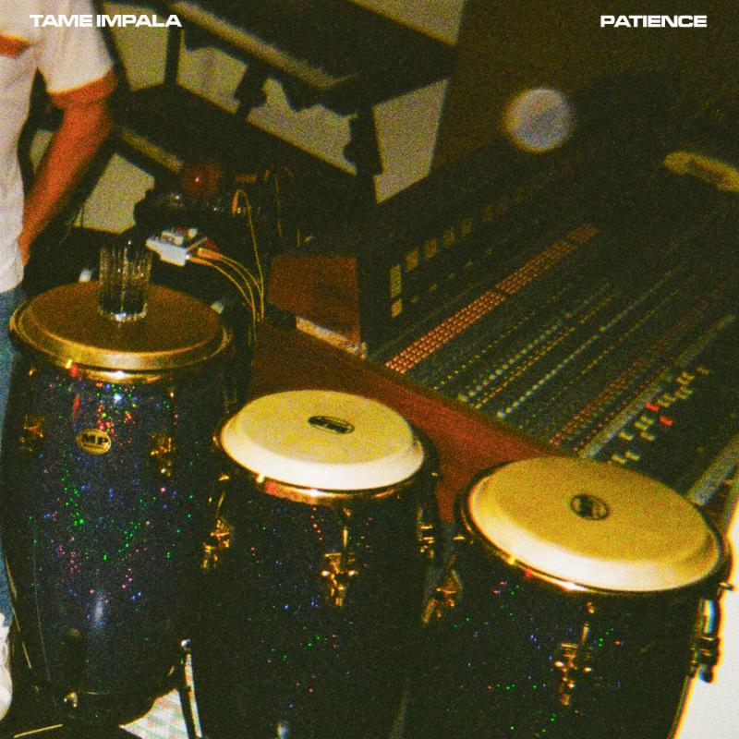

In addition to Coachella, Tame Impala will headline Shaky Knees Festival in Atlanta, GA (May 5), Corona Capital (May 11), Boston Calling (May 25) and Barcelona's Primavera Festival (May 31), Glastonbury (June 26), Lollapalooza (August 01) and more with festival and headline dates planned throughout 2019. Full tour dates below.

Tame Impala is Kevin Parker. His last album Currents was released in 2015 earning him a second GRAMMY nomination, a BRIT award, RIAA Gold-certification and word–wide critical acclaim. The New York Times labeled it a “a tour de force” while Pitchfork said “every song on ‘Currents’ is a revelatory statement of Parker's range and increasing expertise as a producer, arranger, songwriter, and vocalist.” In a 5 star review the Guardian said, “Australian musical polymath Kevin Parker's luscious new album takes psychedelic music into unknown territory” while Q magazine called it “Parker's finest achievement yet”.
Hailing from Perth, Australia, Tame Impala has gone on to headline festivals and theaters around the world and released three full length albums - Innerspeaker, Lonerism and Currents. As a writer and producer Parker has collaborated with Travis Scott, SZA, Lady Gaga, Mark Ronson, Kanye West, Kali Uchis, Theophilus London, Miguel, A$AP Rocky and more.

TOUR DATES
April 13 - Coachella Valley Music & Arts Festival - Indio, CA
April 20 - Coachella Valley Music & Arts Festival - Indio,CA
May 02 - Ascend Amphitheatre - Nashville, TN
May 03 - ExploreAsheville.com Arena - Asheville, NC
May 05 - Shaky Knees Music Festival - Atlanta, GA
May 06 - St. Augustine Amphitheater - St. Augustine, FL
May 07 - Fillmore Miami Beach at the Jackie Gleason Theater - Miami Beach FL
May 11 - Corona Capital Festival - Guadalajara, MEXICO
May 25 - Boston Calling Festival - Boston, MA
May 31 - Primavera Festival - Barcelona, SPAIN
June 01 - We Love Green - Paris, FRANCE
June 05 - Garden - Gotenberg, SWEDEN
June 06 - NorthSide - Aarhus, DENMARK
June 21 - Hurricane Festival - Sheebel, GERMANY
June 22 - Southside Festival - Neuhausen ob eck, GERMANY
June 26 - Glastonbury - Pilton, ENGLAND
August 01-04 - Lollapalooza - Chicago, IL
August 09 - Flow Festival - Helsinki, FINLAND
August 14 - Pukkelpop - Hasselt, BELGIUM
August 15 - La Route Du Rock - Rennes, FRANCE
August 16 - Lowlands Festival - Walibi Holland, NETHERLANDS

Find Tame Impala here:
tameimpala.com
www.facebook.com/tameimpala
www.twitter.com/tameimpala
www.instagram.com/tameimpala

For more information and press enquiries please contact:
Warren Higgins
warren@chuffmedia.com
020 8281 0989

