Michael Kiwanuka And Tom Misch Share New Collaboration.

“Money” Is Streaming Now

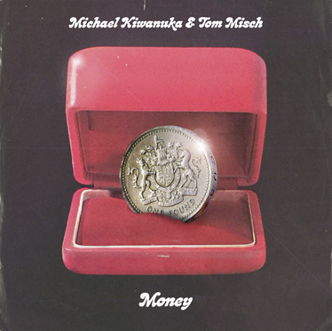

Michael Kiwanuka and Tom Misch are very pleased to share Money, a fantastic new collaboration by two very special British musicians.

Money is a song that harnesses the distinctive, raw vocal of Kiwanuka, here dabbling with falsetto, backed by Misch’s gloriously upbeat signature guitar sound and disco beat. It’s unashamedly loose-limbed and colourful, and it signals one of the Summer’s first definitive songs. Money features YEBBA on backing vocals, and was mixed by Grammy Award winning engineer/producer Russell Elevado (D’Angelo, Kamasi Washington).

Listen to Money here: https://MichaelKiwanuka.lnk.to/MoneyPR

Michael Kiwanuka: “The premise of Money is that, at first listen, it's a song about money and how much I want it and love it. I want to use money to meet people and be around people that have a lot of it. But as you listen closer, it's actually about how too much love for money can be dangerous.”

Tom Misch added: “I have been a big fan of Michael for a few years, so I was really excited to work with him. In the session it was cool to find we share a common love for 80's disco so we thought we would try something with that vibe. It came together really quickly and I enjoyed producing it, Michael killed it on the vocals.

“Big love to YEBBA on the BVs, Tobie Tripp on strings and Russell Elevado for the killer mix!”

Over the past few months, Kiwanuka has been sharing glimpses of his return to the studio working on the follow up to Love & Hate. That second record was one of 2016’s most acclaimed, and garnered Michael both his first number one album and his first BRIT Award nomination too. Ahead of his own new music, Money shows a new versatility and a lighter touch.

Tom Misch released his acclaimed debut album ‘Geography’ in April 2018 via his own Beyond The Groove label. It debuted at number 8 in the UK chart upon release, and featured guest spots by Loyle Carner, De La Soul, and Goldlink. It’s a record that flirts with a variety of genres but lands somewhere distinctively left of centre, in a world all of Tom’s own design. Money showcases that complete vibe of sound that has become so resonant throughout his recordings.

Michael returned to the live arena earlier this month with three European festival slots. He plays his first UK shows next week at the Tramshed in Cardiff, a tiny warm-up show ahead of his evening Park Stage slot at Glastonbury on the 28th June. The festival appearances continue throughout the summer and are detailed below, including his first festival headline performance at End of the Road on 30th August.

Off the back of a sold-out headline tour across Asia, Tom returns to the UK to headline Bristol Sound at Harbourside on 26th June. He will also perform at Eric Clapton’s Crossroads Guitar Festival in Dallas, Texas in September. For full details live details, see below.

Michael Kiwanuka Live:
27th June – Tramshed, Cardiff (Glastonbury warm-up)
28th June – Glastonbury, UK
4th July – Jazzablanca Festival, Casablanca
6th July – Festival Cruilla, Barcelona
9th July – Atlas Weekend, Ukraine
12th July – Pohoda Festival, Slovakia
20th July – One Love Festival, Turkey
5th August – Taubchenthal, Germany
10th August – Haldern Pop Festival, Germany
30th August – End of the Road Festival, UK
1st September – Electric Picnic, Ireland

Tom Misch Live:
26th June – Bristol Sounds, Harbourside Bristol
28th June – Rock Werchter, Belgium
5th July – Jazz a Vienne Festival, France
6th July – Festival Django Reinhardt, France
7th July – Montreux Jazz, Switzerland
14th July – NASS Festival, Shepton Mallet
20/21 September – Crossroads Guitar Festival, Dallas

For further information on both artists’ live shows, please visit www.michaelkiwanuka.com + www.tommisch.com

For more information and press enquiries please contact:

Warren Higgins
warren@chuffmedia.com
020 8281 0989

