**TAME IMPALA RELEASE SINGLE**

**“**[**LOST IN YESTERDAY**](https://tameimpala.lnk.to/LostInYesterday)**”**

***THE SLOW RUSH***

**OUT FEBRUARY 14 ON FICTION RECORDS**

**ANNOUNCED TO HEADLINE BONNAROO FESTIVAL**

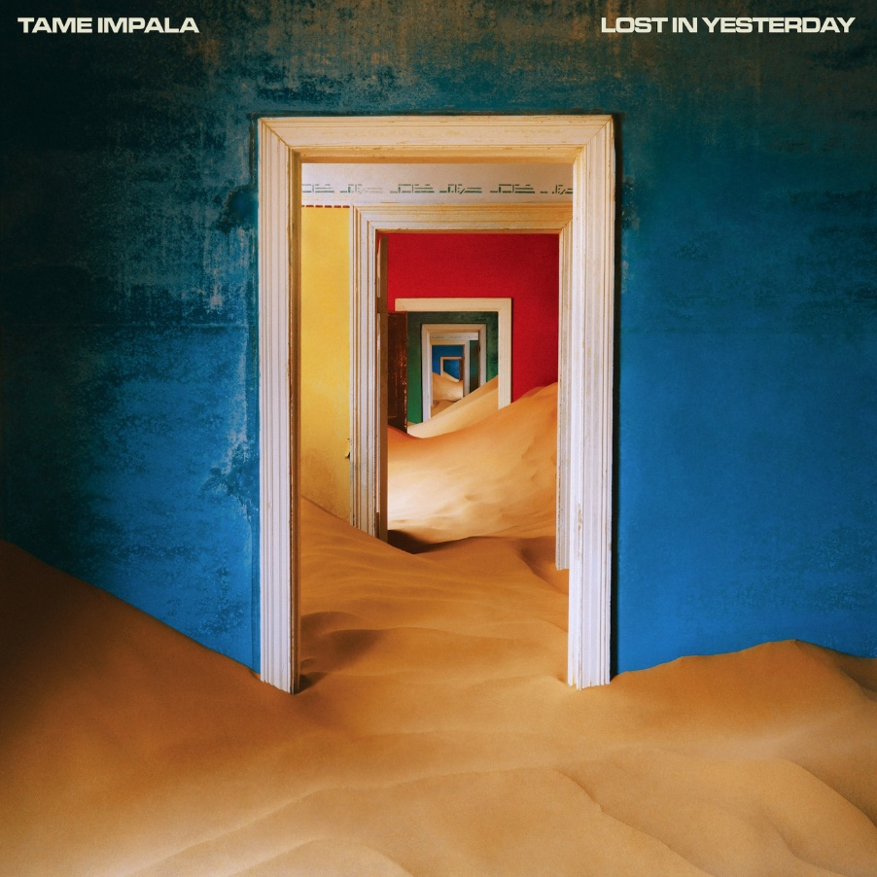

**Tame Impala** (Kevin Parker) will release his fourth studio album ***The Slow Rush*** on February 14th via Fiction Records, and today he releases the single, “[**Lost In Yesterday**](https://tameimpala.lnk.to/LostInYesterday).” “Lost In Yesterday” is a deep dive into the addictive nature of nostalgia propelled by loopy, driving disco. An examination of time’s distorting effect on memories, on “Lost In Yesterday” Parker realizes that even the most disdainful times can take on a rosy tinge the further they recede in the rearview. Looking back can be a tough habit to break, but the track’s compulsive bassline, sprinkles of electronic stardust and chorus catharsis ensure the focus is firmly on the future.   
Click [**HERE**](https://eur02.safelinks.protection.outlook.com/?url=https%3A%2F%2Fyoutu.be%2FC7VlC0QjdHU&data=02%7C01%7CLivy.Coare%40caroline.com%7Cd19d55b0025542c1ac5b08d79422888b%7Cbbcb6b2f8c7c4e2486e46c36fed00b78%7C1%7C0%7C637140748354006148&sdata=BTPPU592btRSliLkMGOq6%2BcD7Hlj4OX2IUHi8MOeMfo%3D&reserved=0) to listen.

This week it was announced that Tame Impala will headline Bonnaroo on Sunday, June 14th. Late last year Tame Impala announced a full North American tour with support from Perfume Genius. The tour kicks off with the previously announced date of March 9th at San Diego’s Pechanga Arena and concludes August 7 at The Gorge Amphitheatre in George, WA.  The dates include two nights at The Forum in Los Angeles on March 10th (sold-out) and 11th.

To date Parker has shared three tracks off *The Slow Rush* in addition to “Lost In Yesterday,” including “[Posthumous Forgiveness](https://eur02.safelinks.protection.outlook.com/?url=https%3A%2F%2Fyoutu.be%2F44lWO3qhQMk&data=02%7C01%7CLivy.Coare%40caroline.com%7Cd19d55b0025542c1ac5b08d79422888b%7Cbbcb6b2f8c7c4e2486e46c36fed00b78%7C1%7C0%7C637140748354006148&sdata=oIKJM3ogdVPrcSVbaKedTK7olTRg6ahUgIvjUs9eIHM%3D&reserved=0),” “[It Might Be Time](https://eur02.safelinks.protection.outlook.com/?url=https%3A%2F%2Ftameimpala.lnk.to%2FItMightBeTime&data=02%7C01%7CLivy.Coare%40caroline.com%7Cd19d55b0025542c1ac5b08d79422888b%7Cbbcb6b2f8c7c4e2486e46c36fed00b78%7C1%7C0%7C637140748354016144&sdata=K%2BM9t1F0FKnz%2B%2Fj5b0K1AK4jZefAp433NA5fv%2BgBHxg%3D&reserved=0),” and, “[Borderline](https://eur02.safelinks.protection.outlook.com/?url=https%3A%2F%2Ftameimpala.lnk.to%2FBorderline&data=02%7C01%7CLivy.Coare%40caroline.com%7Cd19d55b0025542c1ac5b08d79422888b%7Cbbcb6b2f8c7c4e2486e46c36fed00b78%7C1%7C0%7C637140748354016144&sdata=0idIdAU7FZOt%2BzLP%2Fo2qYYmP979wxRxBiukroE1fW%2FY%3D&reserved=0).” *The Slow Rush* was recorded between Los Angeles and Parker’s studio in his hometown of Fremantle, Australia. The twelve tracks were recorded, produced and mixed by Parker. Fans can pre-order The Slow Rush at [tameimpala.com](https://eur02.safelinks.protection.outlook.com/?url=http%3A%2F%2Ftameimpala.com&data=02%7C01%7CLivy.Coare%40caroline.com%7Cd19d55b0025542c1ac5b08d79422888b%7Cbbcb6b2f8c7c4e2486e46c36fed00b78%7C1%7C0%7C637140748354026135&sdata=4vC5U8Wq2LKPWYZzratfMdPZvxlJQUeLwTb0Z4Thhf0%3D&reserved=0) and all major retailers, or with a ticket purchase for any of the North American tour dates.

[High res here. Credit: Neil Krug](https://we.tl/t-bu7N7IdzpE)

The Slow Rush is Parker’s deep dive into the oceans of time, conjuring the feeling of a lifetime in a lightning bolt, of major milestones whizzing by while you’re looking at your phone, it’s a paean to creation and destruction and the unending cycle of life. Parker told the [New York Times](https://eur02.safelinks.protection.outlook.com/?url=https%3A%2F%2Fwww.nytimes.com%2F2019%2F05%2F16%2Farts%2Fmusic%2Ftame-impala-kevin-parker.html&data=02%7C01%7CLivy.Coare%40caroline.com%7Cd19d55b0025542c1ac5b08d79422888b%7Cbbcb6b2f8c7c4e2486e46c36fed00b78%7C1%7C0%7C637140748354026135&sdata=kae%2FSREtKOHvwr79aeonuf4hJSIBGfD3PJb2D6ITlqU%3D&reserved=0) earlier this year, “A lot of the songs carry this idea of time passing, of seeing your life flash before your eyes, being able to see clearly your life from this point onwards. I’m being swept by this notion of time passing. There’s something really intoxicating about it.” The album cover was created in collaboration with photographer [Neil Krug](https://eur02.safelinks.protection.outlook.com/?url=https%3A%2F%2Fwww.neilkrug.com%2F&data=02%7C01%7CLivy.Coare%40caroline.com%7Cd19d55b0025542c1ac5b08d79422888b%7Cbbcb6b2f8c7c4e2486e46c36fed00b78%7C1%7C0%7C637140748354036131&sdata=%2BSyzurVKZiB%2BVEb6HTbWI5oGdfH38PuqEylpqIWwH0Q%3D&reserved=0) and features a symbol of humanity all but swallowed whole by the surrounding environment, as though in the blink of an eye.

Last year Tame Impala have headlined multiple major festivals including Coachella, Glastonbury, Primavera, Lollapalooza, and sold out arenas around the world including The O2 in London and two nights at New York City’s Madison Square Garden.

Tame Impala is Kevin Parker. His last album “Currents” was released in 2015 earning him a BRIT Award for Best International Group, a second GRAMMY nomination and went platinum in Australia, Gold in the USA, Canada, UK, France, Netherlands and Belgium, and enjoyed word-wide critical acclaim. The New York Times labeled it a "a tour de force" and Pitchfork said, “nearly every proper song on ‘Currents’ is a revelatory statement of Parker's range and increasing expertise as a producer, arranger, songwriter, and vocalist while maintaining the essence of Tame Impala." In a 5 star review the Guardian said “Australian musical polymath Kevin Parker’s luscious new album takes psychedlic music into unknown territory” while Q magazine called it “Parker’s finest achievement yet.”

**[](https://www.facebook.com/tameimpala/)**[**‌**](https://www.facebook.com/GrandstandHQ) **[](https://twitter.com/tameimpala)****[](https://www.instagram.com/tameimpala/)**[**‌**](https://www.instagram.com/grandstandmediahq/?hl=en)

[Website](https://official.tameimpala.com/)

**For more information and press enquiries please contact:  
Warren Higgins /** [**warren@chuffmedia.com**](mailto:warren@chuffmedia.com) **/ 020 8281 0989**