MICHAEL KIWANUKA SHARES NEW SINGLE DETAILS

LIGHT (EDIT) STREAMING NOW.

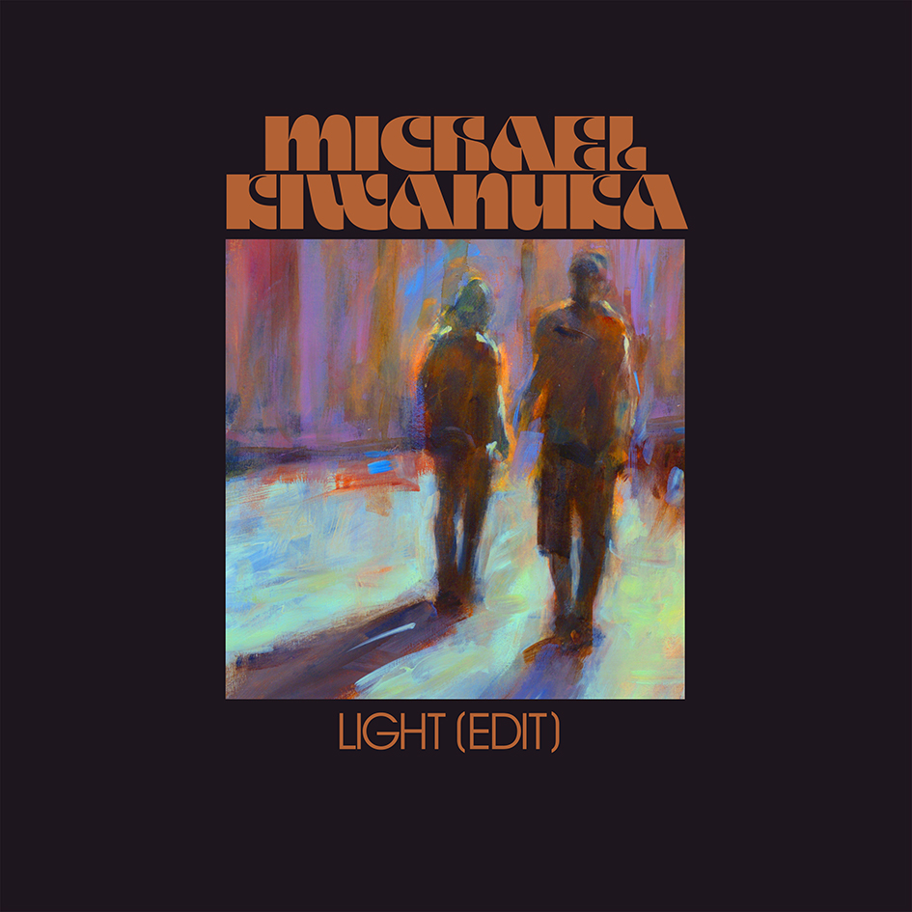

SOLD OUT UK TOUR CALLS AT BRIXTON ACADEMY THIS WEEK

Michael Kiwanuka is pleased to share details of his new single, Light (Edit). It is lifted from the acclaimed third album, KIWAUNKA, out now on Polydor Records.

This year has already been a hectic one for Michael Kiwanuka. Concluding 2019 in almost every record of the year for 2019 lists, Michael took to the road in January, travelling right across the US to bring his devastating new record KIWANUKA to stages there for the first time. He arrived back in London in February, just ahead of the BRIT Awards where he was nominated twice including Album of the Year. Barely had he time to draw breath before he was back out on the road to bring KIWANUKA to UK stages for a first sold out run, including Brixton Academy. A further spate of dates is already locked for later this year, including a hometown show at Alexander Palace, a short walk from Michael’s childhood home where he used to skate on the weekends.

The November release of the richly textured, sonically adventurous but highly listenable KIWANUKA was greeted with acclaim from all corners of the globe. It’s a record that finds its blueprint in Michael previous record Love & Hate but pushes harder and travels further. It feels like a body of work that will be listened to for years to come, and is perhaps testament to an artist who hasn’t been rushed nor guided on his recordings beyond the watchful but encouraging eyes of dual producers Danger Mouse and Inflo. Light (edit) here is a mesmerising, psychedelic-kissed tune that showcases the musicianship and atmospherics that makes KIWANUKA such an alluring record.

A busy Summer festival schedule is already coming together nicely, including a prestigious headline slot at this year’s Green Man Festival and a second to headline slot at the Latitude Festival.

KIWANUKA is a statement record by a rare type of artist. An artist worth treasuring.

Michael Kiwanuka Live UK:
5th March - O2 Academy Brixton, London SOLD OUT
6th March – O2 Academy, Birmingham SOLD OUT
7th March – O2 Apollo, Manchester SOLD OUT
9th March – Corn Exchange, Cambridge SOLD OUT
10th March – De Montford Hall, Leicester SOLD OUT
12th March – O2 Academy, Leeds SOLD OUT
13th March – O2 Academy, Newcastle SOLD OUT
14th March – Barrowlands, Glasgow SOLD OUT
17th July – Latitude Festival, Southwold
11th August – Summer Sessions, Edinburgh
20th August – Green Man Festival, Brecon Beacons
13th November – Brighton Centre
14th November – Empress Ballroom, Blackpool
21st November – Plymouth Pavillions
22nd November – Bonus Arena, Hull
27th November – Alexandra Palace, London SOLD OUT

www.michaelkiwanuka.com

