DECLAN MCKENNA LAUNCHES SECOND SINGLE “THE KEY TO LIFE ON EARTH” FROM FORTHCOMING ALBUM

THE VIDEO STARS NETFLIX’S THE END OF THE F***ING WORLD ACTOR ALEX LAWTHER

THE NEW ALBUM “ZEROS” MOVES BACK TO 21ST AUGUST 2020

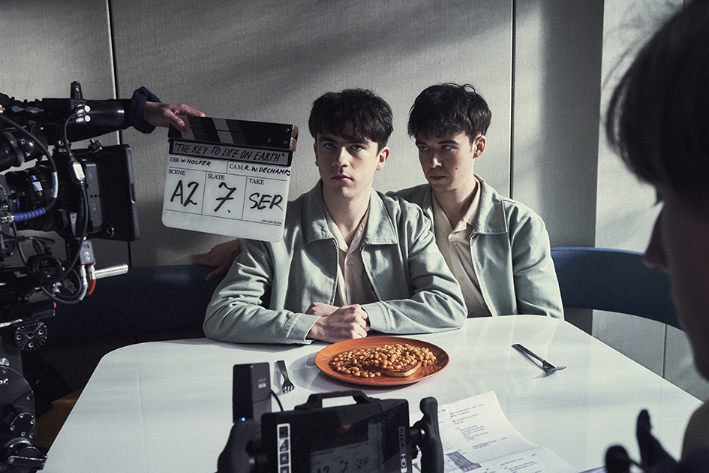

Declan McKenna has launched the second track to be lifted from his forthcoming second album, Zeros.

The Key To Life On Earth is streaming now alongside a new video featuring a special guest role by Alex Lawther from Netflix/C4’s smash hit series, The End Of The F***ing World.

Declan’s new album “Zeros”, previously scheduled for release in late May, now moves back to 21st August.

Shot in East London pre-lockdown by director Will Hooper (who also directed Beautiful Faces), the video brings together two young British faces doing very good things in different worlds. That they look alike proves fortuitous here, and something their fans have been quick to point out at every conceivable opportunity.

“The Key To Life On Earth reflects on mundanity and hostility. I suppose it’s set in suburbia much like my hometown. The video sees two people, who are very similar, in conflict with each other, and I think that’s the simplest analogy for the song’s purpose.
“Alex Lawther is someone I’ve wanted to work with for a long time, I enjoyed watching his roles in Carnage, Black Mirror and The End Of The F***ing world, and I was trying to get in contact after seeing how much people compared us online. After finding I had a mutual friend with one of his family, I was eventually able to get his number and we got talking. We met up for tea a few times and found out we really did have a lot of mutual passions and ideas, and we shared and compared our experiences of working in our respective creative worlds. We hung out at the Extinction Rebellion and I ended up playing him some of my album. We were both keen to work together but syncing up timewise was pretty challenging.

“We eventually pulled together with the video’s director Will Hooper who has helped to put together most of my video projects for this record so far, and with more ridiculous ideas than you could shake a vegan cream tea at; we finally managed to lock in a date to make this video - and just in time as it turns out.”

The Key To Life On Earth is another excellent taster to a fascinating new record. With one eye on all things psychedelic and the other firmly rooted in that insistent, pulsating indie pop that brought him so much attention on the debut album, Declan McKenna has pushed himself hard and let his mind wander to create a genuinely exciting record that should stand out amongst the very best of 2020.

“Zeros” was recorded out in Nashville, produced by Jay Joyce and mixed by Spike Stent. It follows 2017’s critically acclaimed debut album, ‘What Do You Think About The Car?’ (which helped propel Declan to an eye-watering 230 million streams and 200,000 album sales),and introduced a talented teenager with an ear for a melody and a head full of questions. Questions not just for our highest members of state, but also questions for each and every one of us. Questions that Declan’s whip-smart generation were all baying for the responses to.

Watch Declan McKenna perform Beautiful Faces, with four more Declan McKennas on C4’S Sunday Brunch earlier this month.

It’s a record that instantly sounds bigger and bolder, and infinitely wiser. Declan might not have received all those answers he had once sought, but he’s moved on and around them, laterally speaking. The world we find ourselves in is often considered hyper-surreal, almost dystopian in its ridiculousness, and that’s the one Declan chose to focus on throughout “Zeros”. It’s not stuck in the moment but inhabiting a future with the emphasis on the absurd. Otherworldly. Unreal. A reflection on our culture through a warped carnival mirror.

Zeros Tracklisting: 1 You Better Believe!!!, 2 Be an Astronaut, 3 The Key to Life on Earth, 4 Beautiful Faces, 5 Daniel, You're Still a Child, 6 Emily, 7 Twice Your Size,
8 Rapture, 9 Sagittarius A*, 10 Eventually, Darling

New live dates will be announced imminently.

For more information and press enquiries please contact:

Warren Higgins
warren@chuffmedia.com
020 8281 0989

