Black Honey

Share new track ‘I Like The Way You Die’

Taken from upcoming new album ‘Written & Directed’
Due January 29th 2021

WATCH THE BLOOD-THIRSTY VIDEO HERE

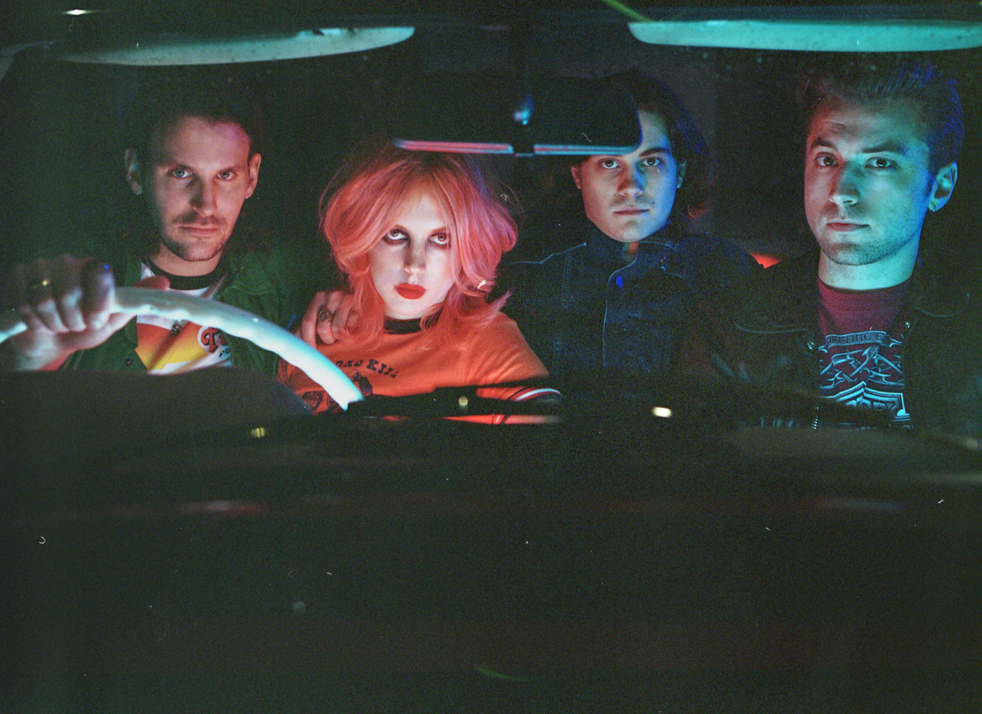

As the dust settles on the recent announcement of their upcoming new record, Black Honey have shared another tantalising slice of what’s to come in the form of new track ‘I Like The Way You Die’.

‘I Like The Way You Die’ lies at the very heart of Black Honey’s new record, ‘Written & Directed’. Within its stomping 3 minutes is a heavy and fully loaded attack on alpha male egotism, swapping it out for pure and unfiltered female power. The accompanying video is typically brilliant of Black Honey and their leader Izzy B. Phillips – setting the song up on a gruesome gothic trip with feme-fatale Phillips at the front and centre.

SINK YOUR TEETH INTO THE NEW VIDEO HERE

Due for release on January 29th 2021, ‘Written & Directed’ is Black Honey’s second album. It follows their outstanding self-titled debut released back in 2018 when the world that surrounded the Brighton fourpiece looked and felt like a very different place. Black Honey however are still the bad-ass, truly original band they have always been, they’ve just graduated from the intriguingly anomalous newcomers to becoming one of UK indie’s most singular outfits. They've travelled the world and released a Top 40 album; graced the cover of the

NME and become the faces and soundtrack of Roberto Cavalli's Milan Fashion Week show; smashed Glastonbury and supported Queens of the Stone Age, all without compromising a shred of the wild, wicked vision they first set out with.

Like ‘I Like The Way You Die’, ‘Written & Directed” delivers one, very singular, message, aiming to unashamedly plant a flag in the ground for strong, world-conquering women. For fierce frontwoman and album protagonist Izzy B. Phillips – it’s the most important message she could send to inspire her cult-like fanbase and fill the female-shaped gap that she felt so acutely when she was growing up and discovering rock music for the first time.

Written throughout 2019 and recorded in fits and spurts between touring, ‘Written & Directed’ is drenched with a hedonistic, anything-goes attitude. It’s also the most full-throttle collection of music that Black Honey have ever-written – egged-on by their run of shows supporting long-term friends and collaborators Royal Blood. Exploring everything from womanhood, to identity and power, it’s an album that revels in the rich history of pop culture, throws a wink to its rock-and-roll heroes, but ultimately (and in true Black Honey fashion) it stands on its own two feet.

With a typically hyper-visual world referencing grindhouse cinema, kitschy pulp films and a flip-reverse of female cinematic representation all primed to unfurl and explode around them, 'Written & Directed' is the sound of Black Honey strapping in and saddling up, of harnessing their quirks, and, as the Phillips has always hoped, riding them joyously into the sunset.

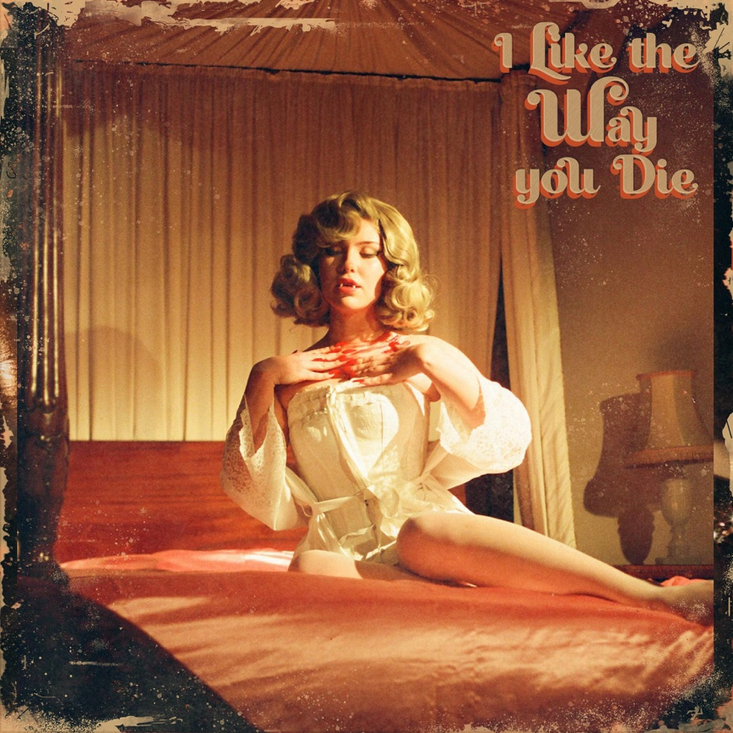

Follow Black Honey
Facebook | Instagram | Spotify | Twitter | Website

For all media information please contact:

Warren at Chuff Media
Tel. 07762 130 510
warren@chuffmedia.com

