CELESTE ‘I CAN SEE THE CHANGE’
The new single, produced by FINNEAS
OUT NOW
Listen to the song here

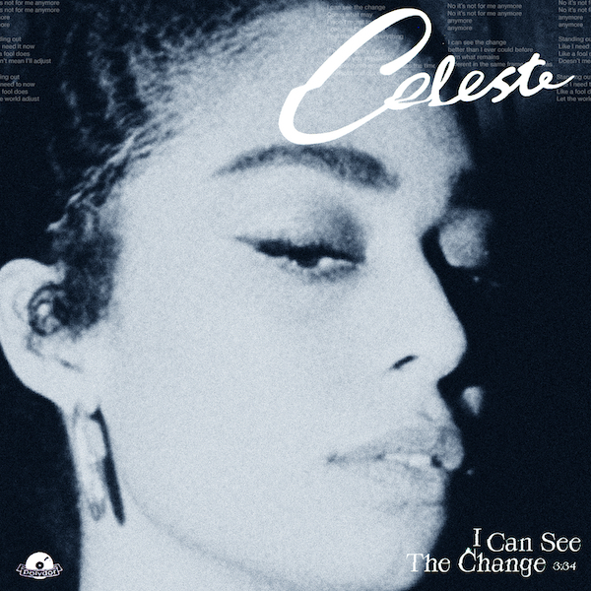

“A once-in-a-generation talent ... the finest British soul singer to emerge in years” – NME
“Smoky, jazz-tinged soul reimagined for the modern age” – Q
“She is so obviously the real soul-baring deal” – Sunday Times Culture
“Celeste has a voice that will break your heart” – Notion
“Incredible, stunning, everything” – Jorja Smith
“That voice…” – Billie Eilish
Ascendant soul singer and BBC Sound of 2020 winner Celeste readies her sweeping, optimistic new single ‘I Can See The Change,’ set for release on 27th May via Polydor Records. Produced by FINNEAS, ‘I Can See The Change’ is a song about finding hope in the wake of adversity and realising that a brighter future lies ahead, a sentiment that no doubt resonates in uncertain times like these.

Speaking about the story behind the new single, Celeste explains, “It was a strange time for me as externally lots of exciting things were happening in my life, but internally I was feeling flat. I felt disconnected from myself and the world around me so I knew something needed to change… It's difficult for me to fully articulate, but when I started writing the song I pictured a blurry, unidentified image far off in the distance that I knew I had to move closer to in order to understand what it was and perhaps what it meant, but also realising that the journey wasn’t going to be easy. Ultimately the song is about hope and change but knowing that to obtain this requires effort, patience and conviction.”

Celeste’s spine-tingling performance of her song ‘Strange’ at this year’s BRIT Awards, coinciding with her Rising Star award win, was a watershed moment for the British-Jamaican singer, placing her in the spotlight in front of luminaries like Stormzy, Dave, Harry Styles and Billie Eilish. Stormzy called it “a perfect song!” while Billie and her songwriter-producer brother FINNEAS have proven to be some of her most outspoken supporters yet, with Eilish picking ‘Strange’ for her recent ‘At home with Apple Music’ playlist. Celeste and FINNEAS ultimately stayed in touch and decided to collaborate on the new song, finishing it during lockdown. “I saw Celeste perform at the Brits back in February and was blown away,” he reveals. “She commanded the stage in a way that was simultaneously intimate and massive and I immediately went home and downloaded her entire catalog. When I was approached about producing ‘I Can See The Change,’ I was thrilled. I have been lucky to produce songs for a few artists who I think will never go out or style and Celeste is certainly on that list.”

Celeste has kept herself busy throughout the UK lockdown with stripped-back and socially distanced performances for the likes of COLORS, the World Health Organisation’s Global Citizen sessions (hand-picked by Chris Martin), The Graham Norton Show and BBC Children In Need’s Big Night In, for which she performed a poignant cover of the late Bill Withers’ ‘Lean On Me’ live from her living room with the aid of a theatrical red velvet curtain. Celeste also showcased her influences with a disco-infused DJ set for NTS Radio’s ‘Remote Utopias’ takeover, raising money for the Global FoodBanking Network. Indeed, in these strange times with live shows cancelled and artists having to adapt to the new normal, Celeste has come into her own – that singular voice shining through.

Connect with Celeste:
https://www.instagram.com/celeste
https://www.facebook.com/celestewaite
https://twitter.com/celeste
Photo credit: Sophie Jones
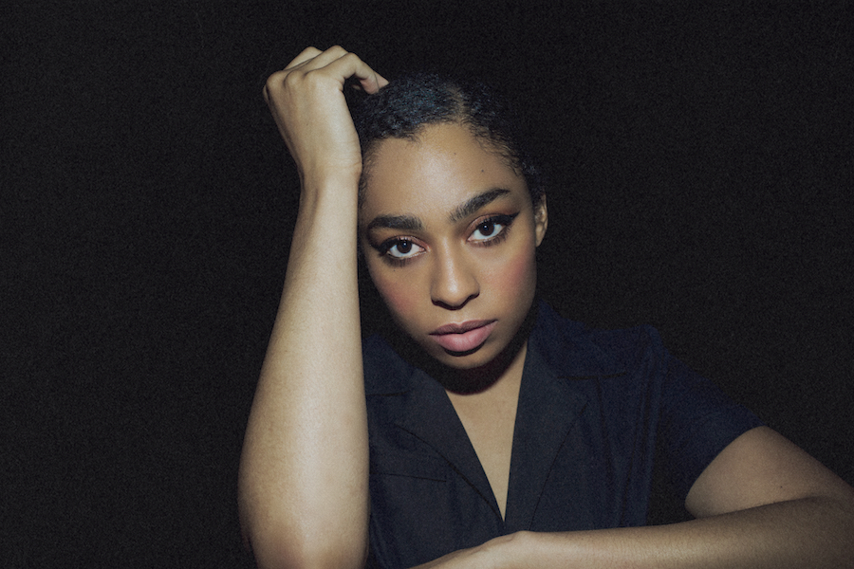

For all press enquiries please contact:
Charleigh Egan / charleigh@chuffmedia.com / 020 8281 0989

