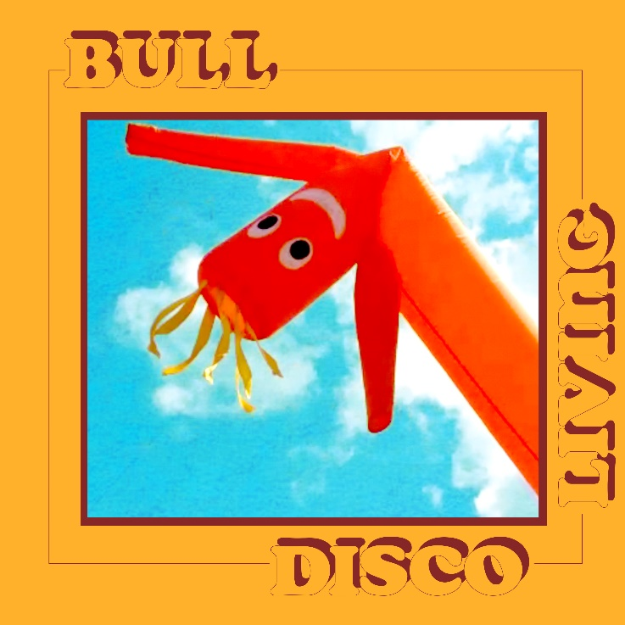
INDIE ROCKERS BULL RETURN WITH ANTHEMIC NEW SINGLE ‘DISCO LIVING’
LONDON AND PORTSMOUTH LIVE DATES ANNOUNCED
LISTEN HERE
WATCH VIDEO HERE
“Alt-rock fans will love the mellow tones of Americana grunge mixed with nineties pop.” – Gigwise
“The four-piece are working towards ‘big things' with their easy-breezy take on lo-fi retro pop." - Dork
York’s finest gang of alt rockers, Bull are back with an addictive new indie banger, ‘Disco Living’ out now on EMI Records/Young Thugs.
Evoking the summery spirit of vintage Britpop, ‘Disco Living’ is a sly look at the ridiculousness of the so-called high-end lifestyle and people’s obsession with luxury. “I wrote this in London when we lived at, our friend and amazing visual artist, Jean Penne’s house and decided to become a world-famous group. I was walking down a street of mansions to meet my friend in Hampstead Heath. I walked past one mansion which was under construction and it had a facade of the completed house on the front with the extremely bold tag line, ‘Discover Effortless Living’. I thought this was really funny so wrote the song with that as the opening line, kind of about that and how absurd it all was.”
‘Disco Living’ comes hot on the heels of ‘Green’, their first single since signing to EMI records in conjunction with York based label, Young Thugs. The song garnered support from the likes of DIY, Dork, and Chris Hawkins 6Music show.
Formed in 2011 by vocalist and songwriter Tom Beer and guitarist Dan Lucas, Bull’s mission is simply to make the music they wanted to listen to, inspired by their 90’s heroes such Pavement, Yo La Tengo and the Pixies. The rest of the band came together through a mix of friendships and happenstance. Drummer Tom Gabbatiss joined after he and Tom jammed together in bars while they were back-packing round Thailand, and Kai West had previously used to jump up on stage with the band and “Bez” (verb meaning to dance badly while intoxicated) before they eventually let him play bass.
A unique group within the city’s already eclectic scene, the band’s sound mixes together their alt-rock influences along with Tom’s down-to-earth song writing and a particularly wry sense of humour that comes naturally to the four Yorkshiremen.
They’ve played support shows for the likes of Squid, The Orielles, Pip Blom and even one of their long-time heroes in the form of Spiral Stairs (AKA Scott Kannberg of Pavement), and their constant gigging has seen them build up a dedicated local following. Not to be restricted to God’s own county, the band have plied their wares in mainland Europe, playing a series of unforgettable shows in Germany and the Netherlands.
The band will be returning to the stage in October with a gig at London’s infamous Shacklewell arms, followed by another gig in Portsmouth in January.
Live Dates
9th Oct 2020 – Shacklewell Arms – London
27th Jan 2020 – Edge of the Wedge – Portsmouth

For More Info
Facebook // Instagram // Youtube
www.youngthugs.com

For all press enquiries please contact:
Warren Higgins
warren@chuffmedia.com
020 8281 0989

