THE ACES RELEASE MUSIC VIDEO FOR
“DAYDREAM”

OUT NOW VIA RED BULL RECORDS

WATCH MUSIC VIDEO: https://youtu.be/maK_2Tv6xRs
STREAM / DOWNLOAD “DAYDREAM”: https://ffm.to/theacesdaydream

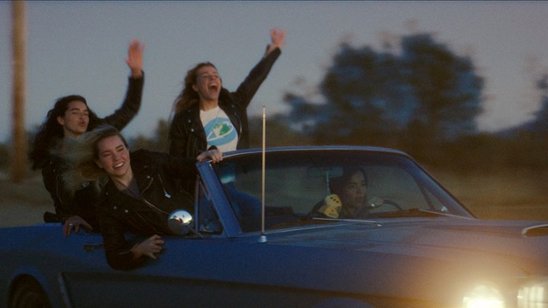

Following their first glimpse of new music this year which sparked much excitement about their return, The Aces have released this playful and cinematic music video companion to their hit single, “Daydream”, which is out now everywhere. Watch the video here. Directed by The Aces' own Alisa Ramirez, the video imagines the band hitting the open road, driving through the desert and getting into trouble. A euphoric and nostalgic showcase of sisterhood, the music video for “Daydream” echoes the vibrant spirit of the single, which garnered over 1.5 million streams in its first week and Spotify New Music Friday placements in more than 18 countries.

“This video was so fun to make and easily a new favorite. Over the years our band has always been described or referred to as a “girl gang”, so we decided to bring that to life in a fun, action packed, classic Hollywood kinda way. When we listen to ‘Daydream’ it makes us think about the best parts of being young, wild, and free. The same feeling we got when pretending to be outlaws for a day in this video.” - Alisa Ramirez (Director/Drums)

Listen to “Daydream” here

About: The Aces
It’s been two years since alt pop band The Aces released their acclaimed debut album, ‘When My Heart Felt Volcanic’, and in those two years the band have amassed over 80 million streams, supported 5 Seconds of Summer, X Ambassadors, sold out their own US headline tour and had their late-night television debut on Late Night With Seth Meyers. The Aces have developed the ability to connect with the new generation of music listeners as they embody what the modern woman has become. Managed by Roc Nation, sisters Cristal and Alisa Ramirez (vocals/guitar and drums, respectively), McKenna Petty (bass), and Katie Henderson (lead guitar/vocals)—all friends since grade school in Provo, Utah—explore growing up and falling in love in the 21st century with candid honesty and endearing relatability.

Hi-Res Download here
Photo Credit: Red Bull Records

Follow The Aces
Instagram | Twitter | Spotify | YouTube | Apple Music

For more information and press enquiries please contact:
Jenny Entwistle
jenny@chuffmedia.com
020 8281 0989

