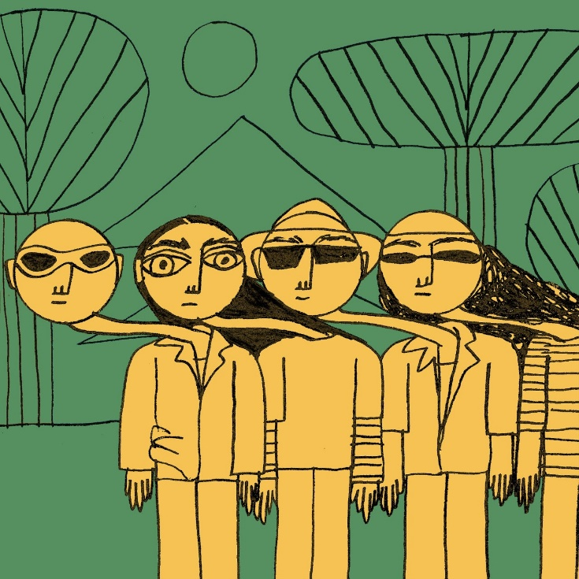
BULL
DECONSTRUCT SONGWRITING ON BRAND NEW SINGLE
‘BONZO PLEASE’

Listen Here
Watch Here

“They’re finding really Interesting ways to do these pop songs that I love” – Declan McKenna
“Alt-rock fans will love the mellow tones of Americana grunge mixed with nineties pop.” – Gigwise
“The four-piece are working towards ‘big things' with their easy-breezy take on lo-fi retro pop." – Dork
Already having a storming year, Bull today release ‘Bonzo Please’, their 3rd single with EMI Records/Young Thugs.

The song finds the band channelling discordant noise-pop vibes similar to the likes of Dinosaur Jr, No Age and Surfer Blood. Featuring fuzzed out guitars, ramshackle drums and a piano that sounds like it’s falling down a flight of stairs (in a good way), the band are venting a spot of songwriter angst, both musically and lyrically.
“’Bonzo Please’ is a song about writing songs, thinking that maybe you can’t be inspired by someone else and that by constantly staring at and comparing yourself to other people, you miss out on what you personally have to offer” vocalist, Tom beer explains.

“It’s also inspired by the modern day preoccupation with staring at your phone/T.V constantly watching other people and ‘entertainment’ and is a kick back against it, trying to shake my head up and break out of the hypnotic depression.”

The theme of inspiration also runs through the song’s video. The band wanted to make it truly collaborative and commissioned 50 pieces of artwork from 50 artists (friends and peers of the band, aged between 7 and 72) to provide a backdrop for a brilliant animation of the band created by Katy Daft. Each artist documented the progress of their piece and some of them have been highlighted in a brilliant photo montage.

Since signing to EMI records in conjunction with, York based label, Young Thugs the band have been growing apace. At radio the band are already being championed by the likes of Chris Hawkins and Steve Lamacq at 6Music, Huw Stephens at BBC Introducing Clara Amfo, as well as being acclaimed by fellow musicains like Elton John on his Beats 1 show and Declan McKenna during his recent appearance on the Radio 1 Future Artists mix tape.

Formed in 2011 by vocalist and songwriter Tom Beer and guitarist Dan Lucas, Bull’s mission is simply to make the music they wanted to listen to, inspired by their 90’s heroes such Pavement, Yo La Tengo and the Pixies. The rest of the band came together through a mix of friendships and happenstance. Drummer Tom Gabbatiss joined after he and Tom jammed together in bars while they were back-packing round Thailand, and Kai West had previously used to jump up on stage with the band and “Bez” (verb meaning to dance badly while intoxicated) before they eventually let him play bass.

A unique group within the city’s already eclectic scene, the band’s sound mixes together their alt-rock influences along with Tom’s down-to-earth song writing and a particularly wry sense of humour that comes naturally to the four Yorkshiremen.

They’ve played support shows for the likes of Squid, The Orielles, Pip Blom and even one of their long-time heroes in the form of Spiral Stairs (AKA Scott Kannberg of Pavement), and their constant gigging has seen them build up a dedicated local following. Not to be restricted to God’s own county, the band have plied their wares in mainland Europe, playing a series of unforgettable shows in Germany and the Netherlands.

Facebook // Instagram // Youtube
www.youngthugs.com

For more information, interviews etc please contact
Warren@chuffmedia.com on 07762 130510

