FLAWES ANNOUNCE A COLLECTION OF THREE BONUS TRACKS RELEASED ON JULY 24 VIA RED BULL RECORDS

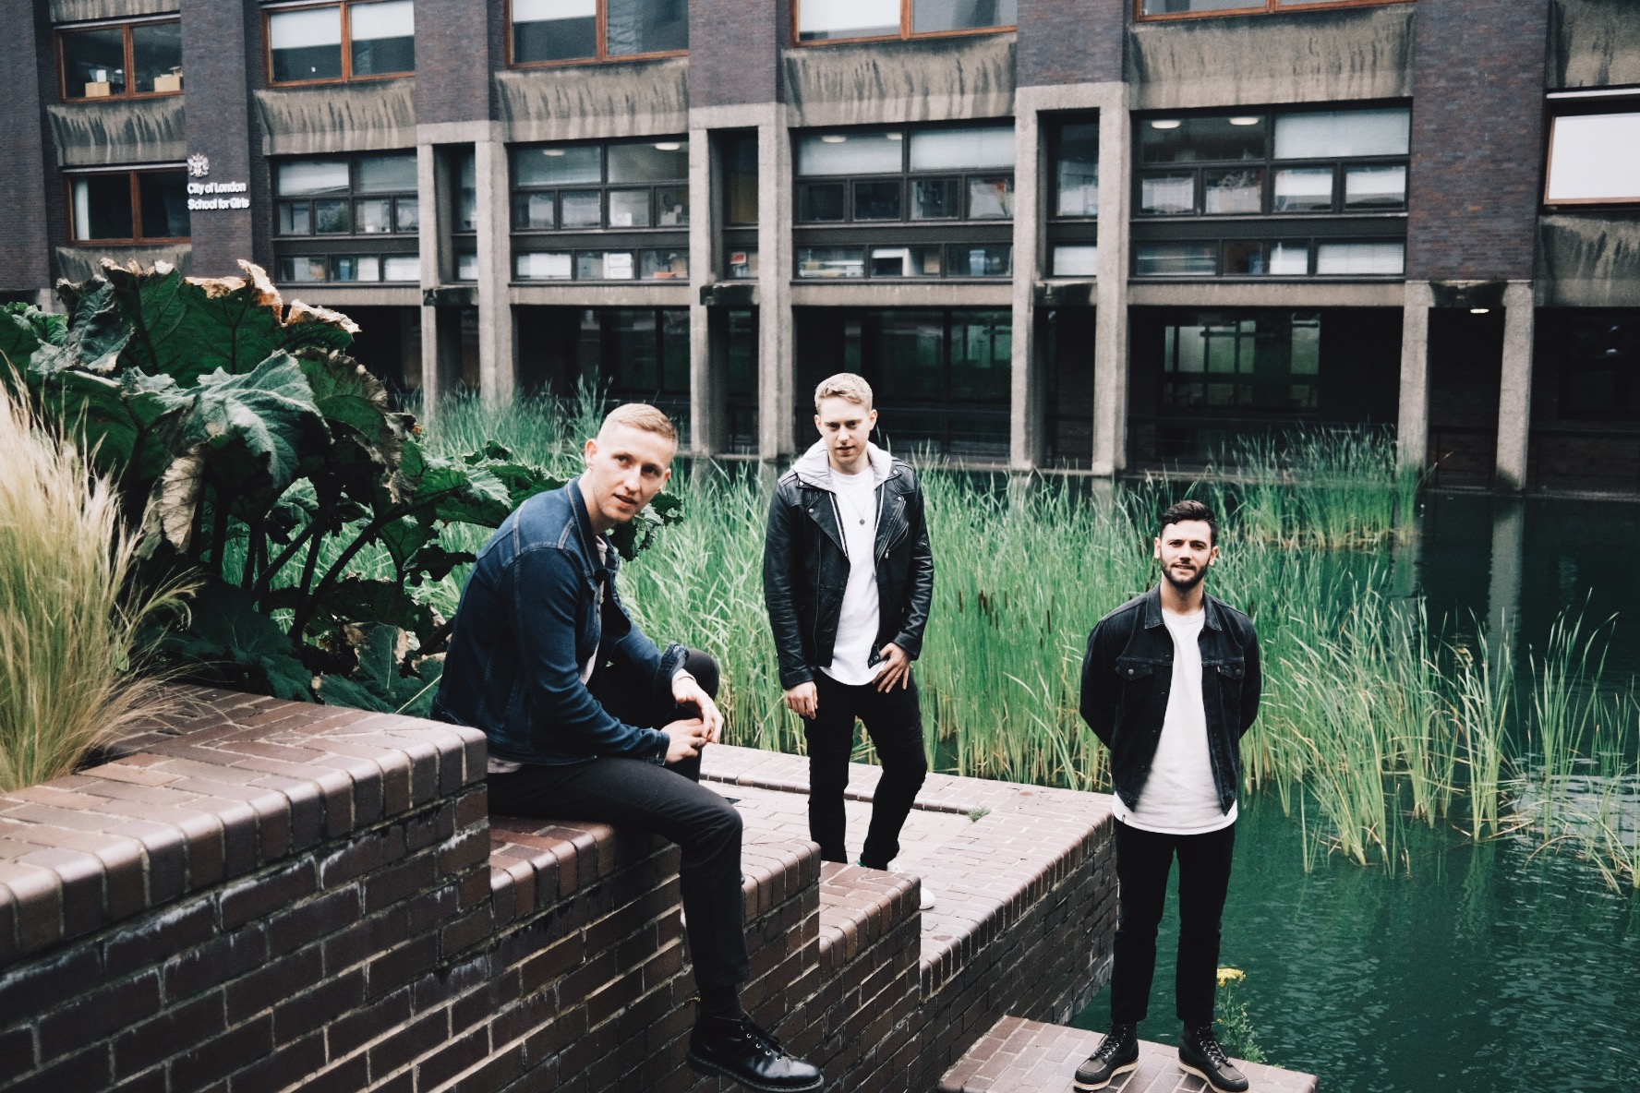

Flawes have announced the release of a collection of three previously unheard bonus tracks, which were recorded during the sessions for their debut album ‘Highlights’. The songs will be revealed on July 24 via Red Bull Records.

Far from falling quiet during global lockdown, the British trio have spent the last three months gaining new fans around the world. The band launched their own immensely popular Isolation Sessions series on YouTube, as well as performing livestream sessions for the likes of Red Bull Records’ inaugural Virtual Festival, Dork Magazine’s Homeschool Festival, Levi’s 501 Sessions and COVAID Africa Live. In addition, the band have been surprising and delighting their fans worldwide with direct Zoom calls.

The three bonus tracks ‘Number One’,‘I’m Letting Go’ and ‘Turn Back Around’ mark the closing of an exciting chapter for the band, who have been releasing music from ‘Highlights’ over the course of 18 months. These three tracks are a primer for the reveal of brand new music, which is set to come later in the year. The band will also take part in Record Store Day 2020 with some exclusive vinyl releases - more details to be announced.

Flawes said: “There were so many songs we still loved from the ‘Highlights’ album writing period that didn’t quite fit on the album so the three of us decided to each choose one song to form the ‘Highlights Bonus Tracks’.”

Singer JC has chosen ‘Number One’, he says: “For me ‘Number One’ was my obvious choice. It’s ultimately a break up song, a look back at a failed relationship and reminiscing ‘what could have been’. It takes a different structural approach to normal which I love, it’s almost like 2 songs glued together. It’s going to be a fun one to play live.”

Guitarist Freddie picked ‘I’m Letting Go’, explaining: “‘I’m Letting Go’ was one of the first songs recorded for Highlights, and for me, it marks a turning point for our sound. Before we wrote this one, the majority of our music was much more relaxed and downtempo. In hindsight it still feels like quite a slow song, but I remember how different it felt at the time!”

Drummer Huss selected ‘Turn Back Around’: “Listening to ‘Turn Back Around’ takes me right back to the first studio we started writing and producing music in... a basement in Notting Hill. That time is filled with lots of late nights and good memories. It’s a nice reminder of how far we’ve come since then. I also picked this song because my mum loves it” he explains.

London based Flawes famously received support from Radio 1 even before they’d performed live. After the two years touring that followed (including shows with Ella Eyre, Maximo Park, Francis and the lights, Chloe Howl and Safia), JC, Huss and Freddie took a step back, re-calibrated, and crafted the sound that would go on to define them.

Their debut album ‘Highlights’ is the musical embodiment of this; the band's sonic evolution over the years. The result is a collection of the very best of their bolder, sleeker and uplifting sound, tailor-made for both dancefloors and festival fields.

Follow Flawes:
https://www.facebook.com/FlawesBand/
https://twitter.com/Flawes
https://www.instagram.com/flawes/
https://open.spotify.com/artist/2x

For all press enquiries please contact:

Warren Higgins
warren@chuffmedia.com
020 8281 0989

