THE LAFONTAINES

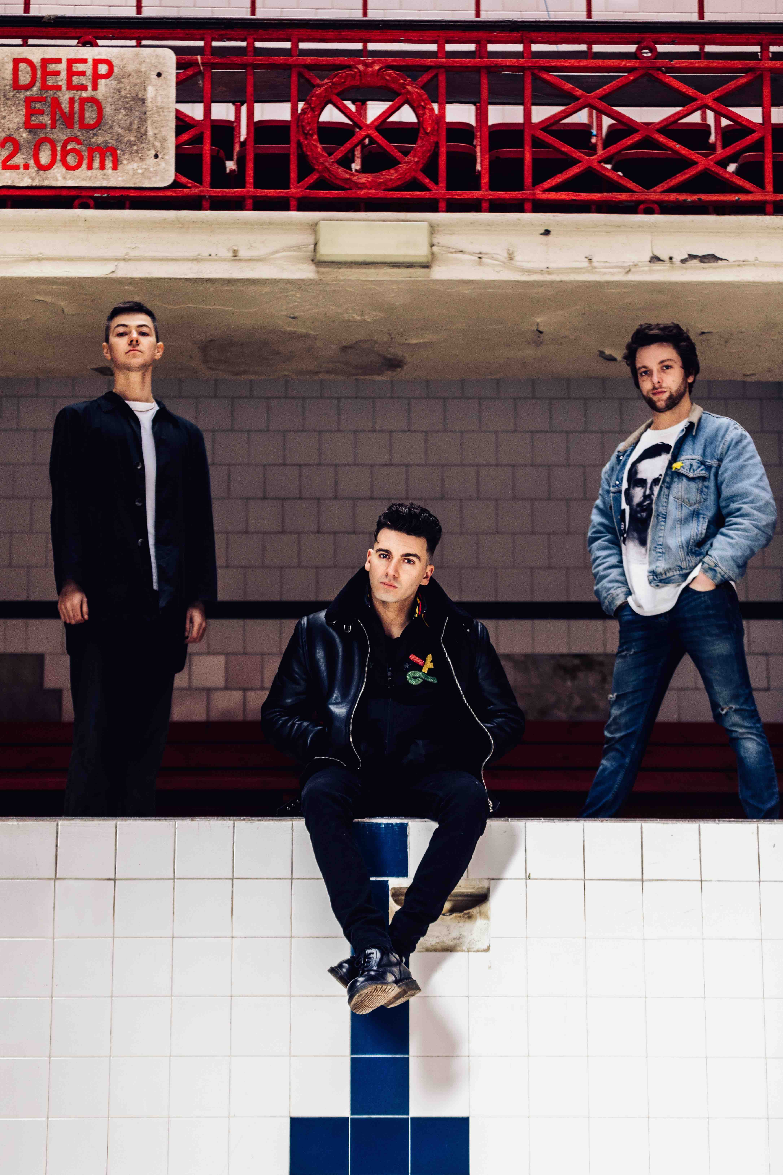

‘BODY’
NEW SINGLE OUT NOW
LISTEN HERE / WATCH HERE

JUNIOR
NEW ALBUM OUT THIS FRIDAY
VIA SO RECORDINGS

JUNE UK HEADLINE TOUR
PLAYING READING AND LEEDS

Scotland’s The LaFontaines have shared their new single, ‘Body’, the latest to be taken from their upcoming album Junior, out this Friday (June 14th) via So Recordings. Pre-order the album here.

Opening to a swaggering bassline, the track builds through verses driven by the expressive rap flow of frontman Kerr Okan into an anthemic combination of infectious vocals and explosive instrumentation, punctuated by huge, arena-sized choruses. To coincide with the release, the band have shared a stunning one take video, filmed at Park Lane Studios.

“Body was the last song we wrote for the record,” explains Okan. “It came as a result of listening to the album as a whole and thinking it needed one final song to complete the story of ‘Junior’. Daz is constantly producing music; he sent me the beat for ‘Body’ and I wrote to it that night in a wee office space somewhere south of Bellshill.

“From a lyrical point of view it’s one of the most personal songs I have ever written. The process of writing it forced me to dig deeper in terms of truth; it demanded I pull something from actual experience as opposed to imagination. I think that’s why in particular Body will leave a mark.“

“Cancel me cast me aside, I know your take on it,
An empty home, ironic I need space from it”

From opening for the legendary Mike Shinoda to winning over audiences countrywide during their UK tour supporting Deaf Havana earlier this year, The LaFontaines are showing no signs of slowing down.

The band also embark on a UK headline tour in June to support the release of their new album. Tickets for the tour are on sale now, and are available via The LaFontaine’s website - thelafontaines.co.uk/

Proving themselves one of the most exciting bands to emerge from Scotland in recent years, The LaFontaines deliver a unique sound that fuses the guitar swagger of Kasabian, the edgy hip-hop delivery of The Streets and the electronic-pop undertones of Twenty One Pilots to create a style that pushes the boundaries of rock.

Junior is the band’s third album and includes the previously released ‘All In’ and ‘Alpha’, which comes with a seamless ‘one take’ video recorded at Park Lane Studios and sees the band performing with finesse and ease. Watch it here.

Renowned for their electrifying live shows, the band have previously been on tour with Anderson .Paak, Twin Atlantic and All Time Low and last year were main support to Don Broco across the UK and Europe.

The band are no strangers to festival stages and will be returning to Reading & Leeds festival this year having also previously played Download, The Great Escape, 2000 Trees, T in the Park, Belladrum, NH7, Secret Garden Party, TRNSMT and Reeperbahn.

UK HEADLINE TOUR

Thurs 13th June – St Lukes Church, Glasgow *SOLD OUT*
Fri 14th June – King Tut’s Wah Wah Hut, Glasgow
Sat 15th June – Fat Sams, Dundee
Sun 16th June – Lemon Tree, Aberdeen
Mon 17th June – Caves, Edinburgh
Tue 18th June – O2 Institute, Birmingham
Wed 19th June – Camden Assembly, London *SOLD OUT*
Thurs 20th June – Night and Day, Manchester

For more information and press enquiries please contact:

Warren Higgins
warren@chuffmedia.com
020 8281 0989

