PALOMA FAITH
MAKES HER EAGERLY-ANTICIPATED RETURN
TO MUSIC WITH THE RELEASE OF HER NEW SINGLE
‘BETTER THAN THIS’
WATCH THE VIDEO HERE <INSERT LINK>

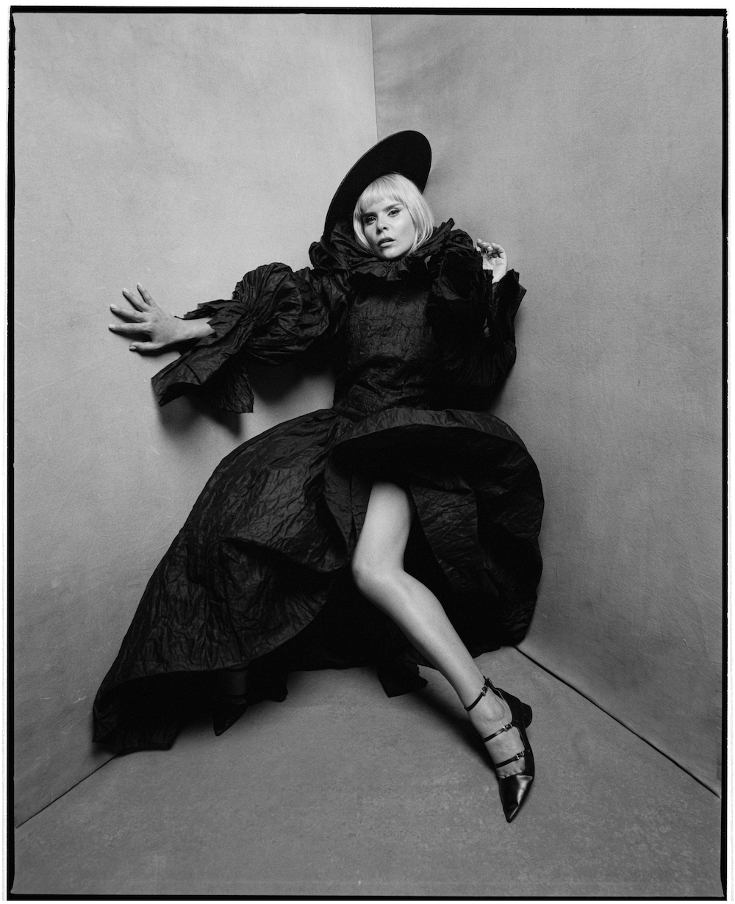

Paloma Faith makes her long-awaited return to music with the release of her brilliant new single, ‘Better Than This’ out today via RCA Records. The single premieres today alongside the stunning David Wilson directed music video.

Watch the video for ‘Better Than This’ here: <insert link>
Stream the single here: <insert link>

‘Better Than This’ sees Paloma return to where she belongs and entirely on her own terms, pulling back the curtain and unveiling what she has been so passionately creating over the last couple of months during lockdown.

The new single already has the feel of a career-defining moment for Paloma, pairing her intimate, rawly honest lyricism with a broader sense of acceptance, relationship and joy. The track effectively acknowledges those holes in our psyche that we try to fill with love and relationships. As Paloma herself puts it, “It’s love songs for people who are there to stay,” Faith says. “That enduring love. Warts and all. I don’t think I’ve ever heard a love song like that, actually.”

The video, also out today, was directed by David Wilson in Paloma’s hometown of Hackney. Shot in a single uncut take; the visual lays Paloma against a backdrop of vignettes of human error which historically continuously repeat. The video sees Paloma shine a light on prevalent issues including climate emergency, police brutality, class divide and the injustices of war. ‘Better Than This’ continues to showcase Paloma’s evolution as an artist.

Since the Covid-19 pandemic swept the world, Paloma spent her downtime creating, learning to produce and just thinking about the world. The enforced downtime was creatively fruitful and taught Paloma that, for most of her career, she’s been “a rat on a wheel” and finally had time to take stock of her frenetic career, and decided what was meaningful to her. Paloma is emerging from lockdown with a new sense of her priorities which has seen her reconnect with her roots.

This is a new Paloma Faith, a Paloma Faith who has retreated within herself and found not the careful, polished veteran of show business - but the 22-year-old art student being led by her own creativity.

Connect with Paloma Faith

Instagram | Twitter | FaceBook | YouTube

For more information and press enquiries please contact:
Warren Higgins
warren@chuffmedia.com
020 8281 0989

