THE LAFONTAINES
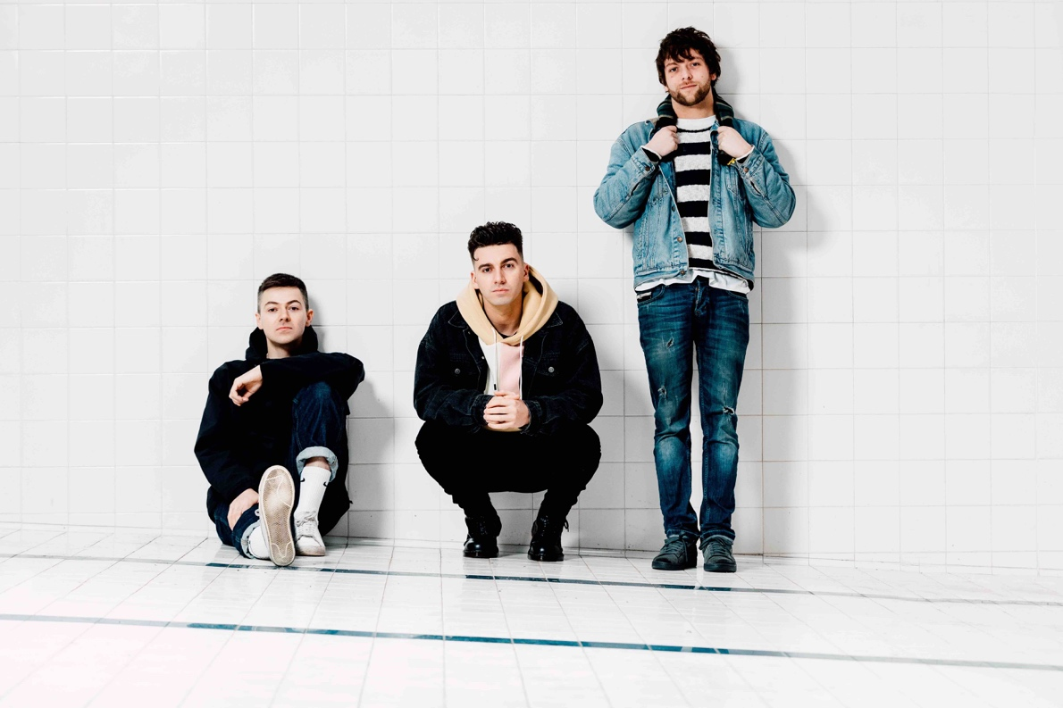
NEW SINGLE
‘ALPHA’
WATCH THE VIDEO HERE

NEW ALBUM
JUNIOR
OUT JUNE 14TH VIA SO RECORDINGS

JUNE UK HEADLINE TOUR
PLAYING READING AND LEEDS

The LaFontaines are just around the corner from the release of their new album, Junior, which will be out on June 14th via So Recordings (pre-order the album here). To whet your appetites further, the band have released the brand new single ‘Alpha’ along with a seamless ‘one take’ video recorded at Park Lane Studios, which sees the band performing with finesse and ease.

WATCH THE VIDEO HERE

Boasting groove-laden backbeats, a suave rap flow reminiscent of Mike Skinner and a gigantic pop chorus, ‘Alpha’ displays the band at their very best – melding genres together to deliver a powerful and awe-inspiring punch.

STREAM ‘ALPHA’ HERE

“’Alpha’ comes as result of the losses we’ve had recently in this area from young males, predominately of the ‘Alpha’ stereotype,” frontman Kerr Okan explains.

“I’ve often struggled with my emotions - anything other than aggression was always seen as a weakness and something that should be locked away. ‘Alpha’ marks the point in my own journey where I realised that there was something real to be gained from embracing the spectrum of emotions - whether you’re male or not.”

From opening for the legendary Mike Shinoda to winning over audiences countrywide during their UK tour supporting Deaf Havana earlier this year, The LaFontaines are showing no signs of slowing down.

The band also embark on a UK headline tour in June to support the release of their new album. Tickets for the tour are on sale now, and are available via the LaFontaines’ website - thelafontaines.co.uk/

Proving themselves one of the most exciting bands to emerge from Scotland in recent years, The LaFontaines deliver a unique sound that fuses the guitar swagger of Kasabian, the edgy hip-hop delivery of The Streets and the electronic-pop undertones of Twenty One Pilots to create a style that pushes the boundaries of rock.

Junior is the band’s third album and follows 2017’s Common Problem and their 2015 debut Class, which saw them hit #1 in the Indie Breakers Chart and make the Top 10 in the Scottish chart.

Renowned for their electrifying live shows, the band have previously been on tour with Anderson .Paak, Twin Atlantic and All Time Low and last year were main support to Don Broco across the UK and Europe.

The band are no strangers to festival stages and will be returning to Reading & Leeds festival this year having also previously played Download, The Great Escape, 2000 Trees, T in the Park, Belladrum, NH7, Secret Garden Party, TRNSMT and Reeperbahn.

UK HEADLINE TOUR
Thurs 13th June – St Lukes Church, Glasgow
Sat 15th June – Fat Sams, Dundee
Sun 16th June – Lemon Tree, Aberdeen
Mon 17th June – Caves, Edinburgh
Tue 18th June – O2 Institute, Birmingham
Wed 19th June – Camden Assembly, London
Thurs 20th June – Night and Day, Manchester

For more information and press enquiries please contact:

Warren Higgins or Charleigh Egan
firstname@chuffmedia.com
020 8281 0989

