APRE premiere new single, ‘5 to 5’
Listen here
Inhaler Tour, Headline shows + more confirmed
“Unapologetically huge...melds Tears for Fears and Foals to stirring effect" Sunday Times
“A humbling anthem…passionate yet refreshing indie-pop gold” The Line of Best Fit
"Frighteningly composed and confident for a band's first step" DIY
"Rich, perfectly produced…shrewd observational narratives." CLASH
“APRE mark themselves out as ones to watch” Dork

APRE return today with new single ‘5 To 5’, which is available now on Polydor Records. Having won over the festival circuit with sets ranging from Glastonbury, SXSW, Community Festival – and opened for the likes of Sam Fender, Lany and Sea Girls – the duo have confirmed an extensive tour alongside Inhaler from September into late October. The band have also announced an additional run of headline shows for February 2020, which include a date at London’s Scala on Feb 27th.
Uplifting but affecting, epic yet intimate, ‘5 To 5’ captures the duality that lies at the heart of APRE, and the brother-like kinship between Charlie and Jules. A band as inspired by the emotive pop of Tears for Fears as the alternative songwriting of Foals, beneath the shimmering surface of ‘5 to 5’ – like all APRE’s work to date – lies a darker truth…
‘5 to 5’ was written, according to the boys, “about the hardships of getting too comfortable within your own life, feeling low about your social position, and being trodden on by the governmental system time and time again. It describes the mundane, never changing lifestyle that so many of us find ourselves falling into. But it also seeks to find hope in understanding that when we all come together and support one another we can be far stronger than our individual parts.”
Across their trilogy of early EPs – and this summer’s standout single, ‘Come Down’ – APRE have emerged one of the UK’s most intriguing new bands. Twisting those most private moments into songs full of brains and heart, the band have quickly found an audience (in part through their outrageously-accomplished live show) that has taken them far beyond the unlikely origins of APRE: specifically a West London chess club, where a chance encounter led Charlie and Jules to start writing songs containing the sort of intimate sentiments they’d seldom voice in public.
If tracks like ‘5 to 5’ capture times of crisis (emotional, political, generational), part of what makes APRE interesting is the way they engage with the madness. Mixing shrewd lyrical storytelling with occasionally surreal touches, the results are transformed into something universal, positive, and affirming. It’s an attitude that’s gotten APRE this far – imagining a stadium where stands a chess club – and now looks set to take them a whole lot further.
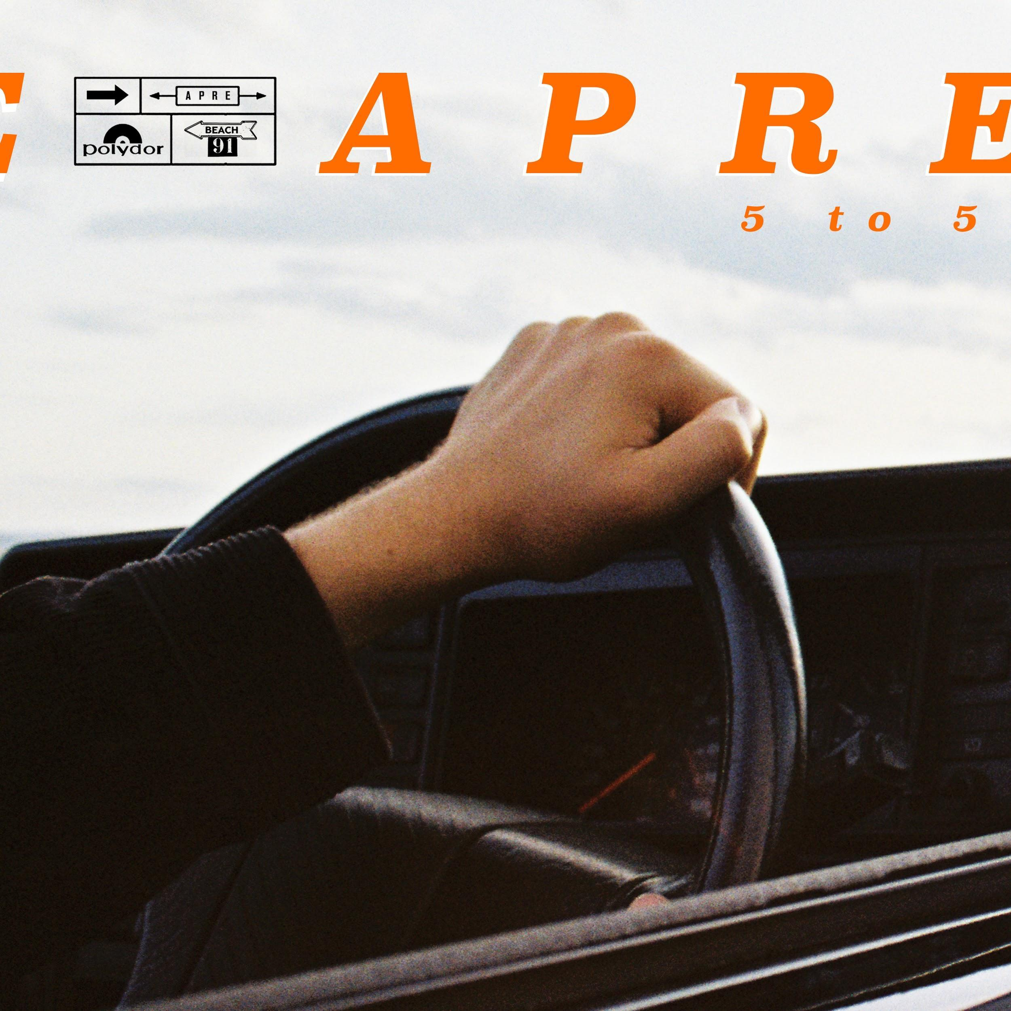

Live Dates:
17th Sept || Germany, Berlin || Auster-Club*
20th Sept || Germany, Cologne || MTC*
22nd Sept || Brussels, Belgium || Orangerie Botanique*
25th Sept || Cork, Ireland || Cyprus Avenue*
26th Sept || Galway, Ireland || Roisin Dubh*
27th Sept || Dublin, Ireland || Whelan’s*
28th Sept || Belfast, UK || Voodoo*
30th Sept || Glasgow, UK || King Tut's Wah Wah Hut*
1st Oct || Leeds, UK || Brudenell Social Club*
2nd Oct || Nottingham, UK || Rough Trade*
4th Oct || Leicester, UK || The Cookie*
6th Oct || Southampton, UK || Heartbreakers*
7th Oct || Brighton, UK || Komedia*
8th Oct || Norwich, UK || The Waterfront*
9th Oct || London, UK|| Camden Assembly*
11th Oct || Birmingham, UK || Castle & Falcon*
12th Oct || Glasgow, UK || Tenement Trail
13th Oct || Bristol, UK || The Exchange*
16th Oct || Paris, France || Le Point Ephemere*
25th Oct || Liverpool, UK || Arts Club*
26th Oct || Sheffield, UK || Plug*
27th Oct || Newcastle, UK || The Cluny*
11th Feb || Birmingham, UK || The Sunflower Lounge
12th Feb || Sheffield, UK || Record Junkee
13th Feb || York, UK || The Fulford Arms
14th Feb || Newcastle, UK ||Think Tank
15th Feb || Manchester, UK || Deaf Institute
17th Feb || Liverpool, UK || Phase One
19th Feb || Leeds, UK || Hyde Park Book Club
20th Feb || Cardiff, UK || Clwb Ifor Bach
21st Feb || Oxford, UK || The Bullingdon
22nd Feb || Bristol, UK || Louisiana
23rd Feb || Nottingham, UK || Bodega
25th Feb || Leicester, UK || The Cookie
26th Feb || Brighton, UK || Green Door Store
27th Feb || London, UK || Scala
* On tour with Inhaler

For more information and press enquiries please contact:

Simon Neal
simon@chuffmedia.com
020 8281 0989

