
RELEASE NEW SINGLE ‘FUCKED UP’ FEATURING
ROBBIE WILLIAMS
LISTEN HERE / WATCH HERE
FINAL PREVIEW OF THE BAND’S EIGHTH STUDIO ALBUM
‘IS THIS HOW HAPPINESS FEELS?’
RELEASED MAY 8TH ON DISTILLER RECORDS
ANNOUNCE UK HEADLINE TOUR IN NOVEMBER
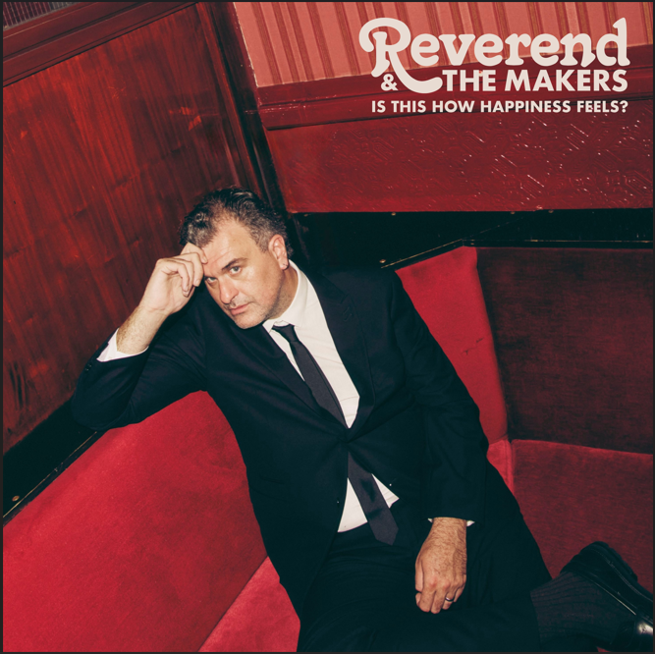
DOWNLOAD ALBUM ARTWORK
PRE-ORDER IS THIS HOW HAPPINESS FEELS? HERE

Reverend & The Makers today unveil their most high-profile collaboration to date: the new single ‘Fucked Up’, featuring Robbie Williams. Serving as the final release before the band drops their eighth studio album Is This How Happiness Feels on Distiller Records on May 8th, ‘Fucked Up’ is a lyrically stark duet ruminating on the perils of excess. The track finds frontman Jon McClure and Robbie Williams reflecting on the chaotic young years they endured in different decades—the noughties and 90s, respectively. Its release is accompanied by a video shot in the desert in Marrakech by director Charlie Lightening.
The collaboration was born after Robbie Williams took to social media to praise ‘You Again’ - the indie-pop thriller McClure co-wrote with Manchester’s Lottery Winners. He sent McClure a text: “Why have we never hung out?”
A friendship instantly formed, leading to Williams suggesting a collaboration. ‘Fucked Up’, written by McClure, emerged as the perfect vehicle for their combined experiences.
"We’d both been mad bastards," notes McClure, "and then you grow as a person, don’t you? Rob’s the soundest fella in the music game. A real pleasure to collab with him."
Reverend & The Makers recently joined Robbie Williams as special guests on his acclaimed ‘Long 90s’ UK tour dates. ‘Fucked Up’ acts as the final curtain-raiser for the band’s eighth studio album, set for release on May 8th. Following the Top 10 success of 2023’s Heatwave In The Cold North, the new 13-track record sees McClure at his most vulnerable and musically ambitious.
Last August, Reverend & The Makers marked two decades together with their most ambitious headline show yet—a massive homecoming set for 30,000 fans at Sheffield’s Rock N Roll Circus.
On the heels of last year’s sold-out run of intimate underplay gigs, the band has now announced a 13-date nationwide UK tour kicking off this November.

UK Live Tour Dates

Nov 11, Birmingham, O2 Institute
Nov 13, Glasgow, SWG3 TV Studio
Nov 14, Newcastle, Northumbria University SU
Nov 16, Leeds, Beckett SU
Nov 17, Cardiff, Tramshed
Nov 19, London, Electric Ballroom
Nov 20, Brighton, Chalk
Nov 21, Oxford, O2 Academy
Nov 23, Northampton, Roadmender
Nov 24, Norwich, Waterfront
Nov 26, Nottingham, Rock City
Nov 27, Manchester, Academy
Nov 28, Bristol, Electric

Is This How Happiness Feels was produced by Danny Lafrombé and Jon McClure and is the follow up to Reverend & The Makers Top 10 album Heatwave In The Cold North. The Sheffield five piece’s eagerly awaited new album is their most musically accomplished yet, merging vintage, sparkling, life-affirming soul with contemporary lyrical storytelling. “This album has been a labour of love owing to personal reasons but has emerged as a joyous triumph,” says frontman Jon McClure. “It’s easily the best thing we’ve ever done and will surprise a few people too.” The album features previously released singles ‘Late Night Phone Call’, ‘Haircut’ featuring Vicky McClure, ‘UFO’ and ‘Twenty-Seven Past Midnight’.
Reverend & The Makers’ seventh studio album, Heatwave In The Cold North hit No. 6 on the Official Charts in 2023, giving the band a remarkable unbroken streak of seven Top 20 albums to their name. This marked their first Top 10 album since their 2007 debut, The State of Things, which reached No. 5, and also delivered their biggest single in over a decade.
Reverend & The Makers are: Jon McClure (lead singer), Thomas Dibb (guitar), Laura McClure (keys/vocals), Antonia Pooles (bass), Adam Crofts (drums)

DOWNLOAD PRESS PHOTO (credit: Ed Cooke)

Connect with Reverend & The Makers
Website | TikTok | Facebook | X | Instagram | Youtube | Threads

For more info contact Warren Higgins
warren@chuffmedia.com

