UNDER EMBARGO UNTIL 00:01 MONDAY 2ND DECEMBER 2019

BBC Studios and FKP Scorpio present

SEVEN WORLDS ONE PLANET
LIVE IN CONCERT

The O2 Arena London
Sunday 24th May 2020

UK Premiere Performance

Stunning footage from the latest BBC Studios Natural History Unit television series
Music by Academy Oscar-winning composer Hans Zimmer and Jacob Shea
And featuring the original song ‘Out There’ by SIA
Performed by the City Of Prague Philharmonic Orchestra
Ticket presale on Wednesday, December 4th 2019

“Breath-taking, moving, harrowing – David Attenborough and the BBC play us like pianos – and at this point in the evolution of natural history TV, they are maestros. Prepare to weep.” ***** - The Guardian

“Out of this World! Is this the Beeb’s best wildlife show ever? This will be the BBC’s most visually magnificent wildlife series yet.” ***** - The Daily Mail

On May 24th 2020, the latest BBC Studios series ‘Seven Worlds, One Planet’, which has become BBC One’s most-watched factual TV show for 2019, will celebrate its UK premiere live concert performance at The O2 Arena in London. This spectacular one-off event will present the very best footage and music from the highly acclaimed television series.
When this landmark series, narrated by Sir David Attenborough, was first broadcast in the UK on October 27th 2019 it took viewers on an epic journey that not only celebrated the diversity of life on each of the seven continents, but also highlighted the many challenges faced by nature in a modern world dominated by humanity.

Seven Worlds, One Planet Live in Concert presents a selection of the most spectacular scenes from the television series displayed on a giant state of the art 4K Ultra HD LED screen. The series took a staggering 1,500 people over 4 years to make, including 92 film shoots across 41 countries.

Accompanying the footage on screen, the series hugely emotive score, written by Academy Award winner Hans Zimmer and Jacob Shea for Bleeding Fingers Music, will be performed by the renowned City Of Prague Philharmonic Orchestra. The score also features the series captivating song ‘Out There’, produced specifically for the series by Zimmer and the multi-award winning artist SIA.

Zimmer said, “Following up Planet Earth II and Blue Planet II was no easy task, but the BBC have outdone themselves yet again with the magnificent Seven Worlds, One Planet. It was a true honour to return to the series to compose the theme with Jacob Shea for Bleeding Fingers Music, and a special pleasure to collaborate with Sia for 'Out There'. These stories of nature are so important for us to show and preserve for future generations, and I am honoured to be a part of spreading this message. I am excited for everyone to get a chance to listen to the incredible score.”
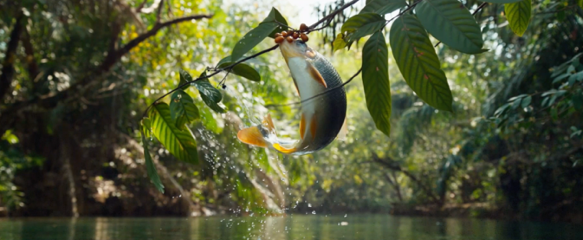
During the concert, the audience will be taken on a journey of discovery through the ‘seven worlds’ - from the colourful paradises of South America to Asia’s vast wilderness; from the unforgiving deep freeze of the Antarctic to the searing heat of Africa; from North America via Australia to wildlife closer to home in Europe.

The documentaries produced by BBC Studios Natural History Unit have inspired generations and helped shape people’s view of the planet. Featuring stunning, never-before-seen visuals, these programmes bring the miracles of the natural world to viewers all over the world, inspiring them to reflect on the power of our planet and have a positive, long-term influence on human behaviour.

The live concert format for these breathtaking television programmes has already proved hugely successful over the past two years, with over half a million UK & European fans having already attended concerts for the outstanding Planet Earth II and Blue Planet II series.

A ticket presale Seven Worlds, One Planet Live in Concert for O2 members will take place on Wednesday, December 4th 2019

Tickets will go on general sale at 9.00am on Friday, December 6th 2019, 9.00am, available from www.seven-worlds-one-planet-live.co.uk and www.axs.com

Event: Seven Worlds, One Planet – Live in Concert
Venue: The O2 Arena
Address: Peninsula Square, Greenwich Peninsula, London, SE10 0DX
Date/Time: Sunday, 24th May 2020
Tickets: £65/£55/£45
Website/Box Office: www.theo2.co.uk / 0844 856 0202; www.AXS.com

www.seven-worlds-one-planet-live.co.uk

For more information please contact Warren@chuffmedia.com on 020 8281 0989

