Planet Earth II
Live In Concert 2020
UK and Ireland Arena Tour

Hosted by Liz Bonnin

Music by Hans Zimmer, Jacob Shea & Jasha Klebe
For Bleeding Fingers Music

City Of Prague Philharmonic Orchestra, Conducted by Matthew Freeman

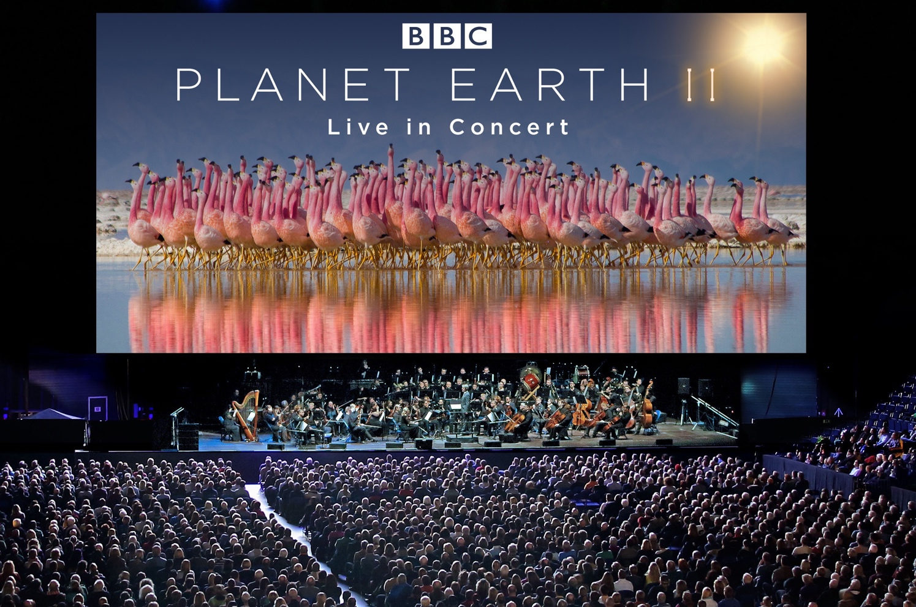

Planet Earth II Live in Concert, from BBC Studios and the acclaimed BBC Natural History Unit that created TV sensations, Blue Planet II and Dynasties, has announced a UK & Ireland arena tour for Spring 2020. Experience sensational footage from the BAFTA and EMMY® award winning BBC series which guarantees to bring audiences closer to the planet’s spellbinding animals, landscapes and wildlife dramas than ever before.

Following on from the recent success of the 2019 Blue Planet II Live In Concert tour, these not-to-be missed live concerts will feature breathtaking, specially-selected footage shown in 4K ultra high-definition on a gigantic LED screen, as the City Of Prague Philharmonic Orchestra, conducted by Matthew Freeman, play the remarkable music by Oscar winner Hans Zimmer, Jacob Shea & Jasha Klebe for Bleeding Fingers Music. The arena tour will run from 26th March through 4th April 2020 and includes a London Matinee show at 2.30pm on Sunday, 29th March.

Zimmer is renowned for his work on the likes of Gladiator, Interstellar and Blade Runner 2049, but said that the landmark BBC series stood out amongst his work. “Planet Earth II is one of the most amazing things I’ve ever been involved in: some of the greatest action scenes ever put on film, some of the most emotional, epic, fragile scenes I’ve ever witnessed. Filmmaking at its absolute peak.”

In this spectacular, audiences across the UK get to rub shoulders with our acrobatic primate cousins in the steaming jungles of Madagascar, race alongside fearsome hunting lions in the remote sandy deserts of Namibia, face stormy Antarctic seas with a family of penguins and feel the raw tension as a baby iguana tries to escape the clutches of deadly racer snakes. And they will no doubt tap their toes along with dancing grizzly bears and be swept away by the bravery of a mother snow leopard.

The Planet Earth II Live in Concert arena tour will be hosted by science and natural history TV presenter Liz Bonnin. With a masters in wild animal biology, Liz has presented over 40 primetime programmes including Blue Planet Live, Super Smart Animals, Galapagos and Horizon.

With her recent landmark BBC One documentary Drowning in Plastic, Liz investigated the ocean plastic crisis, with her hard-hitting environmental reporting raising the level of public debate on this important topic. Liz also regularly speaks at and hosts science and natural history events across the country, including the National Science + Engineering Competition, the Natural History Museum’s Wildlife Photographer of the Year Awards, New Scientist Live and Blue Dot Festival.

Looking ahead to the tour, Liz said, “I am so honoured to have the role of host on the Planet Earth II Live in Concert arena tour. The TV series included some absolutely breathtaking sequences - who can ever forget the marine iguana fighting for its life as it escaped those racer snakes? I will be just as thrilled as the audience to relive such magnificent scenes on the giant screen, accompanied by a spectacular 80-piece orchestra - it will certainly be an experience to remember!”
Mat Way, Global Director, Live Entertainment, BBC Studios, adds, “After the very successful Blue Planet II tour we are delighted to partner with FKP Scorpio once again and bring Planet Earth II Live In Concert to the UK & Irish arenas, an incredible production bringing the BBC’s ground breaking footage to the stage for fans to enjoy.”

To watch the trailer for Planet Earth II Live in Concert click here.

The dates for Planet Earth II Live in Concert are as follows:

The dates for Planet Earth II Live in Concert are as follows:

Thu 26th March Cardiff Motorpoint Arena Tickets
Fri 27th March Manchester Manchester Arena Tickets
Sat 28th March Leeds First Direct Arena Tickets
Sun 29th March London O2 Arena (MATINEE) Tickets
Sun 29th March London O2 Arena (EVENING) Tickets
Wed 1st April Dublin 3Arena Tickets
Fri 3rd April Birmingham Resort World Arena Tickets
Sat 4th April Glasgow SSE Hydro Arena Tickets

Ticket presale for O2 members will take place on Wednesday 12th June.
Ticket presale through all other tour venues will take place from 10.00am on Thursday, 13th June

Tickets go on general sale at 10.00am on Friday 14th June. All Children under -14 entitled to a £10 discount per ticket (Excluding London Evening and Dublin show).

Available from http://www.planetearth2live.uk

For interviews with Liz Bonnin and further information
please contact Warren@chuffmedia.com on 020 8281 0989

PLANET EARTH II – LIVE IN CONCERT

WEBSITE | INSTAGRAM | YOUTUBE | TWITTER | FACEBOOK

Listings info:

Event: Planet Earth II – Live in Concert
Venue: Motorpoint Arena
Address: Mary Ann St, Cardiff, CF10 2EQ
Date/Time: Thursday, 26th March / Show starts 7.30pm
Tickets: (£45/£55)
Website/Box Office: www.motorpointarenacardiff.co.uk / 029 2022 4488

Event: Planet Earth II – Live in Concert
Venue: Manchester Arena
Address: Victoria Station Approach, Hunts Bank, Manchester, M3 1AR
Date/Time: Friday, 27th March / Show starts 7.30pm
Tickets: (£40/£50/£60)
Website/Box Office: www.manchester-arena.com / 0844 847 8000

Event: Planet Earth II – Live in Concert
Venue: First Direct Arena
Address: Arena Way, Leeds, LS2 8BY
Date/Time: Saturday, 28th March / Show starts 7.30pm
Tickets: (£45/£55)
Website/Box Office: www.firstdirectarena.com / 0844 248 1585

Event: Planet Earth II – Live in Concert
Venue: O2 Arena
Address: Peninsula Square, Greenwich Peninsula, London, SE10 0DX
Date/Time: Sunday, 29th March / Show starts 2.30pm
Tickets: (£40/£50/£60)
Website/Box Office: www.theo2.co.uk / 0844 856 0202; www.AXS.com

Event: Planet Earth II – Live in Concert
Venue: O2 Arena
Address: Peninsula Square, Greenwich Peninsula, London, SE10 0DX
Date/Time: Sunday, 29th March / Show starts 7.30pm
Tickets: (£40/£50/£60)
Website/Box Office: www.theo2.co.uk / 0844 856 0202; www.AXS.com

Event: Planet Earth II – Live in Concert
Venue: 3Arena
Address: N Wall Quay, North Dock, Dublin
Date/Time: Wed 1st April / Show starts 7.30pm
Tickets: (€40/€50/€60)
Website/Box Office: www.3arena.ie / www.ticketmaster.ie
ROI: 0818 719 300 / UK & NI: 0844 8472 455

Event: Planet Earth II – Live in Concert
Venue: Resort World Arena
Address: Pendigo Way, Marston Green, Birmingham, B40 1PU
Date/Time: Friday, 3rd April / Show starts 7.30pm
Tickets: (£40/£50/£60)
Website/Box Office: www.resortsworldarena.co.uk / 0121 780 4141; www.theticketfactory.co.uk

Event: Planet Earth II – Live in Concert
Venue: SSE Hydro Arena
Address: The SSE Hydro, Glasgow, G3 8YW
Date/Time: Saturday, 4th April / Show starts 7.30pm
Tickets: (£40/£50/£60)
Website/Box Office: www.thessehydro.com / 0844 395 4000

ABOUT BBC STUDIOS
BBC Studios, a global content company with British creativity at its heart, is a commercial subsidiary of the BBC Group. Formed in April 2018 by the merger of BBC Worldwide and BBC Studios, it spans content financing, development, production, sales, branded services and ancillaries. BBC Studios’ award-winning British programmes are internationally recognised across a broad range of genres and specialisms. It has offices in 22 markets globally, including six production bases in the UK and production bases and partnerships in a further nine countries around the world. The company, which makes 2500 hours of content a year, is a champion for British creativity around the world and a committed partner for the UK’s independent sector. BBC Studios has revenue of £1.4bn, and returns around £200m to the BBC Group annually, complementing the BBC’s licence fee and enhancing programmes for UK audiences.

bbcstudios.com
twitter.com/bbcstudios
twitter.com/bbcstudiospress

ABOUT BLEEDING FINGERS MUSIC
Emmy and BAFTA nominated Bleeding Fingers Music is an established creative force in the world of music for visual media. The collaboration-led composer collective has been entrusted with elevating many iconic projects, highlighte by Fox’s “The Simpsons”, and BBC’s “Planet Earth II” and “Blue Planet II”. The team has also become a reliable music source for many networks and studios, such as Netflix, National Geographic, History, A&E, Sony Pictures and Dreamscape VR.Bleeding Fingers has assembled a diversely talented collective of exceptional composers, providing them with a state-of-the-art environment that encourages creativity, experimentation and collaboration. The team hails from eight countries and their diverse styles, influences and backgrounds come together to give our music a wide ranging appeal. The team has also found innovative ways to bring mainstream musicians into the scoring world, collaborating with artists such as Radiohead, Sia and X Ambassadors.

Twenty state-of-the-art studios based on Hans Zimmer’s world renowned campus and a best-in-class-production team allow Bleeding Fingers the ability to produce music at the very highest standard. Bleeding Fingers has created original music for productions including: BLUE PLANET II (BBC), PLANET EARTH II (BBC), SEVEN WORLDS (BBC), THE SIMPSONS (Fox), SUPERFLY (Sony Pictures), PRINCESS DIANA, IN HER OWN WORDS (Nat Geo), DOPE (Netflix), ALIEN ZOO (Dreamscape), THE PLANETS (Nat Geo), AMERICAN PLAYBOY (Amazon), ROMAN EMPIRE (Netflix), BARBARIANS RISING (History), THE WORLD WARS (History), BIG CATS (BBC), SNATCH (Crackle), THE MAKING OF THE MOB (AMC), SAVAGE KINGDOM (Nat Geo), INTERVENTION (A&E), MASTERCHEF (Fox) and 13 MINUTES TO THE MOON (BBC Podcast)

