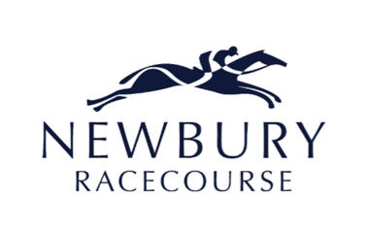
Announces
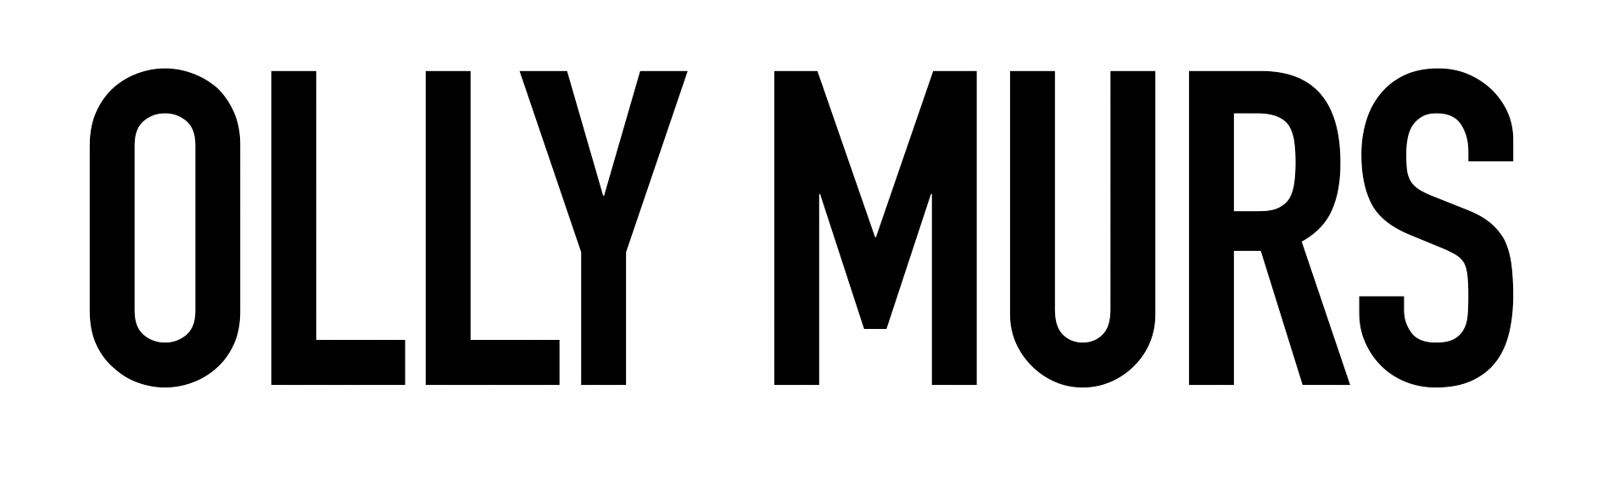
PARTY IN THE PADDOCK
SATURDAY 14TH AUGUST 2021

Part of 2021 Summer UK Outdoor Tour
25 date tour starts June 5th in Swansea

Olly Murs today announces a huge 25 date UK tour for next summer. With much of 2020 coming to a standstill due to the Covid-19 pandemic, next year’s outdoor shows aim to put a smile back on the face of the country where he will perform his biggest hits, including tracks from his recently certified triple platinum album ‘Never Been Better’.
It’s still been a busy year for Olly, who recently captained England in this year's Soccer Aid, and is looking to retain his crown as winning judge on his third series of The Voice, which has currently been postponed at the semi final stages. In lockdown, he also managed an impressive body transformation, working closely with personal trainer Rob Solly, and sharing his fitness routine exclusively with Men’s Health. He is also working on new music to be shared next year.
Olly Murs is no stranger to Newbury Racecourse having performed on Party in the Paddock Stage on two previous occasions. He first performed at the racecourse as part of the 2010 X Factor Party In The Paddock event before returning as a solo artist in 2017 to perform in front of a sell-out crowd.
Harriet Collins, Director of Marcomms for Newbury Racecourse commented: “We all need something to look forward to next summer and are really excited to announce that Olly Murs will return to the Party in the Paddock stage here at Newbury Racecourse next August to perform live after racing. Last here in 2017, Olly performed to a fantastic crowd of over 21,000 and we remain hopeful that we will be able to welcome similar numbers back here next summer after what has been a very challenging year for us all. Here at Newbury, we remain focussed on ensuring we can provide our customers with a safe and fun environment to return to as soon as we are allowed.”
Tickets will be on general sale at 9am on Friday 9th October via newburyracecourse.co.uk, with a presale available to customers at 9am on Thursday 8th October.

Prices:

Premier: £60 / Advanced Saver: £54
Grandstand: £45 / Advanced Saver: £40.50
Hospitality and Dining packages starting from £149
All T&C’s are available on newburyracecourse.co.uk.

For more details and tickets visit newburyracecourse.co.uk or call 01635 40015.

For all media information, including previews, interviews, reviews etc for
Olly Murs at Newbury Racecourse, contact Warren or Charleigh at Chuff Media
tel. 020 8281 0989 name@chuffmedia.com

About Music Plus Sport
Music Plus Sport is an innovative music promoter specialising in large-scale concerts at sport venues & events. Since its beginnings in 2013, Music Plus Sport has successfully promoted over 130 concerts attended by 1.2 million music and sport fans across the UK.
Music Plus Sport operates a number of live music brands including the hugely successful The Jockey Club Live venture, as well as summer events at Motor Sport Circuits, Rugby Stadiums and Cricket Grounds.

About Newbury Racecourse

Newbury Racecourse held its first race in 1905 and has long been one of Britain's leading tracks, staging up to 30 days of top class Jump and Flat racing annually, with at least one race day in every month of the year.

The Racecourse is also a thriving events venue, hosting a huge range of activities including weddings, concerts, and conferences for 20 to 1,000 attendees for a wide spectrum of businesses and organisations in stunning surroundings. In addition, it runs a successful private nursery, providing a safe, happy and stimulating learning environment for many pre-school children.

Newbury is now home to a major housing development by David Wilson Homes, allowing people to live in a unique location alongside a world-renowned sporting venue, which also benefits from a Nuffield Health Club.

The £20-million 'heartspace' redevelopment of the Racecourse, which began in 2016, is now complete and has delivered improved customer experiences in all enclosures.

