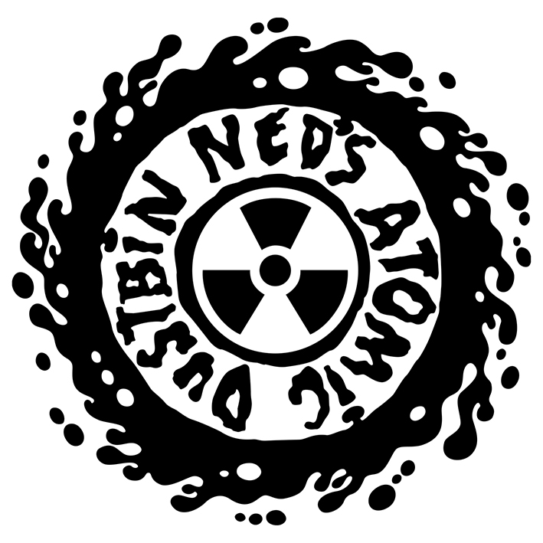
NED’S ATOMIC DUSTBIN ANNOUNCE SPECIAL 30TH ANNIVERSARY ‘INGREDIENTS 30’ SHOWS
Returning to where it all began, NED’S ATOMIC DUSTBIN have announced two special shows at Stourbridge Town Hall for this coming December, with two at London Dingwalls the week prior.

It has been over 30 years since Ned’s Atomic Dustbin recorded their debut release, The Ingredients EP, just a few hundred yards from Stourbridge Town Hall. Although reunited since 2008, this will be the first time the original 5-member line-up have played in Stourbridge since 1988 and the first time they have played Dingwalls, their first London headline and sell-out, since 1990.

Friday 27th November - London Dingwalls
Saturday 28th November - London Dingwalls
Friday 4th December - Stourbridge Town Hall
Saturday 5th December - Stourbridge Town Hall

Singer Jonn Penney says:
"Looks like we're finally coming home! 30 years since we released The Ingredients EP we're finally going to get to play the songs in Stourbridge. It's a homecoming that has been a long time coming (and Rat will probably remind us all again that he's from Sedgley not Stourbridge!) but I think 30 years is long enough to leave it. We can't wait to play the town hall - it'll feel like a new venue to us because it's been such a long time!"

Released in April 1990, The Ingredients EP was the first of three releases by the band for Birmingham based Chapter 22 Records. Songs from this EP were instrumental in claiming their earliest UK audiences and subsequently a global audience that added up to a million album sales. Arguably most significant is ‘Grey Cell Green’ which won over fans on early UK tours with The Wonder Stuff, Pop Will Eat Itself and Jesus Jones. On release of their debut album ‘God Fodder’, ‘Grey Cell Green’ became a hit on US college radio and gained rotation on MTV helping the band crack the States

"It seems so weird now to think that we wrote Grey Cell Green so early on - we were still just boys and we had no idea that we would ever even release a record at the time. That particular song seems to have defined us well before our 'hits' like Kill Your Television, Happy and Intact got written."

Along with fellow Stourbridge bands Pop Will Eat Itself and The Wonder Stuff, Ned’s Atomic Dustbin were part of the ‘Stourbridge’ scene that emerged in the late 80’s. The band’s twin bass guitar line-up gave them a distinctive sound that quickly enabled them to build up a live reputation across the globe, earning top spots at festivals such as Glastonbury and Reading.

In April 1990, as national media were beginning to take notice, their first taste of television came in the form of an interview for a show called ‘Transmission’ after soundcheck at their first London headline show at Dingwalls in Camden Town. The interview captured the excitement and unease of the band just before the EPs release, with no idea if they would
sink or swim. Their fears unfounded the bands ascent into the UK music scene was underway and, with three Indie-chart-topping records under their belts, they signed to Sony Music and notched up appearances on Top Of The Pops and The Word then after three albums and a final show in New York, the band called it a day in 1995.

So, in 2020 Ned’s Atomic Dustbin will be playing the London shows first, before returning home back to their roots – the reverse of their emergence in 1990!

The band are promising a different set each night in London and in Stourbridge to include all tracks from ‘The Ingredients EP’ interspersed with tracks from throughout their catalogue.

50 limited-edition show-specific t-shirt and ticket packages will be available for each show – first come, first served!

Tickets will be onsale 9am Thursday 9th April

Presale 9am Tuesday 7th April
(including ltd edition Tee bundles)
https://www.seetickets.com/tour/ned-s-atomic-dustbin?pre=nadpre

General admission £25 + booking fee
Ltd edition T-Shirt bundle £50 + booking fee
(Limited to 50 per show)

Friday 27th November - London Dingwalls
https://www.seetickets.com/event/ned-s-atomic-dustbin/dingwalls-camden/1525095
Saturday 28th November - London Dingwalls
https://www.seetickets.com/event/ned-s-atomic-dustbin/dingwalls-camden/1525109
Friday 4th December - Stourbridge Town Hall
https://www.seetickets.com/event/ned-s-atomic-dustbin/stourbridge-town-hall/1525113
Saturday 5th December - Stourbridge Town Hall
https://www.seetickets.com/event/ned-s-atomic-dustbin/stourbridge-town-hall/1525122

For more information and press enquiries please contact:

Warren Higgins
warren@chuffmedia.com
020 8281 0989

