3X GRAMMY® WINNER OLIVIA RODRIGO UNVEILS NEW VIDEO, “GET HIM BACK!” – VIEW HERE

SONG IS FROM THE MULTI-PLATINUM SINGER/SONGWRITER’S NEW ALBUM, GUTS, OUT NOW

RODRIGO WILL PERFORM TONIGHT AT 2023 VMAS

September 12, 2023 – Santa Monica, CA – Today, multi-Platinum-selling, three-time GRAMMY®-winner Olivia Rodrigo shared the official video for “get him back!” – the new focus track from her acclaimed sophomore album, GUTS. View HERE.

Pitchfork singled out “get him back!” as a highlight from GUTS, which was released last week via Geffen Records. The New York Times hailed the track as a “playful, infectious and dryly hilarious singalong” while The Atlantic called it “fantastic.”

Directed by Jack Begert (Dominic Fike, Kendrick Lamar, Vince Staples) of production company Psycho Films, and lensed in Los Angeles by director of photography Xiaolong Liu (Beyoncé, Rosalia, Billie Eilish, Travis Scott), the fast-paced video captures the reckless energy of the song and explores the double meaning of the phrase “get him back.” Multiple versions of Olivia are seen—some consumed with exacting revenge on an ex and others dreaming up ways to win him back.

The fast-paced visuals using the crash zoom technique were achieved with the new 5x Telephoto camera on iPhone 15 Pro Max. iPhone 15 Pro models feature powerful camera upgrades that enable the equivalent of seven pro lenses, with incredible image and video quality. With the new USB-C connector, creators and filmmakers can enjoy the benefits of new pro workflows like ProRes recording directly to an external drive up to 4K 60fps. And iPhone 15 Pro now enables Log encoding, offering more range and flexibility for visual effects and color grading in post production. It’s also the first smartphone in the world to support ACES — Academy Color Encoding System — a global color standard for major movie productions.
Rodrigo will perform at tonight’s VMA ceremony, airing at 8PM ET/PT. Her official video for “vampire,” which was directed by Petra Collins, is nominated for six VMAs: Video of the Year, Song of the Year, Best Pop, Best Cinematography, Best Editing, and Song of the Summer.

The first single from GUTS, “vampire,” debuted at No. 1 on the Billboard Hot 100, set the Spotify record for the biggest debut for a solo song in 2023, and ultimately shot to No. 1 at U.S. Top 40 Radio and on the UK Official Singles Chart. Hailed as an “instant classic” by Rolling Stone, the follow-up to Rodrigo’s 4x Platinum, chart-topping 2021 full-length debut SOUR, GUTS was produced by her frequent collaborator Daniel Nigro and partly created at the legendary Electric Lady Studios in New York City. The album is a major leap forward in both the unbridled honesty of Rodrigo’s songwriting and the bold originality of her sound. GUTS is available to stream/download HERE.

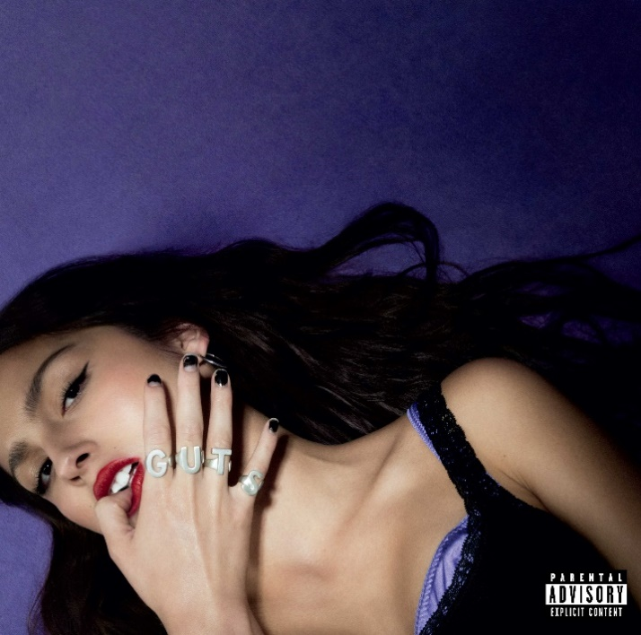
Download cover artwork HERE

# # #

For more information and press enquiries please contact

Jenny Entwistle
Jenny@chuffmedia.com

