RESCHEDULED 2021 SHOWS PLUS ADDITIONAL DATES DUE TO DEMAND

FIREDANCELIVE.CO.UK

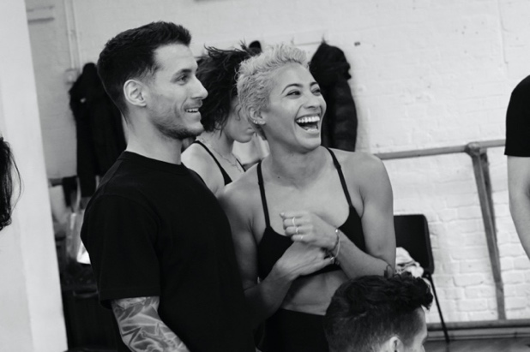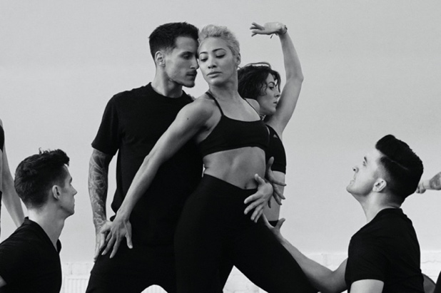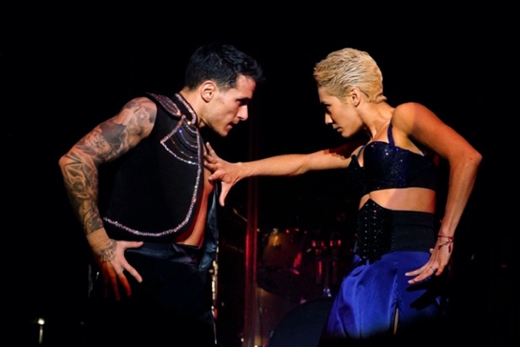

Two Latin dancers from rival Houses meet at The Festival of Fire. Full of passion, bravado and rhythm, when their eyes lock there is an instant connection. Through a mix of Latin, Commercial and Contemporary dance, eclectic musical styles and hypnotic rhythms, we see a passionate affair unfold.

Raymond Gubbay & Kilimanjaro Live are delighted that Strictly Come Dancing’s Karen Hauer and Gorka Marquez are to return in 2021 with their Latin spectacular FIREDANCE. Having completed a handful of the original shows prior to the tour being halted due to the current health crisis, Karen and Gorka will be turning the heat up once again with rescheduled dates in Spring 2021; in addition, they have added a host of new shows due to phenomenal demand including a landmark date at London’s Royal Festival Hall on Friday 26th February.

With an incredible live band featuring Latin musicians and a dynamic dance ensemble performing Argentine Tango, Flamenco, Contemporary, Paso Doble, Samba and Salsa, audiences can expect a captivating show of fresh and exciting dance from two of the world’s finest. The constraints of the ballroom are thrown off, making way for hot pulsing beats, seductive choreography and passionate performances that will take your breath away. Featuring iconic songs such as In the Air Tonight, Sway, Bad Romance, Sweet Dreams, Relight My Fire, Bamboleo and many more.

The making of the production was recently documented in an in-depth BBC Four programme ‘Danceworks – Firedance: Latin Fever’, showcasing the intricacy, skill and astonishing physical demand behind the show produced jointly by Raymond Gubbay & Kilimanjaro Live. Detailing the creative process from rehearsal to behind the scenes of the opening nights, it gives an insight into Karen and Gorka’s sheer technical ability and passion for the discipline, pushing the boundaries of what is known of Latin dance. Watch here.

Stuart Galbraith (CEO Kilimanjaro Live) and Anthony Findlay (CEO Raymond Gubbay Ltd) who jointly produce the show and tour said, “FIREDANCE is an exciting, contemporary, breath-taking spectacle and we’re really proud to have been involved in the creation and production of such an innovative and visually stunning show. It’s great that it’s coming back in 2021 as the public reaction to it earlier this year was so fantastic. We worked very hard to rearrange the dates that had to be postponed, are returning to many venues for a second show and we’ve added some brand new ones to the tour list as well so that even more people can have the opportunity to see and enjoy the jaw-dropping skills of Karen and Gorka”

FIREDANCE is back for 2021 and is the hottest ticket in town.

Karen said, “I can’t wait to bring FIREDANCE on Tour across the UK in 2021. The passion, warmth and excitement from the audiences who saw it in 2020 was absolutely incredible and I know the whole FIREDANCE team can’t wait to be back onstage very soon”

Born in Venezuela and having grown up in New York from the age of 10, Karen Hauer is most known for dancing on BBC’s Strictly Come Dancing. Joining the series in 2012 she has been partnered with household names including Westlife's Nicky Byrne, The ‘Hairy Biker’ Dave Myers, Mark Wright, Jeremy Vine, Will Young, and Sunday Brunch chef Simon Rimmer. In 2019 Karen reached the semi-finals of the series with comedian Chris Ramsey.

Karen has an amazing presence on stage and is one of the most expressive and charismatic dancers on the current dance scene. Able to express emotion through each and every movement right through to her fingertips, Karen takes choreographed routines to new heights and she has that rare talent to attract the eye of every audience member whenever she dances.

Gorka said, "I had such a great time on the FIREDANCE tour; the audience, Karen, our fellow dancers and team made it a truly memorable experience so the bar has been set for 2021. I can't wait to return."

Gorka’s flair for dancing started from a very young age. Originally from Bilbao, Spain, aged 11 he attended Ballroom and Latin dance classes where he quickly excelled and became one of the top dancers representing Spain across the world.

Most famously known for his appearance on BBC’s Strictly Come Dancing, Gorka Marquez has continuously displayed outstanding talent and charisma in the 2016, 2017 and 2018 series. His debut saw him paired with EastEnders star Tameka Empson. In 2018 he was partnered with TV star Katie Piper after having waltzed Alexandra Burke to the final the previous year.

FEBRUARY 2021
Thursday 25th New Theatre, Peterborough 7:30pm*
Friday 26th Royal Festival Hall, London 7:30pm – ON SALE SOON
Saturday 27th Wycombe Swan, High Wycombe 7:30pm

MARCH 2021
Tuesday 2nd Corn Exchange, Cambridge 7:30pm*
Thursday 4th Alhambra Theatre, Dunfermline 7:30pm*
Friday 5th Royal Concert Hall, Glasgow 7:30pm*
Monday 8th Pavilion, Bournemouth 7:30pm*
Tuesday 9th Royal & Derngate, Northampton 7:30pm*
Wednesday 10th G Live, Guildford 7:30pm
Thursday 11th Orchard Theatre, Dartford 7:30pm*
Friday 12th Cliffs Pavilion, Southend 7:30pm*
Sunday 14th Auditorium, Grimsby 3pm*
Wednesday 17th The Hexagon, Reading 7:30pm
Thursday 18th The Anvil, Basingstoke 7:30pm
Saturday 20th The Bridgewater Hall, Manchester 7:30pm
Sunday 21st St. David's Hall, Cardiff 3pm
*Rescheduled March 2020 shows

Tickets available from firedancelive.co.uk

For more information please contact
Warren@chuffmedia.com on 020 8281 0989 / 07762 130 510

