FLAWES ANNOUNCE RELEASE OF ‘LOWLIGHTS’ EP - OUT MAY 13 VIA RED BULL RECORDS

REVEAL ‘LOOK NO FURTHER’ LOWLIGHTS VIDEO

WATCH HERE

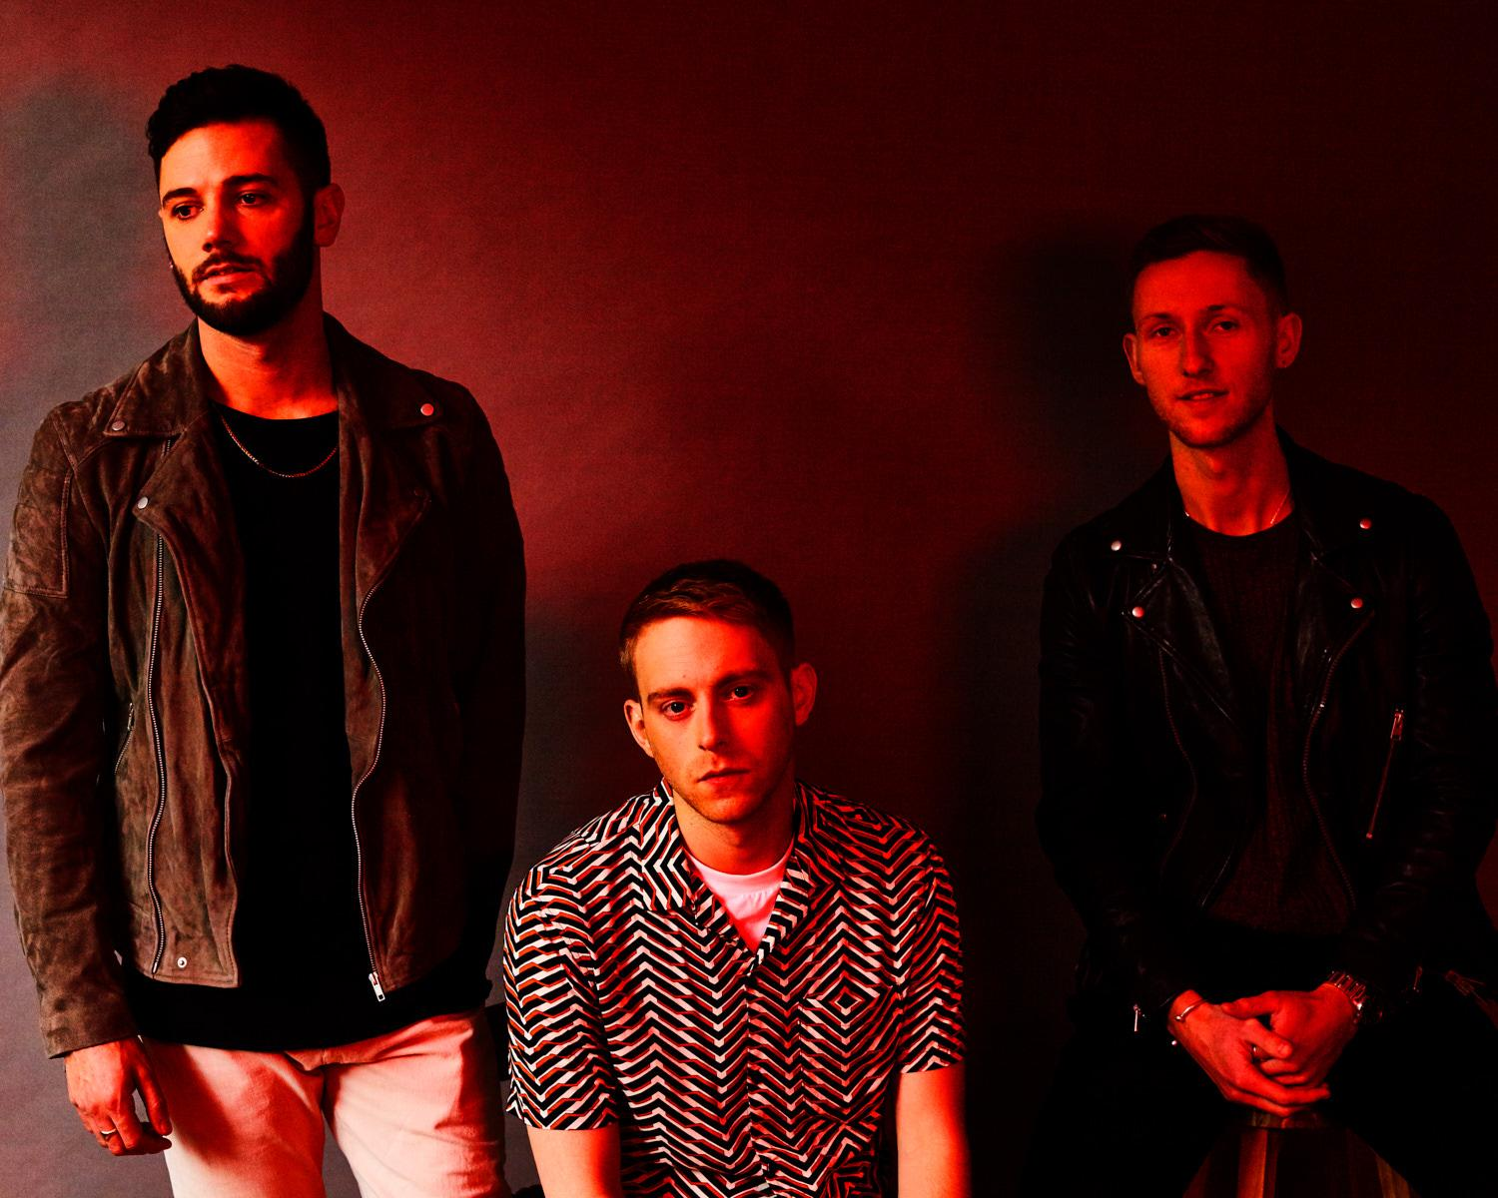

Following the release of their debut album ‘Highlights’ earlier this year, British alt-pop trio Flawes announce ‘Lowlights’ - an EP of four songs taken from the album, and stripped back to their rawest form. The EP is released via Red Bull Records on May 13.

The band have also unveiled a video of the ‘Lowlights’ version of one of their most anthemic songs ‘Look No Further’, the intimate recording revealing the intricacies and emotion of the track.

Flawes performed as part of the inaugural Red Bull Records Virtual Festival last weekend, joining label-mates Beartooth and The Aces among others. Their lockdown-filmed performance can be re-streamed here.

Known for their polished production, and huge awe-inspiring live performances, ‘Lowlights’ gives the listener an opportunity to get to know the band on a much deeper level. In addition, undeterred by lockdown, the band have been recording and releasing a series of impressive ‘isolation sessions’, with each member performing remotely from their own home. Watch the sessions on their YouTube channel here.

“‘Lowlights’ is a selection of songs from our debut album that have been stripped right down to their bare bones. We love to create a huge wall of sound when playing live, so to mix things up we decided to challenge ourselves and take the complete opposite approach” explain the band “The songs are so exposed, there’s almost nowhere to hide. ‘Don’t Count Me Out’ in particular is literally just a piano and vocal, taking the song right back to where it started life.”

The band recorded the EP at Red Bull Studios in London, and some of the performances were recorded and left totally live for the final EP.

In what has been an exciting 3 years for the London based band, Flawes famously received support from Radio 1 even before they’d performed live. After the two years touring that followed (including shows with Ella Eyre, Maximo Park, Francis and the lights, Chloe Howl and Safia), JC, Huss and Freddie took a step back, re-calibrated, and crafted the sound that would go on to define them.

Their debut album ‘Highlights’ is the musical embodiment of this; the band's sonic evolution over the years. The result is a collection of the very best of their bolder, sleeker and uplifting sound, tailor-made for both dancefloors and festival fields.

The band are currently working on brand new songs with more releases to be announced later this year.

‘Lowlights’ Track Listing:

Here To Stay
Don’t Count Me Out
When We Were Young
Look No Further

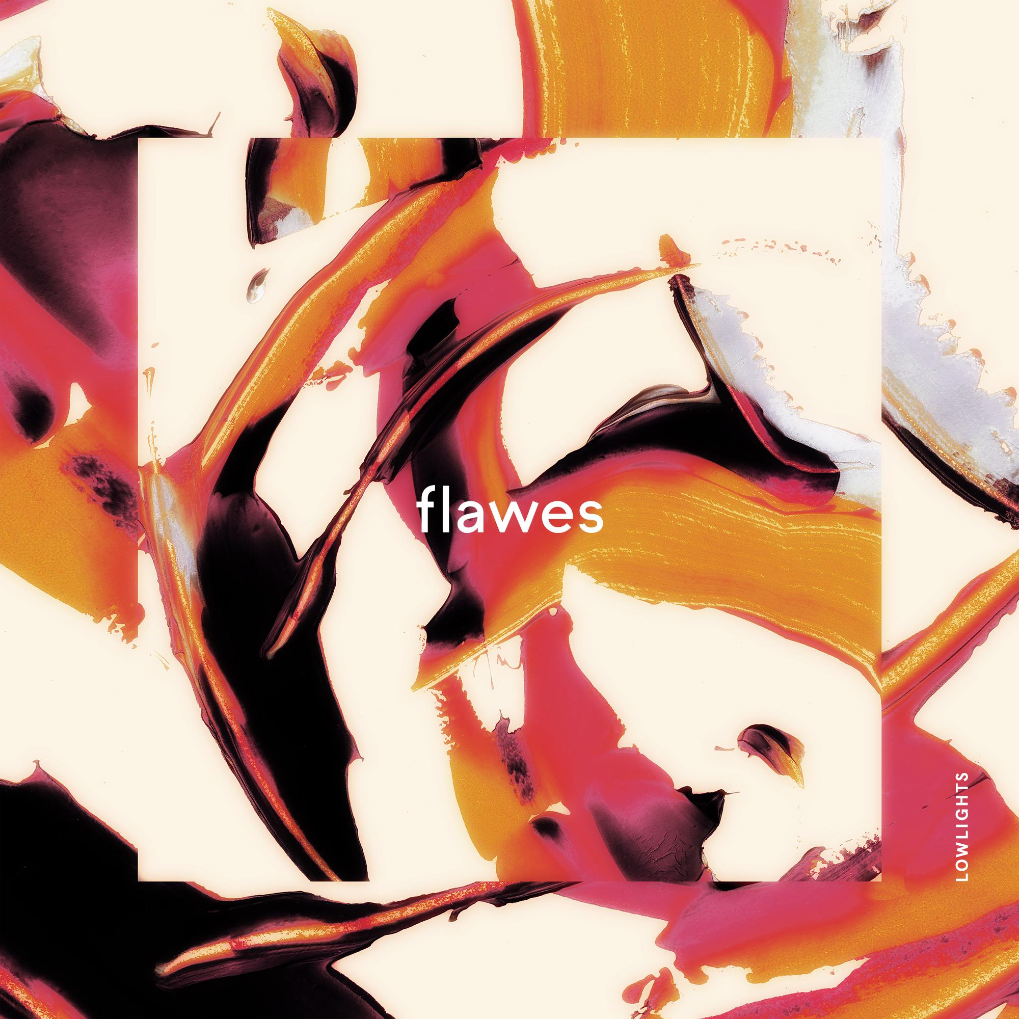

Follow Flawes:
https://www.facebook.com/FlawesBand/
https://twitter.com/Flawes
https://www.instagram.com/flawes/
https://open.spotify.com/artist/2x

For all press enquiries please contact:

Warren Higgins
warren@chuffmedia.com
020 8281 0989

