BULL RELEASE THE ‘LOVE GOO EP’
THE YORK BAND CAP OFF 2020 WITH THEIR FIRST EP WITH EMI RECORDS IN CONJUNCTION WITH YOUNG THUGS
Listen Here / Watch Here
“They’re finding really Interesting ways to do these pop songs that I love” – Declan McKenna
“Alt-rock fans will love the mellow tones of Americana grunge mixed with nineties pop.” – Gigwise
“The four-piece are working towards ‘big things' with their easy-breezy take on lo-fi retro pop." – Dork
York based alt-rockers, Bull are back with ‘Love Goo’ the title track for their new EP, also out now on EMI Records in conjunction with Young Thugs.
‘Love Goo’ is another example of Bull’s ability to combine sweet pop melodies with a core of ramshackle jangle rock. Laced with spritely xaphoon lines (a kind of pocket saxophone), tin whistle, and piano it’s a brilliant slice of indie maximalism.
“Love Goo is a song about getting along with people" Tom explains. “It looks at my relationship with my family as well as my own feelings of 'sticky love goo', when thinking about people in my life and from my childhood. It’s about the difference between people, universal truth, gender fluidity, peace & love, understanding and all of that stuff”
The Love Goo EP comes at the end of a stellar year for the band and compiles the 3 singles they’ve released in 2020, alongside ‘Love Goo’. Including the catchy as hell fuzz-rock of ‘Disco Living’, the Noisey pop of ‘Bonzo Please’ and the summery vibes of ‘Green’, it’s a brilliant portrait of the band and their music.
Since signing to EMI records in conjunction with, York based label, Young Thugs the band have been growing apace. At radio the band are already being championed by the likes of Chris Hawkins and Steve Lamacq at 6Music, Huw Stephens at BBC Introducing Clara Amfo, as well as being acclaimed by fellow musicians like Elton John on his Beats 1 show and Declan McKenna during his recent appearance on the Radio 1 Future Artists mix tape.
Formed in 2011 by vocalist and songwriter Tom Beer and guitarist Dan Lucas, Bull’s mission is simply to make the

music they wanted to listen to, inspired by their 90’s heroes such Pavement, Yo La Tengo and the Pixies. The rest of the band came together through a mix of friendships and happenstance. Drummer Tom Gabbatiss joined after he and Tom jammed together in bars while they were back-packing round Thailand, and Kai West had previously used to jump up on stage with the band and “Bez” (verb meaning to dance badly while intoxicated) before they eventually let him play bass.
A unique group within the city’s already eclectic scene, the band’s sound mixes together their alt-rock influences along with Tom’s down-to-earth song writing and a particularly wry sense of humour that comes naturally to the four Yorkshiremen.
They’ve played support shows for the likes of Squid, The Orielles, Pip Blom and even one of their long-time heroes in the form of Spiral Stairs (AKA Scott Kannberg of Pavement), and their constant gigging has seen them build up a dedicated local following. Not to be restricted to God’s own county, the band have plied their wares in mainland Europe, playing a series of unforgettable shows in Germany and the Netherlands.
The band will also be played a special live streamed gig on the 16th December. The Snow Global tour will be a paid for stream coming from a special winter wonderland location. Each ticket not only guarantees access to the stream, but fans will also receive a special screen-printed t-shirt or poster to commemorate the occasion.
More details here
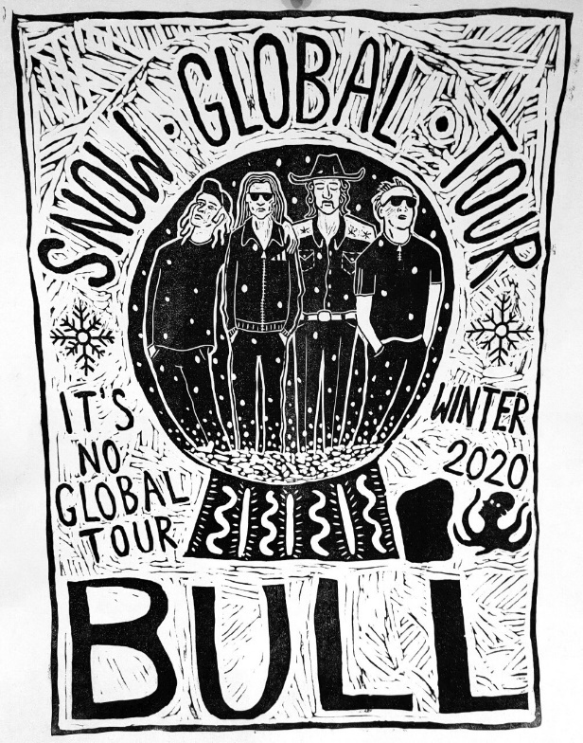
For More Info
Facebook // Instagram // Youtube
www.youngthugs.com

For all media enquiries please contact Warren @chuffmedia.com on 07762 130510

