‘The Art Of Closure ‘
New mini-album out now
(Polydor)

Listen to new single 99% HERE

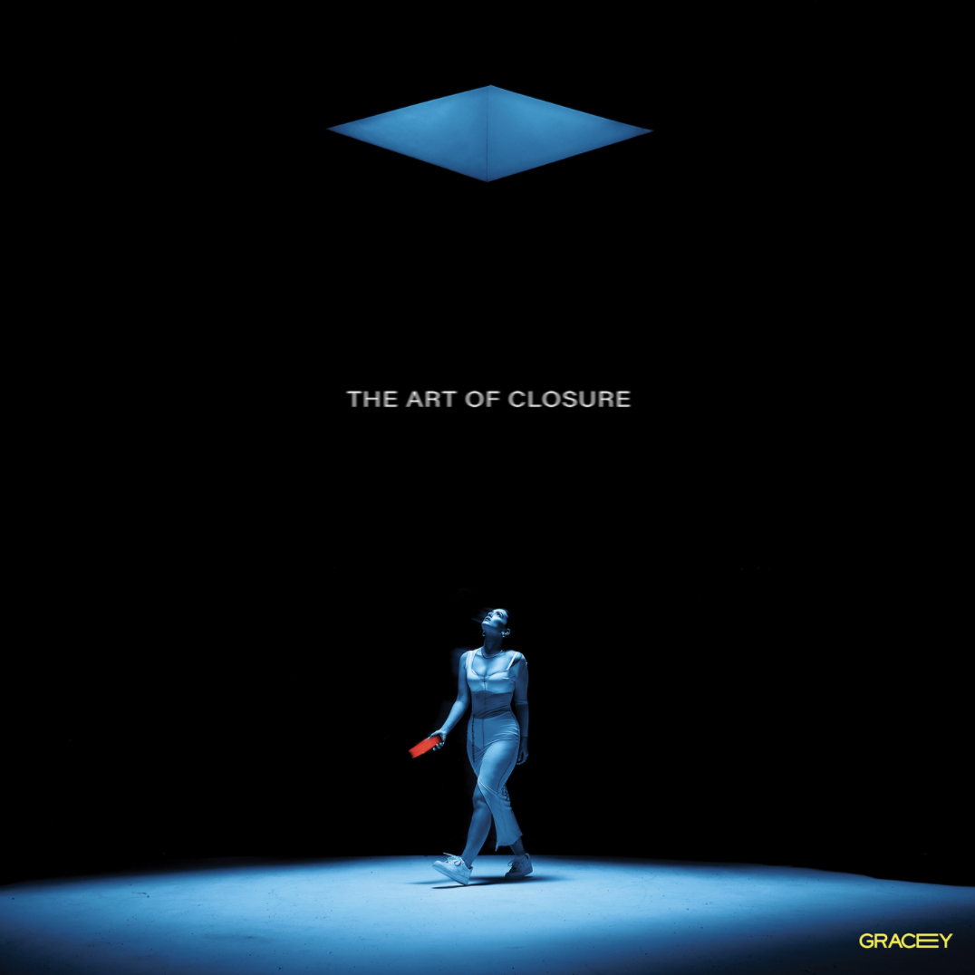

“All shimmering space-pop balladry” The Guardian
“Ethereal alt-pop” Wonderland
“Songwriter extraordinaire” i-D
“Stunning alt-pop” Sunday Times Culture
“Gloriously gutsy alt-pop cut hints at potential for further greatness.” The Line Of Best Fit
“She’s mega” The FACE
"Total pop legend" Popjustice
“The voice of lockdown” Evening Standard

Today GRACEY - the unstoppable new voice in UK pop – releases her brand new mini-album ‘The Art Of Closure’ into

the world. The mini-album comes with brand new single ‘99%’ which is also out today on Polydor.

2020 has seen GRACEY confidently emerge as one of the most talked about and successful new British artists. Not only has she released a string of brilliantly relatable and catchy-as-hell pop gems (including most recent single ‘Like That’ which currently sits comfortably on the Radio 1 playlist) but the 22-year-old Brighton born star has become a household name by scoring her first ever Top 10 single in the UK charts and on TikTok, where her single ‘Alone In My Room (Gone)’ became a certified lockdown anthem.

As a result, GRACEY’s new mini-album ‘The Art Of Closure’ is the sound of this fiercely talented new popstar firmly in control of her ascent, celebrating everything she has achieved so far and looking forward to her brilliantly beckoning future. Between its astounding 6 tracks lies a story of vulnerability at its most powerful as GRACEY sits inquisitively and assuredly in her own relatable feelings and explores how you can protect yourself – from yourself, your heart, social media and life spent increasingly in the spotlight.

Simultaneously, the outrageously good ‘99%’ steps up as GRACEY’s new single. Lying at the very core of ‘The Art Of Closure’, 99% is GRACEY’s biggest and most assertive release yet, finding the 22-year-old singer and songwriter in full control of new-relationship proceedings, armed with a pop top-line that, just liked herself, is destined for inevitable greatness.

On writing ‘The Art Of Closure’ GRACEY says – “I’m so excited for my mini album to be out in the world! Throughout the process of writing these songs I found I started to understand myself better, not only as an artist, but as a person. The lyrics are honest and upfront (a lot of them formed from shower thoughts of things I wish I had said) and I’d like to think there’s power in their truthfulness. ‘The Art of Closure’ is my journey towards ending toxic habits and gaining closure from past behaviours and relationships.

‘99%’ is extra special as it was actually one of the first song’s I wrote for myself. I instantly knew it had to stay with me and it’s acted as a pillar to build my sound around ever since. It marks the end of one chapter and a little nod to the next! I hope you enjoy.”

‘The Art Of Closure’ track list -

99%
Empty Love (ft. Ruel)
Don’t
Like That (with Alexander 23)
Care Less
Alone In My Room (Gone)
220 KID & GRACEY – Don’t Need Love

LISTEN TO ‘THE ART OF CLOSURE’ HERE / STREAM ‘99%’ HERE

Follow GRACEY :
Facebook / Instagram / Spotify

For more info contact warren@chuffmedia.com on 07762 130510

