boygenius
release critically acclaimed debut album the record
and premiere ‘boygenius: the film’ directed by Kristen Stewart

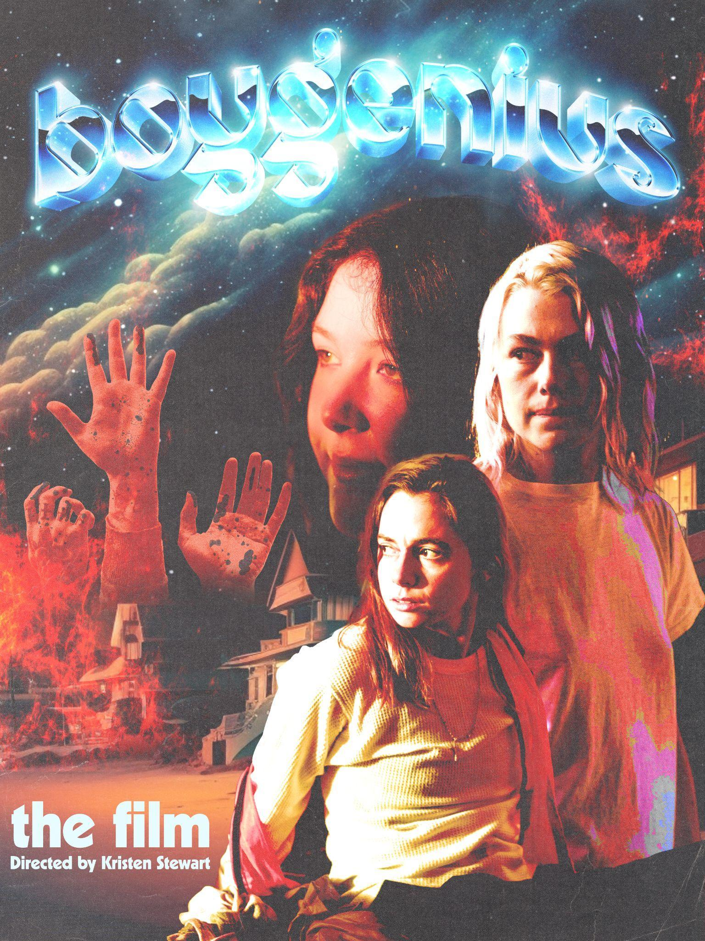
(download hi-res HERE)

"The instant classic we were hoping for" - NME, ★★★★★
“A spectacular debut” - Independent ★★★★★
"The intense collaboration and deep mutual admiration between Julien Baker, Phoebe Bridgers and Lucy Dacus is plain in every song” - Evening Standard ★★★★★
"they are better because of each other… it’s no mean feat given their statuses as three of the best songwriters around" - DIY ★★★★★
"On ‘the record’, boygenius come together for something that is nothing short of seismic. Ambitious and inimitable, their first debut album is an earth-shattering feat” - Dork ★★★★★
"a debut album for the ages” - The Forty Five ★★★★★

Today, acclaimed trio boygenius (Julien Baker, Phoebe Bridgers, Lucy Dacus) have released their highly anticipated debut album the record via Polydor/Interscope Records to critical acclaim. A short film directed by Kristen Stewart via Black Dog Films, the film, set to the first three singles ‘$20’, ‘Emily I’m Sorry’, and ‘True Blue’, also premiered today on MTV Live, MTVU, MTV Biggest Pop and across MTV’s global network of channels, as well as on the Paramount Times Square billboards. The band made an appearance for an official screening and Q&A last night at Los Angeles’ El Rey Theatre.

The film was directed by Academy Award-nominated actor/director Kristen Stewart and guides the viewer through three vignettes that highlight the band’s close and intimate bond.

boygenius announced their long awaited debut album, the record, in January and made global headlines with their Nirvana-nodding cover of February’s Rolling Stone magazine. Latest single ‘Not Strong Enough’ premiered as Hottest Record on BBC Radio 1, and arrived alongside a candid video self-shot by the band and edited by Jackson Bridgers. Following their surprised SXSW sets at Austin Airport baggage claim, boygenius will perform at this year’s Coachella Music Festival on Saturday, April 15th and Saturday, April 22nd in addition to headlining the inaugural Re:Set Concert Series with stops in Los Angeles, New York, Chicago and more, before heading out on a newly announced headline US tour and then over to the UK and Europe, where in August they will play a landmark date at London’s Gunnersbury Park (with support from MUNA and Ethel Cain) and two dates at Halifax’s historic The Piece Hall. The band also recently announced two special acoustic shows in association with Banquet Records, which sold out in seconds.

WATCH THE FILM HERE
STREAM/PURCHASE ‘the record’ HERE

NORTH AMERICAN TOUR DATES:
April 12 - Pomona, CA @ Fox Theater
April 15 - Indio, CA - Coachella Music & Arts Festival
April 22 - Indio, CA - Coachella Music & Arts Festival
June 2 - San Diego, CA - Thrive Park at Snapdragon Stadium !
June 3 - Los Angeles, CA - Brookside at the Rosebowl !
June 4 - Stanford, CA - Frost Amphitheater at Stanford !
June 6 - Phoenix, AZ - Arizona Financial Theatre *
June 8 - Houston, TX - White Oak Music Hall *
June 9 - Dallas, TX - Texas Trust CU Theater Grounds !
June 10 - New Orleans, LA - City Park !
June 11 - Atlanta, GA - Central Park !
June 13 - Asheville, NC @ ExploreAsheville.com Arena *
June 14 - Wilmington, NC @ Live Oak Bank Pavilion *
June 16 - Columbia, MD - Merriweather Post Pavilion !
June 17 - New York, NY - Forest Hills Stadium !
June 18 - Boston, MA - The Stage at Suffolk Downs !
June 20 - Pittsburgh, PA @ Stage AE +
June 21 - Toronto, ON @ Budweiser Stage ^+
June 23 - Columbus, OH - Kemba Live! Festival !
June 24 - Chicago, IL - Riis Park !
June 25 - Nashville, TN - Centennial Park !
July 28 - Vancouver, BC @ PNE Amphitheater % =
July 29 - George, WA @ The Gorge Amphitheater % =
July 30 - Bend, OR @ Hayden Homes Amphitheater % =
August 1 - Bonner, MT @ Kettlehouse Amphitheater =
August 2 - Boise, ID @ Outlaw Field at the Idaho Botanical Garden =
August 3 - Salt Lake City, UT @ Library Square =
August 5 - Morrison, CO @ Red Rocks Amphitheatre =

! Re:SET Concert Series with Clairo, Dijon, and Bartees Strange
* Support from Bartees Strange
^ Support from Broken Social Scene
% Support from Carly Rae Jepsen
+ Support from Claud
= Support from Illuminati Hotties

UK & EUROPEAN DATES
August 11 - Oslo, NO @ Øya Festival
August 12 - Gothenburg, SE - Way Out West
August 13 - Copenhagen, DK - KB Hallen &
August 15 - Berlin, DE - Verti Music Hall &
August 16 - Cologne, DE - Palladium &
August 18 - Hasselt, BE - Pukkelpop Festival
August 19 - Biddinghuizen, NL - Lowlands Festival
August 20 - London, UK - Gunnersbury Park & ~
August 22 - Halifax, UK - Piece Hall ~ *SOLD OUT*
August 23 - Halifax, UK - Piece Hall ~
August 24 - Kingston Upon Thames, UK - Banquet Records Outstore at PRYZM Kingston *SOLD OUT*
August 24 - Kingston Upon Thames, UK - Banquet Records Outstore at PRYZM Kingston *SOLD OUT*
August 25 - Saint-Cloud, FR - Rock en Seine
August 27 - Edinburgh, Scotland - Connect Festival
August 28 - Dublin, IE - Royal Hospital Kilmainham &
& Support from MUNA
~ Support from Ethel Cain

ABOUT BOYGENIUS:

Once, when boygenius was on a road trip in Northern California, Phoebe asked Julien and Lucy to listen to a very important song, and pushed play, and got on the freeway headed in the wrong direction. The song was “Trapeze Swinger” by Iron & Wine—about a dead person telling the living how he wants to be remembered. It was impossible to interrupt this ten-minute-long song. Because of how the exits were spaced, “Trapeze Swinger” added an hour to their travel time. Phoebe felt like an idiot. Lucy turned that drive into the song “Leonard Cohen.”

What happens when you see an hour-long detour, not as a detour, but as part of the trip—the part where you listened to “Trapeze Swinger” while driving the opposite direction from your destination. Does that become the most valuable hour on the trip? Does time transform into something other than alternating “valuable” and “not valuable” hours? What if the right song can dislodge, for its duration, this piece of capitalist furniture?

the record started in June 2020. A week after Punisher came out, Phoebe sent Lucy and Julien a demo of “Emily I’m Sorry” and asked if they could be a band again—for the first time since those five short months in 2018, when the boygenius EP was conceived, written, recorded, released, and toured. Nobody had wanted to be the first to ask—to make such a demand on everyone’s time. Now, Julien made a Google Drive folder called “dare I say it?”, and everyone flooded it with potential songs.

the record is about recapturing joy—about the wasteful detour that turns out not to be the most important thing. Julien wrote “$20” after realizing that what she wanted for the band was More Sick Riffs. It’s hard to say such things as an individual artist, when it’s your music, soon to be collapsed with your identity. You don’t want to seem like—or be—a superficial meathead. But it’s things like sick riffs that made you truly giddy when you were first learning how to play, making music with your friends “for no reason.” Why do non-reasons sometimes feel so much more urgent than reasons?

the record is about making time, and finding new ways to record it, over time. The opening track, “Without You Without Them,” picks up where the EP left off—with “Ketchum, ID,” and an old-school Carter Family vibe—and it’s a song about picking up where something else left off, about everyone who came before, and made the person you love now. Lucy had been singing this song for years, while she did the dishes. A recurring theme: what we see about each other is a tiny fraction of a huge glacier that shifts over time. On a historical scale, that means you were shaped over hundreds of years, by people you’ll never know. On a human scale, who you are is constantly revealed, as you live, to the people who are paying attention. History loses its mystery. (Lucy: “I find comfort in knowing that I'm going to know you two a long time, and get to see the different iterations of the person you are.”) Because it’s disclosed over time, truth is constantly changing: the theme of “True Blue.” It comes together and disperses, like planetary formations.

The first thing boygenius did after getting vaccinated last April was meet up to write music together. That’s where the record changes. The first four songs were written individually. The rest are conversations. Sometimes, each person takes a verse, and writes their own version—like on “Satanist,” which Julien, who was raised religious, wrote, after watching the documentary “Hail Satan?.” She could, she thought, be a Satanist—and would her friends join her for this phase in the journey? In other words: “Do you want to be in my life a long time?” Or, as Phoebe put it: “Would you still love me if I was a bug?” Isn’t that what time is—the thing that makes everyone into a bug?

Lucy first sang “We’re In Love” a cappella to Phoebe, in Phoebe’s bed, on New Years Day in 2022. They were holding each other’s faces: a function of totally legal drugs. Lucy was weeping and did not blink. Later, in the studio, Julien thought the song was too… long. In retrospect, Julien hadn’t been ready to engage. When the truth sank in, the truth of a love song, she went away for six hours. (Julien: “It’s still a learning process to know the difference between being scrutinized and being seen.”) Then she came back. She was ready.

The album was recorded in January 2022, at Shangri-La, in Malibu: ten-hour days every day, for a month. Nobody questioned the schedule. (Julien: “We are all at least one type of the same psycho. The Venn diagrams overlap in ‘Every day for a month.’”) At one point, Julien was freaking out because there weren’t a thousand guitar tracks on “Emily I’m Sorry.” Lucy comforted her by pointing out that Phoebe was definitely going to rewrite that song a thousand times: the neuroses smoothed each other out. Back home, Julien made a thousand guitar tracks and emailed them to Catherine Marks, the co-producer, while Phoebe re-recorded “Revolution 0” and changed the words at the last minute. She “did the Flaubert.” (Julien: “That’s the old mot juste, my guy.”) The mot juste was “spiraling.”

Now the record is on the sound system and you’re merging onto the freeway. Glen Campbell’s guitar is doing the Sad Beatles, as the wrong exit comes up on the left. Soon you’ll be at the ocean, which Julien still sort of thinks is a creek, and the Venn diagrams are overlapping, and the years are rushing by in descending order. This interchange has way more than four levels. 2018 rushes past, and the EP—there’s Phoebe, and her dog!—and the illegal fireworks, and your mother’s father’s mother. Then the track changes, and it’s time for the overdue U-turn that isn’t actually overdue, and “spiraling” is the mot juste and the crack in your plan is where the light comes in. Why is this song is so long? How can it take this much time? Can we afford it? And meanwhile the time keeps unfolding, until the only think you had to sacrifice was the idea of sacrifice: everything was the important thing. Six hours later, you’re ready to engage, and 2023 is here, and the record is now. - Elif Bautman, January 2023

KEEP UP WITH BOYGENIUS:
Web / Instagram / Twitter

For more information and press enquiries please contact

Jenny Entwistle
Jenny@chuffmedia.com

