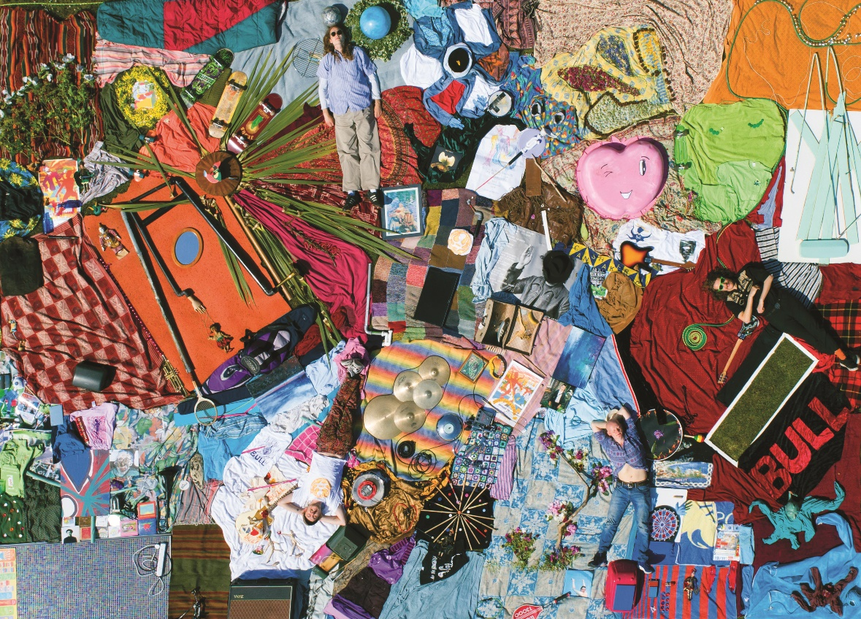

BULL BIO

There’s a pleasing irony to the fact that the oldest song from York quartet Bull’s forthcoming debut ‘Discover Effortless Living’ - due 26th March via EMI, is a jangling, harmony-drenched offering entitled ‘Green’. Dating back to 2012, shortly after the group of then-young teenagers first formed, it introduces a band that - though still only in their mid-twenties - are actually far from wide-eyed apprentices on the scene (the green newcomers you might expect); instead, vocalist and chief songwriter Tom Beer, guitarist and fellow original member Dan Lucas, bassist Kai West and drummer Tom Gabbatiss have notched up more than 500 gigs to their name, honing their wares over nearly a decade of graft and emerging with a record that stands as testament to that long-term, tight-knit bond.

“We’ve played pretty much every different way you can play, in all different kinds of rooms, to all different kinds of audiences - you start to learn what you need to do at any given time, and that’s a pretty good skill that you can only get by playing constantly,” says Kai. “I feel more comfortable on stage playing a gig than at any point in the day before the gig,” Tom G nods. “I’m much more worried about everything else, but as soon as I’m on stage playing I know that everyone knows what they’re doing. I feel like we trust each other enough to let whatever happens happen and roll with it a bit. It’s very comfortable.”

Initially coming together at the end of 2011 when Tom B first met Dan (the former had started dating the latter’s sister - “I’d come round to see her and then end up playing guitar with Dan for three hours,” he remembers), a first incarnation of the band gave way to their current line up in 2017 when Kai and Tom G joined the fold. “When they came in we were all determined to take the band seriously - to have lots of fun but also to tour and write a lot,” Tom B states. “I realised I was having so much fun I wanted to spend all my time doing it,” Dan agrees. “I’d tried to direct my life in that way even after we’d only been playing for a few months - studying music and doing the band properly.”

Having spent their formative years sharing music and developing a mutual love of Pavement, Pixies, Yuck, Dinosaur Jr and the “guitar-heavy, artistic rock music” that had come from the more lyrically-minded end of the ‘90s American indie spectrum, there’s an audible ease to the way the four work together that comes from

having devoted - for some of them - almost half their lives to doing it. Yet, while the fuzzy slacker pop of many of those influences are audible across the loose, warm kicks of last year’s ‘Bonzo Please’ or understatedly propulsive album track ‘Shiny Bowl’, Bull have also sharpened a knack for the nuances of the genre too: cleverly needling melodies that’ll stay in your mind for days, and pretty harmonies that sweeten every riff.

“We all use every limb we can use at any time; if you’ve got a foot spare and we want to have a big crash cymbal - it’s a no brainer for all of us that we want to use every possible thing we can,” Tom B enthuses. “We all sing and we do four-part harmonies - it’s a free instrument. We use as much as we can to make it as interesting and fun and beautiful as we can.

“All my favourite music is pretty,” he continues. “That’s our thing, I think. If we’ve got a thing, it’s that we like nice melodies. Because pop music doesn’t have to be boring, and the lyrics and the production don’t have to be boring. You can have the pop melody AND have the sound AND have the lyrics, so why just have one when you can have it all?”

It’s an attitude that writes itself all over the 13 songs of their debut. Recorded across a long, two-year bout of repeated trips to Amsterdam with producer Remko Shouten at the helm (“He’s Pavement’s sound engineer. We met him in a bar at 3am when he was on tour with Spiral Stairs”), ‘Discover Effortless Living’ doubles down on these ideas, fusing the easy atmosphere of four friends with a near-symbiotic musical relationship and the intricacies of a group unafraid to push their potential to create an album that reveals more of itself with each listen. Sure, ‘Eddie’s Cap’ might come on with a slow-burn before erupting into a wailing, cathartic purge, but can you hear the crunch they left in from their daily George Foreman grilled toastie?

“I think we used every single instrument in the studio at one point,” grins Tom G. “There’s that story of The Beach Boys recording ‘Good Vibrations’ and they recorded it in six different studios over a year. So I think the album is quite good for that reason; because we did it over such a long time, all the songs sound like they’re coming from a different place,” continues Dan as Tom B picks up: “Sometimes you plug in and play and you capture a bit of magic, but not very often. So this is the best way - to try and capture as much magic as possible and put it all together.”

On their debut, Bull have undeniably captured a lot of magic. Adorned with an Art Attack-style giant collage made by the band themselves (“I spent a month in the run up just walking around Scarborough, going down alleyways and finding anything with a nice colour or texture and shape - wood, a turquoise toilet, a pink apple, shit in skips…” recalls Tom B), its insides are just as playfully familiar yet pleasingly new as its sleeve.

From the purposeful naivety of ‘Love Goo’ to the intimate vocals of forthcoming single ‘Eugene’, the irrepressible melodic sensibilities of opener ‘Bedroom Floor’ to the wonkier, more percussive ‘Smoke’, ‘Discover Effortless Living’ sounds like a lost alt-classic - one that could nestle in happily alongside any of their heroes on the record shelf, but with a personality and rapport that’s entirely Bull’s own.

“We want to be the band that you think is the best band ever and that makes the best music you’ve ever heard,” grins their singer. “That’s what I want; that’s all I’ve ever wanted.”

For More Info
Facebook // Instagram // Youtube
www.bulltheband.com
www.youngthugs.com

For all media enquiries please contact Warren@chuffmedia.com on 07762 130510

